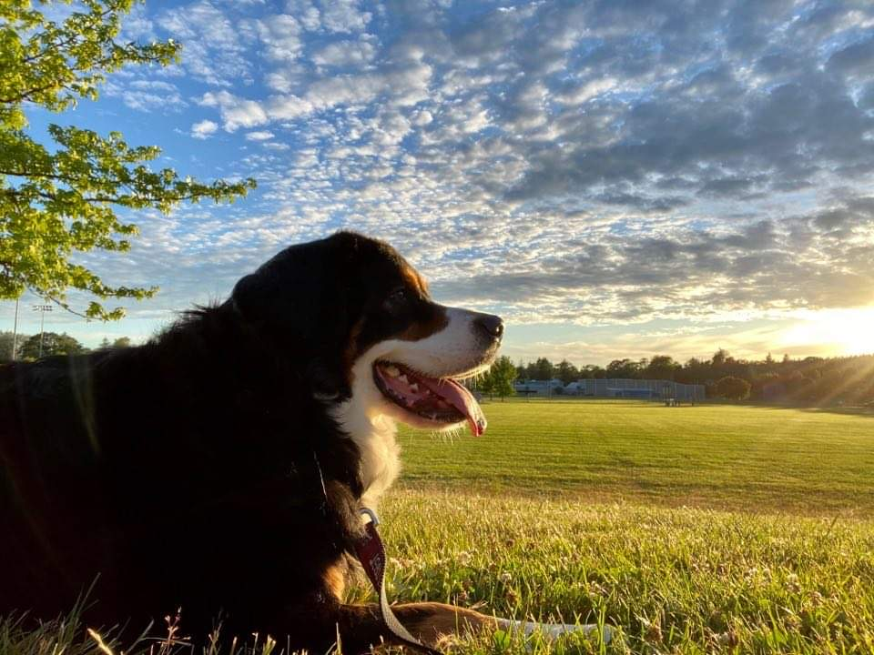

Dog Control
and Enforcement
under the Dog Control Act 1996
Guidelines for New Zealand Territorial Authorities
July 2026



Disclaimer
The information in this publication is, according to the Ministry for Cities, Environment, Regions and Transport’s best efforts, accurate at the time of publication. The Ministry will make every reasonable effort to keep it current and accurate. However, users of this publication are advised that:
- the information does not alter the laws of New Zealand, other official guidelines, or requirements
- it does not constitute legal advice, and users should take specific advice from qualified professionals before taking any action based on information in this publication
- the Ministry does not accept any responsibility or liability whatsoever whether in contract, tort, equity, or otherwise for any action taken as a result of reading, or reliance placed on this publication because of having read any part, or all, of the information in this publication or for any error, or inadequacy, deficiency, flaw in, or omission from the information in this publication
- all references to websites, organisations or people not within the Ministry are for convenience only and should not be taken as endorsement of those websites or information contained in those websites nor of organisations or people referred to.

This document may be cited as: Ministry for Cities, Environment, Regions and Transport. 2026. Dog Control and Enforcement under the Dog Control Act 1996: Guidelines for New Zealand Territorial Authorities. Wellington: Ministry for Cities, Environment, Regions and Transport.
Published in July 2026 by the Ministry for Cities, Environment, Regions and Transport
PO Box 10362, Wellington 6143, New Zealand
mcert.govt.nz
ISBN: 978-1-997358-02-2
Publication number: MCERT 4
© Crown copyright New Zealand 2026

Acknowledgements
The Ministry acknowledges the significant contribution of the working group that helped develop these guidelines, including representatives from council animal management teams across New Zealand, Taituarā and Local Government New Zealand. Their practical experience has been invaluable in shaping this guidance.
We also thank the wider group of stakeholders involved in dog control, animal management and welfare, who reviewed and contributed to the guidelines. Input from councils, central government agencies, animal welfare organisations and industry bodies has helped ensure the guidance is practical, balanced and informed by a range of perspectives.

Previous guidelines (contact mailto:dogs@mcert.govt.nzdogs@mcert.govt.nz for access)
Title | Action Date | Contents
Enforcement Guidelines under the Dog Control Act 1996 | May 2009 | Guidelines to help improve the enforcement of the Dog Control Act 1996, covering a range of issues and encourage consistency of application.
Supplementary information to the Enforcement Guidelines under the Dog Control Act 1996 | 2015 | Clarifies council responsibilities in three areas: online dog registration, animal welfare roles of SPCA and councils and use of search and entry powers under the Search and Surveillance Act 2012.

Document Version Control
Version No. | Action Date | Summary of Revisions

Contents
Disclaimer 2
Acknowledgements 3
Contents 3
Foreword 7
Introduction 8
Purpose of the guidelines 8
Why the guidelines refresh? 8
Glossary 9
Part 1 – Legislative context, approaches to dog control and registration 12
Legislative context 13
Dog Control Act 1996 13
Animal Welfare Act 1999 14
Other legislation intersecting with dog control 15
Role of central government agencies and other organisations 17
Approaches to dog control 18
Dog population dynamics 18
Dog ownership 18
Dog control matters and activities 19
Registration 22
Setting registration fees 22
Promoting/incentivising registration and following up on non-registration 23
Multiple dog ownership settings 24
Microchipping 24
Responsible dog ownership 24
Recognising responsible dog ownership 25
Working dogs 26
Disability assist dogs 27
Part 2 – Dog control management 28
Dog control policy 29
Dog control bylaws 31
Standard operating procedures 32
Dog control and elected members 32
Funding and resourcing dog control 33
Training and health and safety 33
Training 33
Health and safety 35
Provision of dog recreation areas and pound facilities 37
Provision of recreation areas 37
Provision of a holding facility (pound) 37
Part 3 – Enforcement 40
Enforcement policy 41
Enforcement measures 41
Enforcement decision making 42
Investigation and collecting evidence 43
Alternatives to prosecution 44
Responding to complaints 45
Seizing and impounding 47
Powers of entry 49
Classification of dogs 51
Monitoring a dog classification 51
Classification of owners 53
Dog breed or type restrictions 55
Offences and prosecution 56
Warnings 56
Infringements 56
Prosecution 57
Destruction 60
Objections, appeals and applications 61
Enforcement pathways for non-compliance 62
Part 4 – Preventative measures 74
Intervention to control dog numbers 75
Neutering 75
Control of dogs on public conservation land 75
Education and community awareness 75
Working with other organisations 77
Part 5 – Information management and reporting 79
Record keeping, reporting and monitoring 80
National Dog Database 80
Dogs register 80
Section 10A reporting 80
Information sharing 82
Website information on dog control 82
Use of apps and AI 83
Resources and Appendices 84
Resources and links 85
Appendix 1 – List of templates, forms, and processes 87
Taituarā Council Toolkit 87
Other templates a council may wish to develop 88
Dog Control (Prescribed Forms) Regulations 1996 89
Appendix 2 - Statistical reporting template 90
Section 10A(2) of the Dog Control Act 1996 90
1. Mandatory reporting fields 91
2. Optional reporting fields 93

Foreword

New Zealanders deserve to feel safe in their neighbourhoods, parks and public spaces. However, dangerous and uncontrolled dogs continue to cause serious harm to people, other animals and communities across New Zealand. Following a series of major dog attacks, the Government announced a review of the Dog Control Act 1996 to ensure councils have the tools they need to respond effectively and keep communities safe.
The Dog Control Act 1996 provides the legislative framework for dog control in New Zealand, with councils playing a vital role in administering and enforcing the legislation. Councils are responsible for responding to dog attacks, roaming dogs, nuisance complaints, and other public safety concerns, while also promoting responsible dog ownership through registration, education and community engagement. Every day, dog control and animal management officers undertake challenging and important work to keep communities safe.
These refreshed Dog Control and Enforcement Guidelines are the first step in the Government’s wider programme of work on dog control. They have been developed to support councils in carrying out their responsibilities. They provide practical guidance, examples of good practice and operational considerations to assist councils in applying their statutory powers consistently and effectively. The guidelines have been informed by the experience and expertise of animal management professionals across New Zealand alongside other local government organisations such as Local Government New Zealand and Taituarā.
Effective dog control is about more than enforcement. It relies on fostering responsible dog ownership and preventing harm before it occurs. These guidelines reflect today's operating environment and support councils to make informed decisions on dog control.
I would like to thank everyone who contributed to the development of these guidelines. I encourage councils to draw on this material in their day-to-day work to promote responsible dog ownership and support safer communities.




Hon Simon Watts

Minister of Local Government

Introduction

Purpose of the guidelines
The purpose of dog control is to maintain and improve public safety and the welfare of other animals. This places responsibilities on dog owners and where there is non-compliance or risk, provides councils (territorial authorities) with powers to take enforcement action.
These guidelines support councils in carrying out their dog control responsibilities by promoting effective, consistent, and proportionate enforcement. They provide practical guidance and examples of good practice to assist decision-making and implementation. The guidelines are split into five parts, followed by a list of resources and templates:
Part 1 – Legislative context, approaches to dog control and registration
Part 2 – Dog control management
Part 3 – Enforcement
Part 4 – Preventative measures
Part 5 – Information management and reporting

Why the guidelines refresh?
The initial Enforcement Guidelines were developed following a 2007/08 review of public safety under the Dog Control Act 1996 (DCA). The review found that safety could be improved by more consistent and effective enforcement of the DCA. The guidelines were published in 2009, with supplementary information released in 2015.
Since then, both anecdotal and statistical evidence tells us that dog control has become increasingly challenging for councils. Issues associated with difficult, irresponsible, and non-compliant dog owners contribute to problems like roaming dogs, menacing dogs, and increased dog attacks, both minor and serious.
In 2025, a review of the Enforcement Guidelines was initiated to determine whether they were still fit-for-purpose. Although some challenges may ultimately require legislative consideration, legislative reform can be a lengthy process. Refreshing the guidelines provided a practical way to support councils in the near term by promoting consistent and effective use of the powers already available under the DCA.
These refreshed guidelines consolidate content from the 2009 and 2015 material, while incorporating new content relevant to the current operating environment. They strengthen existing guidance, provide clarity where needed, and include reporting templates to support more consistent data collection. The guidelines also highlight additional resources, including the Taituarā Council Toolkit which may assist councils in implementing the guidance in practice.
The guidelines were developed by the local government function within the Ministry for Cities, Environment, Regions and Transport (MCERT), formerly within the Department of Internal Affairs, in collaboration with a working group. The working group included representation from animal management teams across New Zealand, Taituarā and Local Government New Zealand.
These guidelines may be reviewed and updated in response to legislative changes or when deemed necessary, in consultation with the sector and led by the agency responsible for administering the DCA.

Glossary
Note: in these guidelines “section” when referencing a section in legislation has been abbreviated to “s”.
Term | Description
Abandoned dog | For these guidelines: means a dog that has been deliberately or inadvertently cast off or left behind by a previous owner and is subsequently uncontrolled and uncared for. The dog may be surviving by living in a wild state and forming packs with other abandoned dogs or feral dogs. These dogs may have microchips implanted and are also known as stray dogs.
Aggressive | For these guidelines: means behaviour displayed by a dog showing a readiness to attack another animal or person. This can include raised hackles, bared teeth, growling or snarling, barking, rushing or lunging, and snapping or biting.
Attack | For these guidelines: means a dog bite incident ranging from aggressive behaviour with skin-contact by teeth but no skin-puncture, to severe dog bite incidents with multiple deep puncture wounds. A dog bit incident can be made against a person or an animal.
Council | For these guidelines: means a territorial authority as referred to in the DCA, which means a city or district council named in Part 2 of Schedule 2 of the Local Government Act 2002.
Disability assist dog | Defined in the DCA: a dog certified by one of the organisations listed in Schedule 5 of the DCA as being a dog that has been trained (or is being trained) to assist a person with a disability.
Dog control officer (DCO) | Defined in the DCA: appointed under s11 of the DCA, including a warranted officer exercising powers under s17. A DCO must have a warrant of appointment.  Note: some councils refer to DCOs as ‘animal control officers (ACO)’ or similar, although the DCA only uses ‘dog control officer’. These guidelines use ‘DCO’ (which also applies to dog rangers unless noted otherwise).
Dog owner | Defined in the DCA: means someone who owns a dog or is in possession of a dog, except for less than 72 hours for specified purposes. Also, the parent or guardian of someone under 16 who owns the dog and is a dependant of the parent or guardian and member of their household.
Dog ranger | Defined in the DCA: appointed under s12 of the DCA, including an honorary dog ranger.  Note: A dog ranger must have a warrant of appointment. Generally, dog rangers require less stringent appointment criteria and have similar powers to DCOs although there are exceptions, such as under s14 of the DCA, which enables only DCOs (and others assisting them) to enter premises under specified conditions.
Dwellinghouse | For these guidelines: means a vehicle or building (or part of a building) that is used, or intended to be used, as a place of residence (i.e. for people to live and sleep), including structures that are an integral part of that residential use (for example, a garage or sleepout).
Feral dog | For these guidelines: means a dog that has never had an owner and was born in the wild. This dog has minimal or no socialisation with humans, living primarily by hunting, scavenging and forming packs, actively preying on stock, poultry or wildlife, and displaying avoidance or aggression towards people.
Fresh pursuit | For these guidelines: means the immediate and continuous following or tracking of a dog by a DCO or dog ranger, commencing at the time and place of the event.
Infringement offence | Defined in the Summary Proceedings Act 1957: any offence under any Act in respect of which a person may be issued with an infringement notice.
Nuisance | For these guidelines: means a dog causing problems or annoyance by doing anything harmful or distressing to an individual, the wider community, or any animal. Examples can include persistent and loud barking, wandering or roaming, and undealt with defecation.
Poultry | Defined in the DCA: means any live bird (including a domestic fowl, a duck, a goose, a turkey, a guinea-fowl, a pheasant, an emu, an ostrich, a quail, or a pigeon) that is kept or raised for the purpose of sale or of producing eggs, hatching eggs, or poultry products or for the purpose of rearing on behalf of another person.
Protected wildlife | Defined in the DCA: any animal protected under s3 and s5 of the Wildlife Act 1953 or a marine mammal as defined by the Marine Mammals Protection Act 1978.
Provocation | For these guidelines: means a person or animal that has done something deliberate or unreasonable with intent that would cause an ordinary, socialised dog to react defensively or aggressively. This can include actions such as teasing, hurting, threatening, or threatening a person or animal that the dog would normally be expected to protect.
Public place | Defined in the DCA:  - means a place that, at any material time, is open to or is being used by the public, whether free or on payment of a charge, and whether any owner or occupier of the place is lawfully entitled to exclude or eject any person from that place; and  - includes any aircraft, hovercraft, ship or ferry or other vessel, train, or vehicle carrying or available to carry passengers for reward.
Rushing | For these guidelines: means the purposeful lunging movement of a dog directed towards a person, animal, or vehicle in a way that suggests the intent of threat or harm. It is not necessary for contact to be made.
Serious injury | For these guidelines: means the results of a dog attack that may include skin punctures requiring stitches, multiple bite wounds, injury requiring hospital treatment, injury resulting in lasting impairment, or injury to a vulnerable area like the face or neck.
Stock | Defined in the DCA:  - any live horse, cattle, sheep, swine, alpaca, llama, bison, donkey, hinny, mule, or water buffalo that is not in a wild state; and  - any deer, goat, tahr, rabbit, possum, or other animal that is kept within a fence or enclosure for domestic or farming purposes.
Veterinarian | For these guidelines means a person who is registered with the Veterinary Council of New Zealand and who holds a current practising certificate. See: Code of Professional Conduct, Veterinary Council of New Zealand.
Working dog | Defined in the DCA: any disability assist dog or any dog kept by specific persons or entities for specific purposes. A council may declare, by resolution, that a dog is a working dog for the purposes of the DCA. A working dog must be registered as such.  Note: it is important to recognise that while all disability assist dogs are working dogs, not all working dogs are disability assist dogs. So, working dogs are not afforded the same legislative protection for access rights that disability assist dogs are.

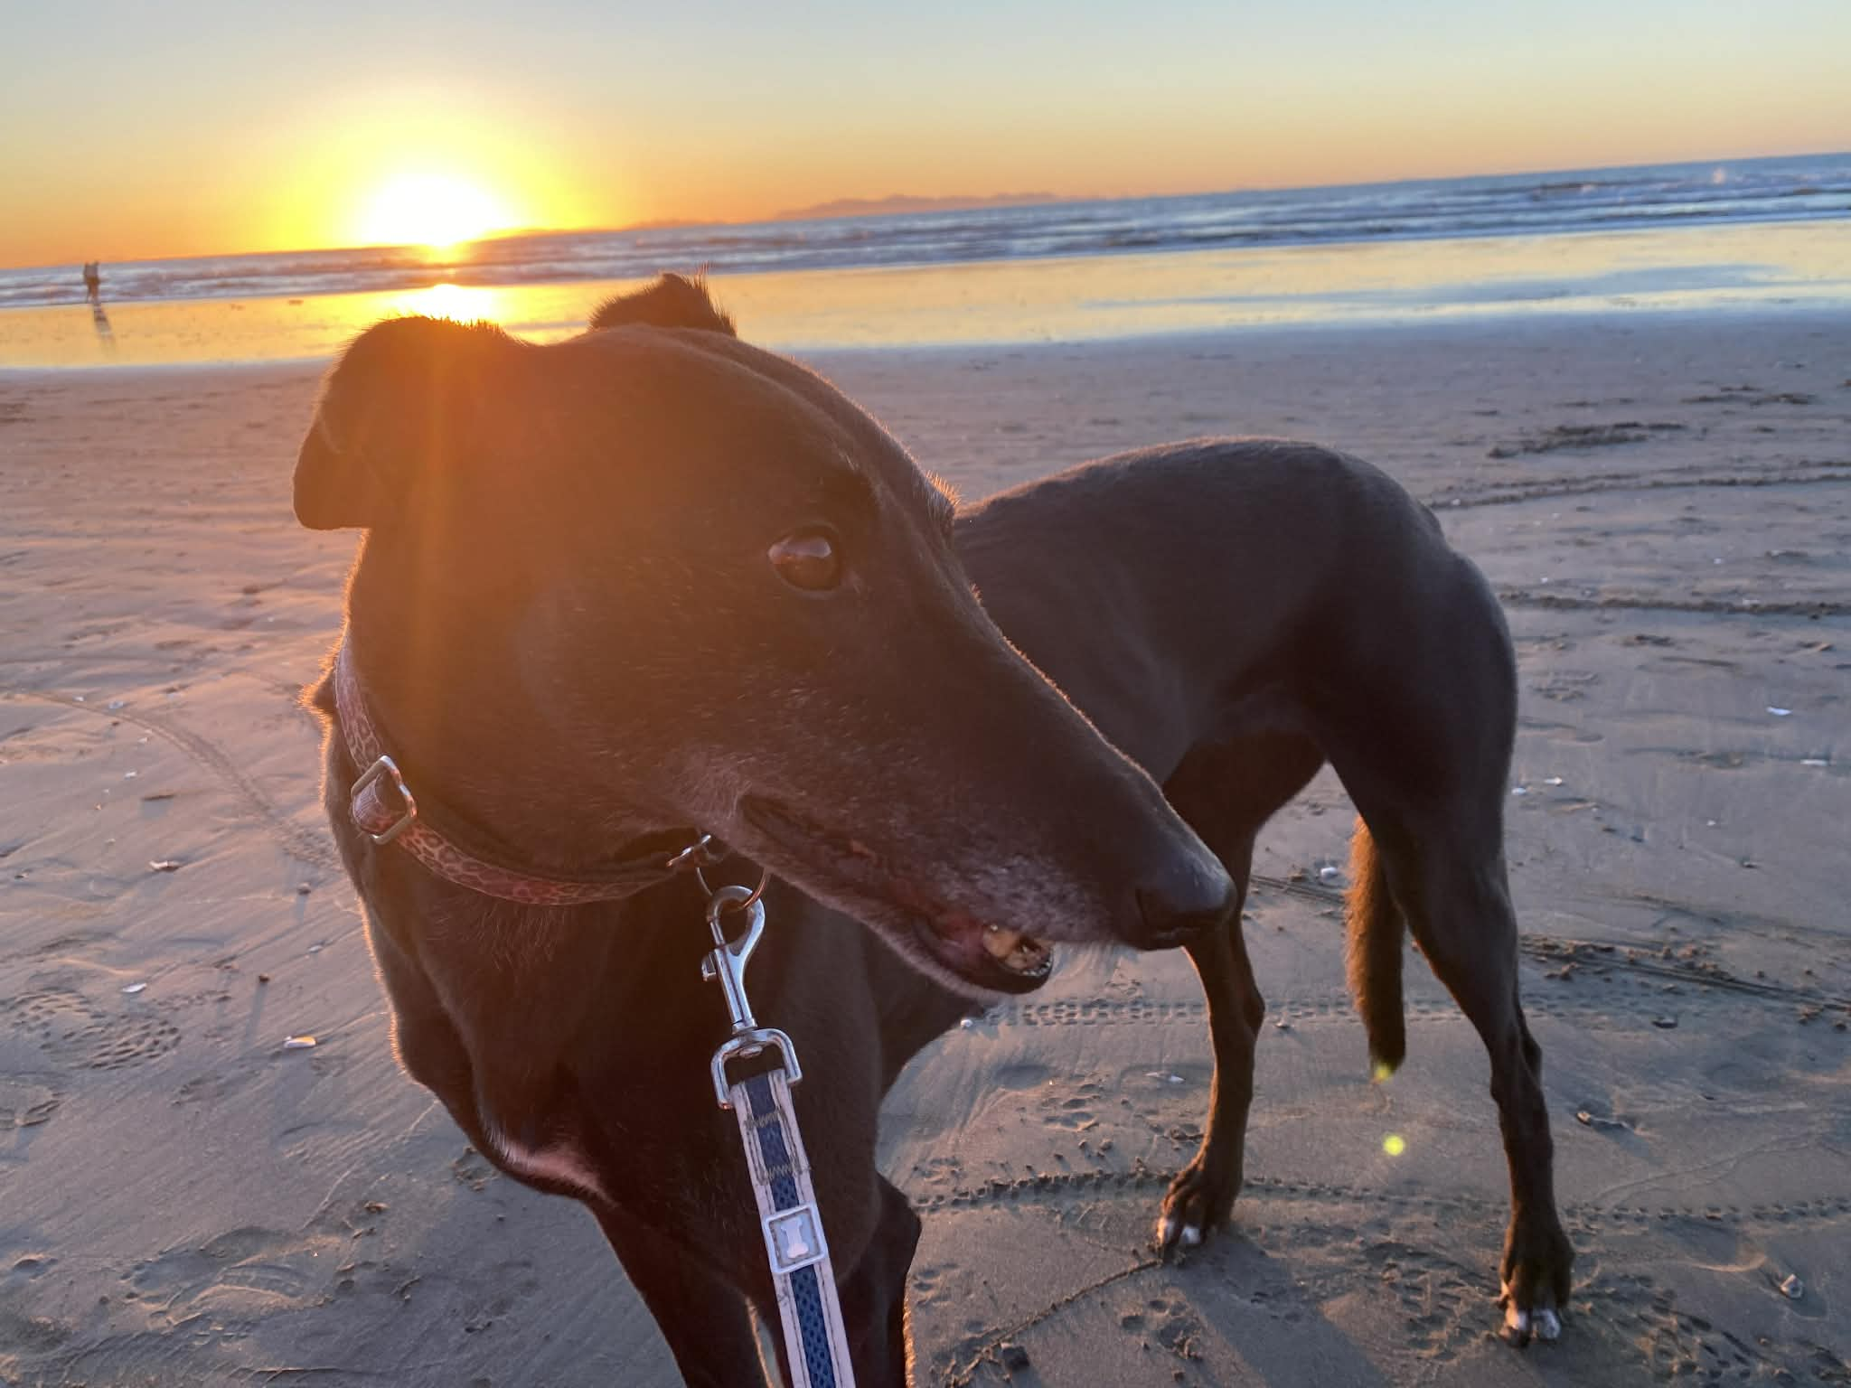
Part 1 – Legislative context, approaches to dog control and registration

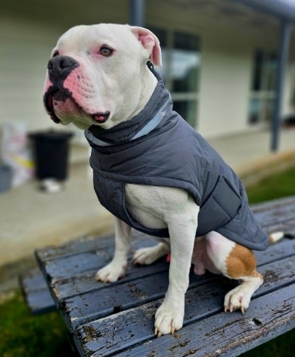
Legislative context

Dog Control Act 1996
Dog control is regulated by the Dog Control Act 1996 (DCA) which was introduced after a major review of dog control in the mid-1990s. The DCA focuses on managing risk and enables actions to mitigate unreasonable risk. Figure 1 highlights the key features of the DCA and associated regulations.
MCERT administers the DCA. These guidelines provide information to help understand and comply with the DCA. However, individual councils remain responsible for their own legal risk.
Figure 1: Features of the DCA and Regulations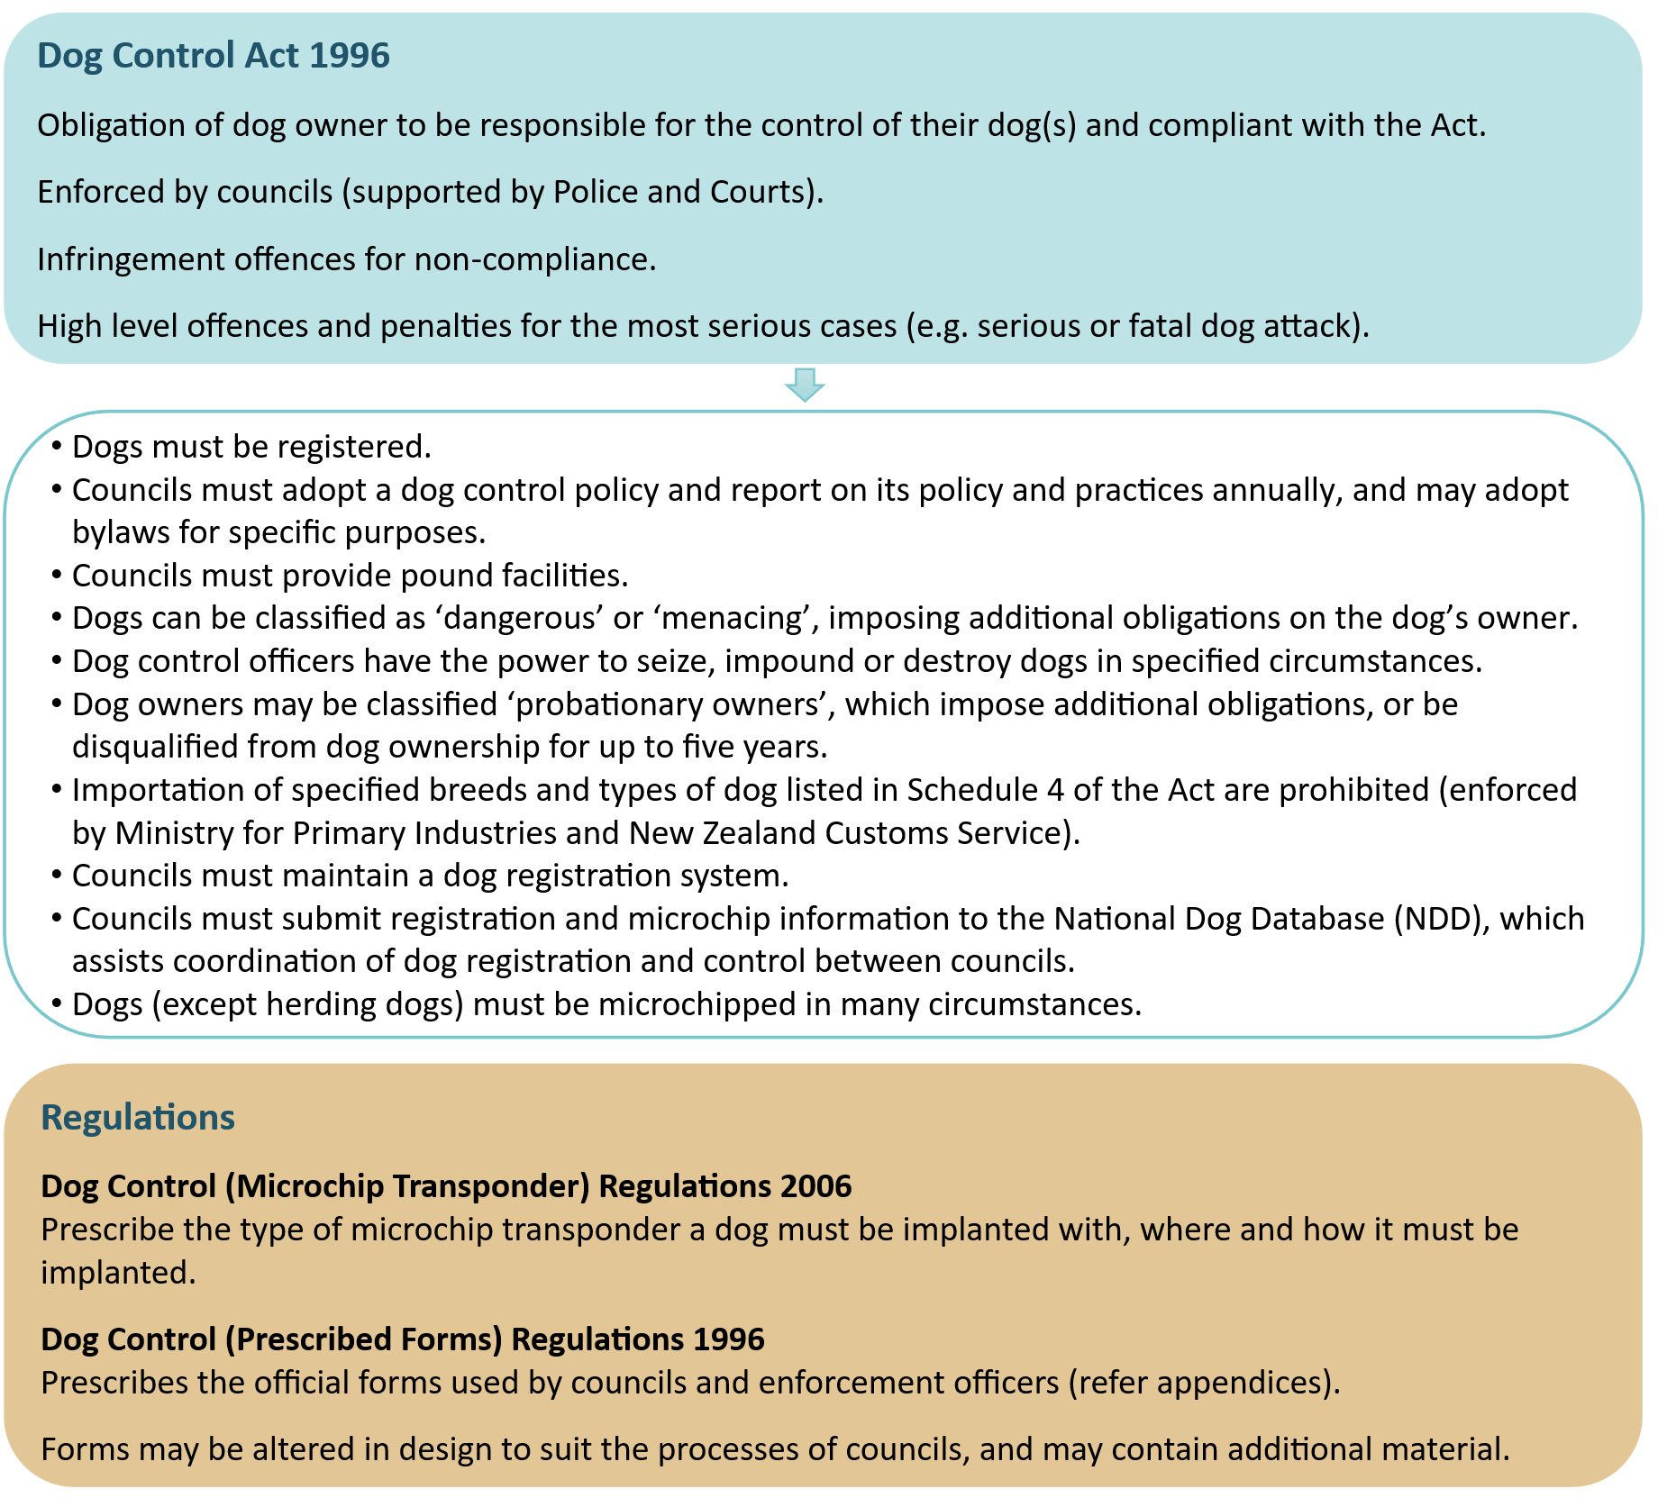

Animal Welfare Act 1999
The Animal Welfare Act 1999 (AWA) is designed to prevent animal cruelty and places a duty of care on people in charge of animals to meet their animals’ needs. The Ministry for Primary Industries (MPI) and the SPCA jointly enforce the AWA. However, the SPCA, as an approved organisation under the AWA, focuses on the welfare of companion animals. DCOs are only warranted to deal with animal welfare matters under the DCA, not the AWA. However, DCOs (and animal shelter staff) are subject to the obligations of the AWA and relevant regulations and codes.
Section 127 allows inspectors and constables to enter vehicles or premises (but not a dwellinghouse) without a warrant for the purposes of inspecting any animal at a reasonable time.
A council’s approach to dog control should incorporate animal welfare considerations as a matter of standard practice. All relevant standards and requirements as indicated in Figure 2 need to be met in carrying out dog control activities.

Figure 2: The animal welfare system in relation to dogs
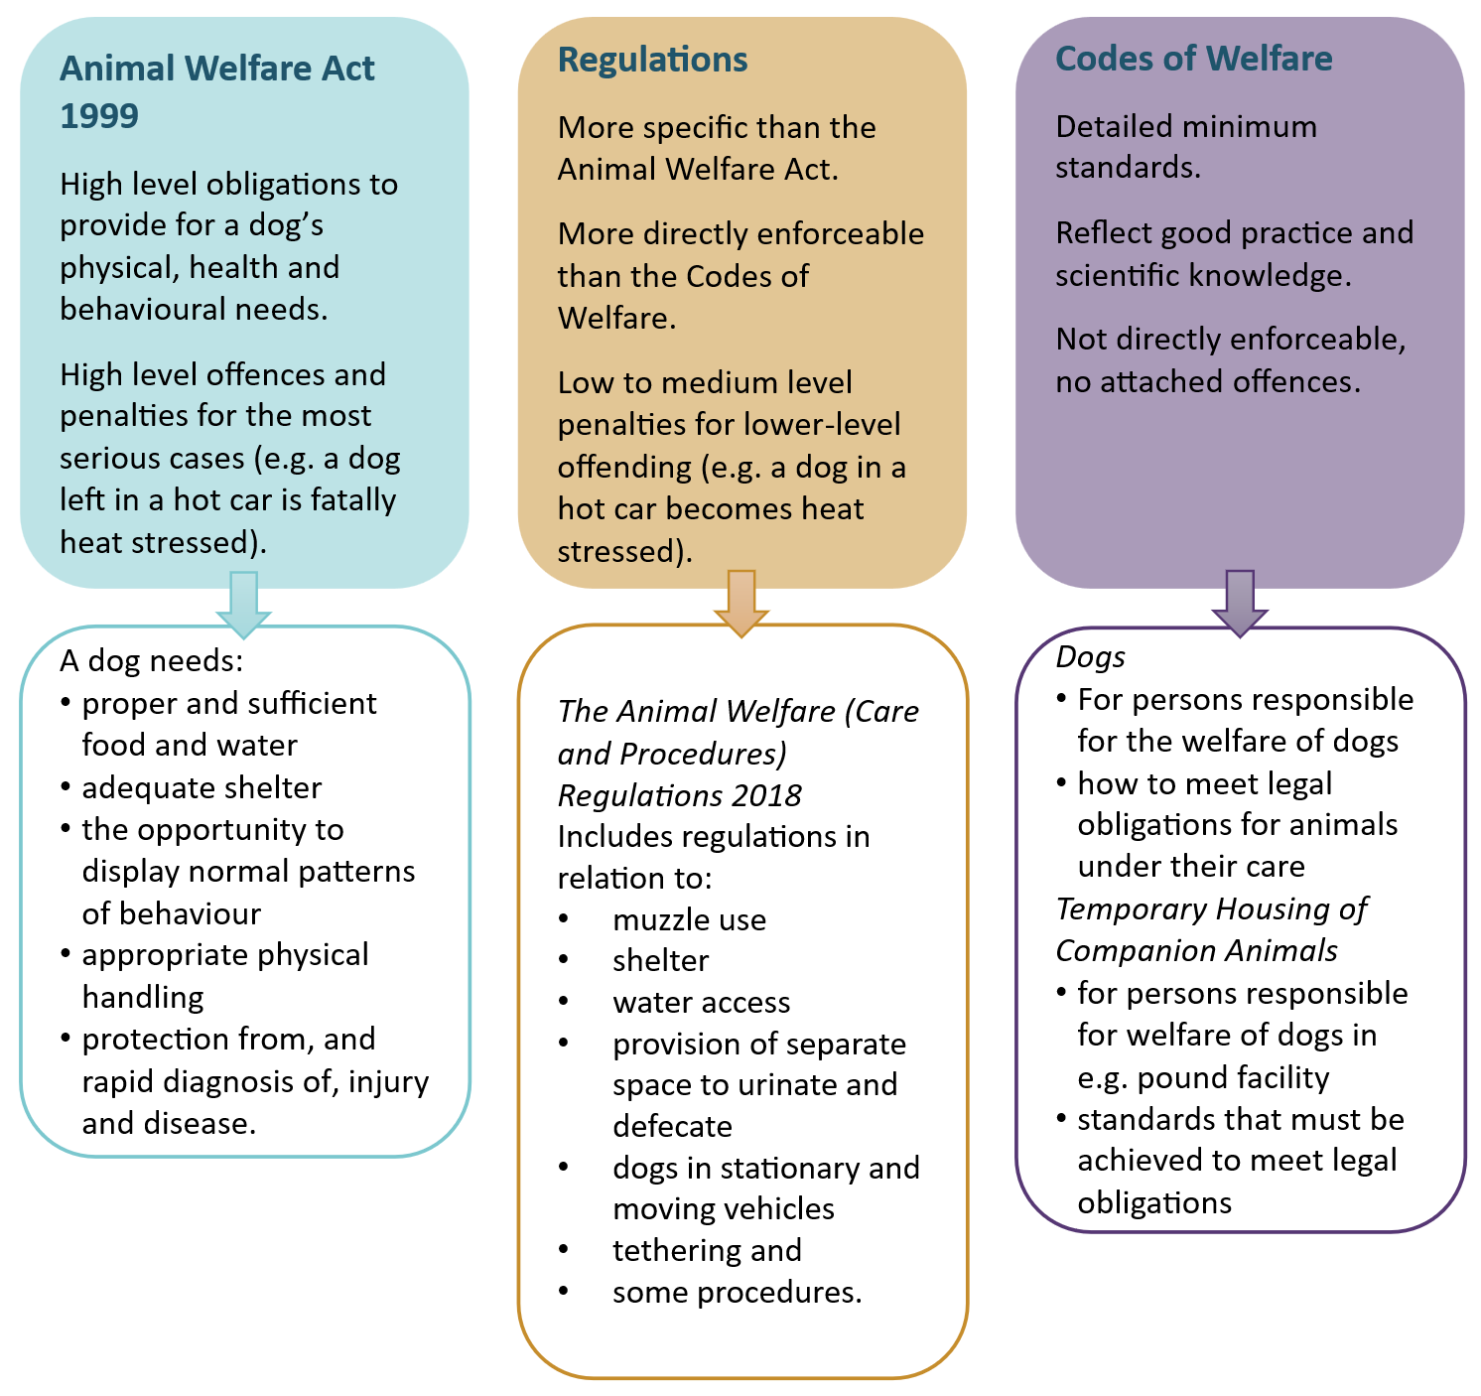

Other legislation intersecting with dog control
There is a range of other legislation that the DCA interacts with and that DCOs need to be aware of as it relates to aspects of their work. The key pieces of related legislation are listed in Table 1.
Table 1: Other legislation that intersects with dog control
Legislation | Intersect with dog control
New Zealand Bill of Rights Act 1990 | As dogs are the property of their owner, DCOs must have regard to protections against unreasonable search and seizure under section 21 of this Act.
Search and Surveillance Act 2012 | This Act contains provisions relating to entry onto land or premises, searches, seizures, and use of warrants (relevant to DCA s14, s56 and s57). The Act’s purpose is to facilitate the monitoring of compliance with the law and the investigation and prosecution of offences in a manner that is consistent with human rights values.
Summary Proceedings Act 1957 | Section 21 of this Act describes the procedure for District Court proceedings regarding infringement offences.
Criminal Procedures Act 2011 | This Act describes the categories of offences, which is relevant to court proceedings under certain sections of the DCA.
Victims’ Rights Act 2002 | This Act aims to improve the provisions for the treatment and rights of victims of offences. This holds relevance to councils and DCOs when they are dealing with victims of offences against the DCA such as dog attacks.
Legislation Act 2019 | Section 17 of this Act relates to a document required to be sent by post and the time it is considered as received. Section 54 describes how time periods referenced in legislation are calculated. For example, if an action must occur within a specified period after an event, the day of the event is not counted. These rules matter where, for example, a council is authorised to act after a lapse in time.
Privacy Act 2020 | Dog control work routinely involves the collection, use, sharing, and retention of personal information about identifiable individuals. A council must have regard to the 14 information privacy principles (IPP) under this Act. Some examples of how these interact include:  IPP2 Source of personal information – for example, owners should be approached directly for information. Third party collection (for example neighbours, landlords) must be justifiable (and documented).  IPP10 Limits on use of information – for example, information collected to resolve a barking complaint should not be automatically used to initiate an unrelated enforcement.  IPP11 Limits on disclosure of personal information – for example, a DCO shouldn’t disclose complainant details to dog owners, but may need to disclose to other enforcement agencies.
Conservation Act 1987 | A council’s dog control policy must identify land within its district that is included in a ‘controlled dog area’ or ‘open dog area’ as defined by this Act. No dog control bylaw has effect in such an area. If a person, by taking a dog into such an area, is convicted of the offence, a council may, under the DCA, classify the owner as probationary or disqualify them from owning a dog. Part 5C of this Act (Control of dogs) includes the ability for warranted DOC officers to seize or destroy dogs in certain circumstances such as if found in a controlled dog area and outlines dog-related offences.
National Parks Act 1980 | A council’s dog control policy must identify land within its district that is included in a national park. No dog control bylaw has effect in a national park. If a person, by taking a dog into a national park, is convicted of the offence under this Act, a council may classify the owner as probationary or disqualify them from owning a dog.
Te Urewera Act 2014 | A council’s dog control policy must identify land within the district that is included in Te Urewera. No dog control bylaw has effect in Te Urewera. If a person, by taking a dog into Te Urewera, is convicted of the offence against this Act, a council may classify the owner as probationary.
Wildlife Act 1953 | This Act identifies wildlife that are protected. Action can be taken under various parts of the DCA if protected wildlife is threatened or killed by a dog.
Marine Mammals Protection Act 1978 | Under the DCA ‘protected wildlife’ includes any marine mammal as defined by this Act. Action can be taken under various parts of the DCA if protected wildlife is threatened or killed by a dog.

Role of central government agencies and other organisations
Table 2 lists the role of organisations (other than councils) in administering the DCA and associated dog control-related activities.
Table 2: Role of government agencies and other organisations in dog control
Agency/ organisation | Role
Minister of Local Government (MoLG) and Ministry for Cities, Environment, Regions and Transport (MCERT) | The MoLG is responsible for the administration of the DCA including amending or adding to the breeds or types of dogs in Schedule 4 (subject to ban on importation, and muzzling) and adding or removing organisations authorised to certify dogs as disability assist dogs in Schedule 5. MCERT is responsible for administering the DCA on behalf of the MoLG, including the National Dog Database (NDD).
Ministry for Primary Industries (MPI) | MPI and the SPCA jointly enforce the Animal Welfare Act 1999 and ensure compliance with the minimum standards contained in Codes of Welfare (developed by the National Animal Welfare Advisory Committee). SPCA takes the lead regarding companion animals (and specifically dogs).
Police | Many of the powers conferred upon DCOs and dog rangers may also be exercised by constables. Constables are also required in certain situations to be present when entering private property (refer guidelines section: Police involvement in search and seizure).
Department of Conservation (DOC) | DOC is responsible for setting access conditions and rules for public conservation land and providing for visitor safety under various Acts. Dogs are generally prohibited from such land unless otherwise permitted. These Acts allow DOC to seize and destroy unauthorised dogs if doing so is necessary to protect the safety of people or wildlife. DOC may shoot, or capture and then humanely kill, feral dogs or dogs that are causing harm without an identifiable owner.
Royal New Zealand Society for the Prevention of Cruelty to Animals (SPCA) | SPCA and MPI jointly enforce the Animal Welfare Act 1999 (AWA) and ensure compliance with the minimum standards contained in Codes of Welfare. A DCO may be the first informed when a person is concerned about the welfare of a dog. While DCOs do have powers to enforce the specific animal welfare provisions under the DCA, the SPCA have more powers under the AWA so where practicable referring welfare matters to them is good practice.
New Zealand Customs | Schedule 4 of the DCA states that certain breeds and a type of dog are banned from being imported into New Zealand (see section: Dog breed or type restrictions). All importations of dogs (except specific exemptions) must have an accompanying Exempting Statutory Declaration. Failure to have made such a declaration makes the importation unlawful (regardless of breed or type) and the animal is forfeit and may be seized.

Approaches to dog control
Good dog control needs to balance the interests and freedoms of responsible dog owners with the need to protect the public (and other animals) from harm from dogs. It is a regulatory activity that can be highly emotive.
The DCA seeks to improve public safety by mitigating the risk of harm, injury or nuisance from dogs living in our communities.

Dog population dynamics
There are different sub-populations of dogs typically found in New Zealand that interact to form the overall dog population. DCOs primarily interact with owned, lost, roaming, abandoned and surrendered dogs. DOC manages unauthorised, uncontrolled and feral dogs on public conservation land, although these dogs may also live in other places such as large backcountry stations.

Dog ownership
New Zealand has one of the highest rates of companion animal ownership in the world. About a third of New Zealand households are home to a companion dog.
The COVID-19 pandemic had an impact on dog ownership with an increase in the number of households owning dogs and in the overall dog population, likely due to the companionship they provided, especially during the lockdown periods. Ownership and the dog population have dropped a little since but remain higher than pre-pandemic times.
There are obligations on both dog owners and councils as indicated in Figure 3.
Figure 3: Obligations of dog owners and councils
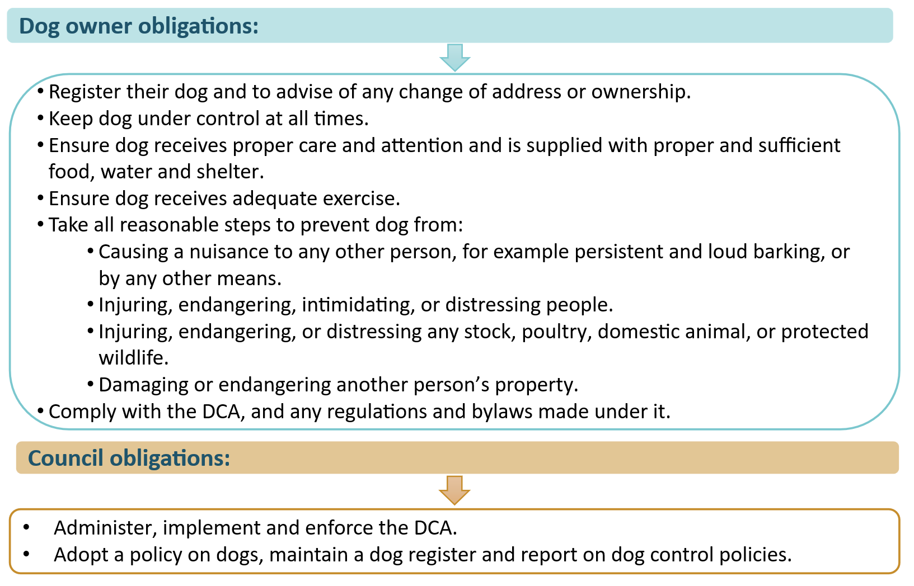

Dog control matters and activities
Several matters can be considered in developing approaches to dog control consistent with the general principles of administering and enforcing regulatory regimes. How a council chooses to approach dog control matters determines the outcomes and effectiveness of their activities on the ground, especially enforcement. In addressing dog control issues, a council should be seeking to achieve the most positive and enduring outcome in accordance with sound regulatory practice.
The model in Figure 4, although developed for compliance and enforcement under the Resource Management Act 1991, can be viewed as applicable to dog control under the DCA. Other regulatory models include the Braithwaite pyramid of responsive regulation and the VADE model (Voluntary, Assisted, Directed and Enforced behaviours).

Figure 4: Compliance model applicable to an approach to dog control
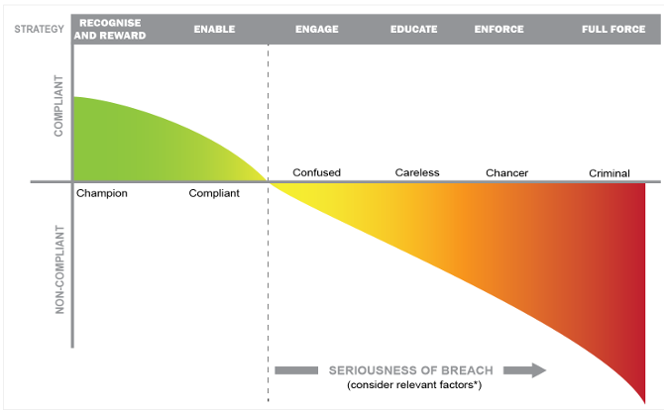
* relevant factors are set out in Table 9 of Part 3 – Enforcement
Based on the model above, an example of approaches and activities are shown in Table 3.
Table 3: Dog control approaches and activities
Approach/strategy | Aims of activity | Activity example
Recognise and reward | Acknowledge responsible dog ownership | ‘Approved dog owner’ status provides benefits such as reduced registration fees  On the spot rewards such as dog food for owners walking on lead issued when patrolling
Enable | Make it easy to comply, incentivise compliance and remove obstacles to compliance | Notify owners when registration is due with online registration and payment available  Make information and forms available in accessible formats and in languages other than English  Provide clear signage for on-lead and off-lead dog exercise areas  Offer incentives for early registration, for example
Engage | Use various communication channels including social media and events to inform and encourage compliance | Promote registration, neutering and responsible dog ownership at events and through communication channels
Educate | Educate on responsible dog ownership, safety around dogs, and ensure the public know and understand the consequences of their choices | Build community awareness, understanding, support, and involvement through the provision of information and public education, for example through schools, events
Enforce | Actively apply dog control legislation and bylaws, utilise various enforcement tools, escalate from one tool to another, and sanction | Issue warnings and infringements, and seize and impound dogs where appropriate
Full force | Apply the strongest available regulatory interventions where there is a significant risk to public safety or repeated non-compliance | Prosecution, owner disqualification, seize and impound dangerous dogs and destruction orders where appropriate

Based on the model in Figure 4, owners are categorised in Table 4 with their indicative level of compliance, enforcement needs and risk.
Table 4: Categories of dog owners and their levels of compliance, enforcement and risk

 | Compliance level | Steps towards compliance | Enforcement | Risk
Champion | Always comply with the rules  Encourage others to do the same | Not required | Not required | Unlikely to be associated with un-reasonable risk to public safety
Compliant | Generally choose to comply | Takes the appropriate steps to comply | Not required
Confused | Well-intentioned but may not always comply with all their obligations or fully understand their dog | Can be encouraged to become responsible owners and take the appropriate steps if given helpful tips, advice, reminders and warnings to ensure compliance | Low level enforcement action may be required | Some likelihood to be associated with unreasonable risk to public safety  May become associated with unreasonable risk
Careless | May be willing to comply but may need assistance with more than general messages |  | Low level enforcement action may be required
Chancer | Does not always comply despite an awareness of consequences | Warnings to encourage compliance may be required | Low-medium level enforcement action may be required | May become associated with unreasonable risk
Criminal | Chooses not to comply | Cannot be encouraged to take appropriate steps | Escalating levels of enforcement can be expected | Present risk
In practice, focusing awareness on rewarding and recognising, enabling, engaging and educating people on the choices they can make, and the consequences of those choices, can be very effective. Inevitably however, in some cases enforcement action will be required. Although enforcement activities may only be required in respect of a few dog owners, these activities are time and resource intensive.
A successful approach requires alignment of approaches to funding, policy, and dog control activities including enforcement and monitoring. This ensures dog control issues are recognised and met with a considered response.
A council should consider a total services approach, that is integrated with and supported by other council services, which builds and maintains strong and effective relationships with other agencies and groups, such as:

- Fire and Emergency New Zealand, Police, courts, Court Collections, New Zealand Customs Service
- SPCA, HUHA, and other animal welfare and rehoming organisations
- Blind Low Vision NZ Guide Dogs and other disability assist dog providers
- Health New Zealand, Plunket, Kāinga Ora, New Zealand Post, Work and Income, ACC, National Emergency Management Agency and the Department of Conservation
- primary sector organisations such as Federated Farmers and Beef + Lamb New Zealand
- local veterinarians, pet shops, boarding kennels and breeders
- iwi, hapū, and communities generally.

Registration
The registration of dogs is central to the DCA. A council should aim to register all dogs aged three months and over. Registration:
- is a legal obligation of all dog owners, regardless of where the dog is kept
- allows communication with dog owners
- allows a council to record and monitor a history of both dog and owner behaviour for incentives or future enforcement activity
- provides legal certainty of liability, necessary for the effective operation of offences and penalties.
While a person of any age can be a dog owner, the parent or guardian of a person younger than 16 will likely be required to register the dog with a council.

Setting registration fees
A council is authorised to set a reasonable registration fee regime for the control of dogs under s37 – s39 of the DCA. Council consideration of registration fees takes place in the wider context of financial management, which is subject to the provisions of the Local Government Act 2002 (LGA).
It is common practice for a council to structure registration fees that recognise good practice, responsible dog ownership, and the characteristics of their district as indicated in Table 5 below.
Offering financial assistance to dog owners that need it to enable them to register their dog(s) could also be considered. This may include part payments, paying off over time, using AfterPay or paying off in advance for the following year.
Table 5: Possible registration fee differentiation based on dog/owner characteristics
Type of dog/dog ownership | Level of fee and coverage
Recognised responsible dog owner | Less than the standard registration fee
Standard dog ownership | More than responsible owner fee
Dangerous dog | Required to pay 150% of a council’s (standard) dog registration fees (under s32(1)(e) of the DCA)
Neutered dog | Less than the standard registration fee
Dog living in rural area | May be lower than urban dog fee, due to levels of service  Discounted fees for multiple working dogs (farm dogs, for example)
Dog living in urban area | May be higher than rural dog fee due to the higher level of dog control services provided
Other dog owner status | SuperGold or Community Services Card holders may have a lower fee than the standard registration fee
Working dogs | Discounted or free registration may be offered to working dogs defined under s2 of the DCA
Service dogs | Free registration may be offered to disability assist dogs certified by an organisation authorised under Schedule 5 of the DCA

Promoting/incentivising registration and following up on non-registration
Public awareness and education campaigns promoting registration due dates and fees, along with reminder notices to registered owners, are effective tools for supporting voluntary compliance.
Where dogs remain unregistered, a council may undertake targeted follow-up activities. After-hours DCO contractors could be utilised (where possible) to follow up non-registration through door-knocking and confirming the presence of dogs, before issuing reminders or informal warnings. Follow-up and enforcement activity could be prioritised based on the number of consecutive years a dog has remained unregistered.
Where a dog is impounded, offering the owner no impound fees if the owner claims and registers the dog within 24 hours provides an incentive for compliance. Information on the enforcement pathway for non-registration is covered in Table 17.
Incentives for registering could include:
- early bird competition – those who register early are automatically entered into a draw to win prizes, such as dog food or other dog-related products, dog obedience training coupons
- reduced or free fees for first-time dog registrations to encourage entry into the registration system
- waive registration fee in the year a dog is neutered, or offering reduced registration fees for neutered dogs, to support responsible ownership and dog population control
- outreach programmes, such as providing free or subsidised microchipping initiatives at the same time as registration
- lower fees where owners have taken part in council approved dog obedience training (or are otherwise recognised as a responsible owner, subject to further criteria being met)
- issuing an infringement notice for overdue registration, with the infringement fee waived for first-time offenders if registration and all outstanding payments are made (for the first year of late payment only).

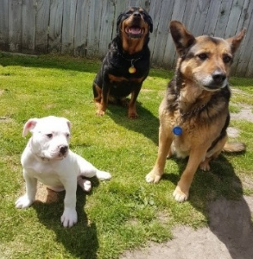
Multiple dog ownership settings
A council can set a bylaw that limits the number of dogs that may be kept on any land or premises. Similar limits may also be imposed through licensing regimes for specific activities, such as breeding kennels. If setting limits, it would be appropriate to do so for both urban and rural settings. The size and characteristics of the property are important considerations. A council may wish to consider setting a maximum number of dogs that can be kept on a property without a permit.
If a permit is issued allowing more than the maximum number of dogs, a council should also consider the circumstances in which the permit may be revoked.
For example, revocation may be appropriate where permit conditions are repeatedly breached or where the owner keeps more dogs than the authorised number.
Before revoking a permit, written notice of the breach and opportunity for the owner to lawfully dispose of the additional dog(s) should be provided. If the owner continues to be non-compliant, an infringement notice against the bylaw may be appropriate.
In the case of working farm dogs, as several farm shepherds may work on a single farm, each with their own dogs. It is therefore important that bylaws and registration systems distinguish between the owner and the property on which it is kept. Working dogs in rural areas should be registered to its owner, rather than the property.

Microchipping
All dogs must be microchipped (including dogs classified as dangerous or menacing but excluding herding dogs) and recorded on the National Dog Database (NDD), although many councils choose to additionally record this on their own council dog register. This makes it easy for lost pets to be identified and reunited with their owners, and to identify the owners of roaming dogs, dogs involved in attacks, or dogs that are the subject of complaints.
Encouraging compliant behaviour could be achieved through free microchipping events, offering a discounted microchipping fee or subsidising veterinary microchipping fees. Non-compliant owners that do not register their dogs may also not comply with the microchipping requirement and vice-versa. Impounded dogs must be microchipped before being released, unless it is their first time being impounded. The council may recover costs relating to this from the dog owner.
Where there is failure to provide microchip details, warning letters could be issued to all dog owners in breach, stating an expected timeframe for the supply of their dog’s microchip details. If the information is not provided by the due date, an infringement can be issued, which is waivered if they then comply, or enforced if not.

Responsible dog ownership
Dogs are valued both as companions and working animals. Responsible dog owners comply with the DCA and relevant bylaws, value their dog, and make sure it is well cared for.
Section 54 of the DCA requires owners to ensure that their dog receives proper care and attention, including adequate food, water, and shelter and exercise. If not properly managed and cared for, a dog’s welfare can be affected and increase the risk of negative impacts on other dogs, humans, animals and the environment.
Meeting the recreational needs of dogs is both an animal welfare issue and a nuisance prevention measure. Healthy, happy, well socialised, and adequately exercised dogs are less likely to be problematic to the owner, the community or to the council.
A breach of the basic welfare provisions in the DCA can amount to an infringement offence or a prosecution offence.
Responsible dog ownership also requires owners to keep their dog under control at all times and ensure they do not cause a nuisance to, or endanger, other people or animals. Responsible dog owners positively contribute to maintaining public safety through abiding by the basic obligations of dog ownership and abiding by local bylaws.

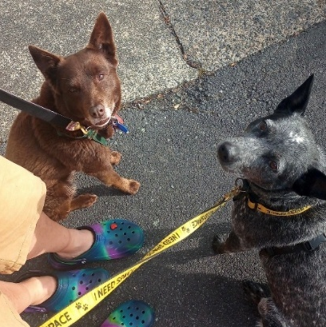
Recognising responsible dog ownership
Recognising and rewarding responsible dog ownership is good practice and supports the broader objectives of public safety and effective dog control. There are a variety of ways a council can recognise and encourage responsible dog ownership.
At events or when on patrols, observed positive behaviour could be spontaneously rewarded with a small acknowledgement, such as a packet of dog food or dog waste bags. Giving a free lead to those walking their dog without one may also encourage education and awareness.
Some councils set predetermined criteria for ‘approved owners’ (or an equivalent status), as indicated in their dog control policies (refer Table 6 for example criteria).
Recognition of responsible owner status may be incentivised in reduced registration fees. A council may also wish to provide a limited number of free registrations each financial year for owners who meet the criteria.
Where a formal status is used, continued recognition should be conditional on maintaining the required standards of ownership and compliance. The status may be revoked if those standards are no longer maintained. For example, approved owner status could be removed where an owner fails to register their dog, repeatedly breaches bylaws or receives an infringement notice relating to the behaviour of the dog or the owner.
Table 6: Example of criteria for responsible dog owner status
Broad criteria | Owner ensures dog:
Registration and microchipping | - is registered and microchipped with registration fees paid on or before the annual due date  - always wears its tag
Good behaviour | - has not been impounded, nor been the subject of justified complaints in the previous 24 months
Under control | - responds to its owner’s commands and is obedient and well trained  - is kept leashed and muzzled as required
Welfare | - is up to date with vaccinations and parasite prevention  - is appropriately accommodated (determined by a range of criteria, for example, size of the kennel) and steps are taken to reduce the potential for nuisance (for example, proximity to neighbours)
Containment | - is kept securely on their property (the area of the property the dog has free access to is fenced and gated and does not include the main entrance/visitors entrance to the dwelling)
Warnings, infringements, and offences | - has not received a warning  - has not been convicted of an offence under the DCA  - has not been issued with an infringement notice for an offence under the DCA in the previous 24 months

Working dogs
The DCA definition of a working dog includes any disability assist dog or any dog kept:
- by the Police, New Zealand Customs Service, Ministry for Primary Industries (formerly the Ministry of Agriculture and Forestry and Ministry of Fisheries), Ministry of Defence, Department of Corrections, or DOC (or by an employee, for the purposes of carrying out their functions, powers and duties)
- solely or principally for the purposes of herding or driving stock
- solely or principally for the purposes of destroying pests or pest agents under any pest management plan under the Biosecurity Act 1993
- by AvSec, as defined in s5 of the Civil Aviation Act 2023 (or by an employee of AvSec, for the purposes of carrying out their functions, powers and duties)
or a dog:
- certified for use by the Director of Civil Defence Emergency Management to carry out functions, duties, and powers conferred by the Civil Defence Emergency Management Act 2002
- owned by a property guard as defined in s9 of the Private Security Personnel and Private Investigators Act 2010, or a property guard employee as defined in s17 of that Act, and kept solely or principally for specific purposes under that Act
- declared by council resolution to be a working dog for the purposes of the DCA, or any dog of a class declared by the council, being a dog owned by any class of persons specified in the resolution and kept solely or principally for the purposes specified.
Working dogs are generally excluded from certain requirements and obligations under the DCA, such as leashing or microchipping, depending on the type of working dog.
When a council prepares its policy and bylaws, the range of working dog types should be considered and explained, along with the approach taken to support working dog owners and encourage compliance. For example, a council may choose to charge lower registration fees for working dogs, fix different fees for the various classes of working dogs, and/or limit the number of working dogs owned by a person which qualify for lower fees.
Although not specified in the DCA, a council may choose to exempt working dogs from the requirement to dispose of faeces through a bylaw, however consideration of exemptions should be balanced with the risk of spreading disease and parasites.
Improving public awareness about raising, training and managing working dogs should form part of educational material. This could be designed to help the broader community to understand working dog practices.

Disability assist dogs
Under s75(1) of the DCA, if accompanying and assisting a person with a disability or engaged in training, a disability assist dog may enter and remain in any premises or in any public place. The person accompanied by the dog must comply with any reasonable conditions for bringing the dog into the premises.
Schedule 5 of the DCA lists organisations that are authorised to certify dogs as disability assist dogs. There is no legal requirement under the DCA for a person to have proof that their dog is a disability assist dog, although authorised disability assist dog organisations provide and require their clients to wear an identifiable jacket or harness and carry an ID card.

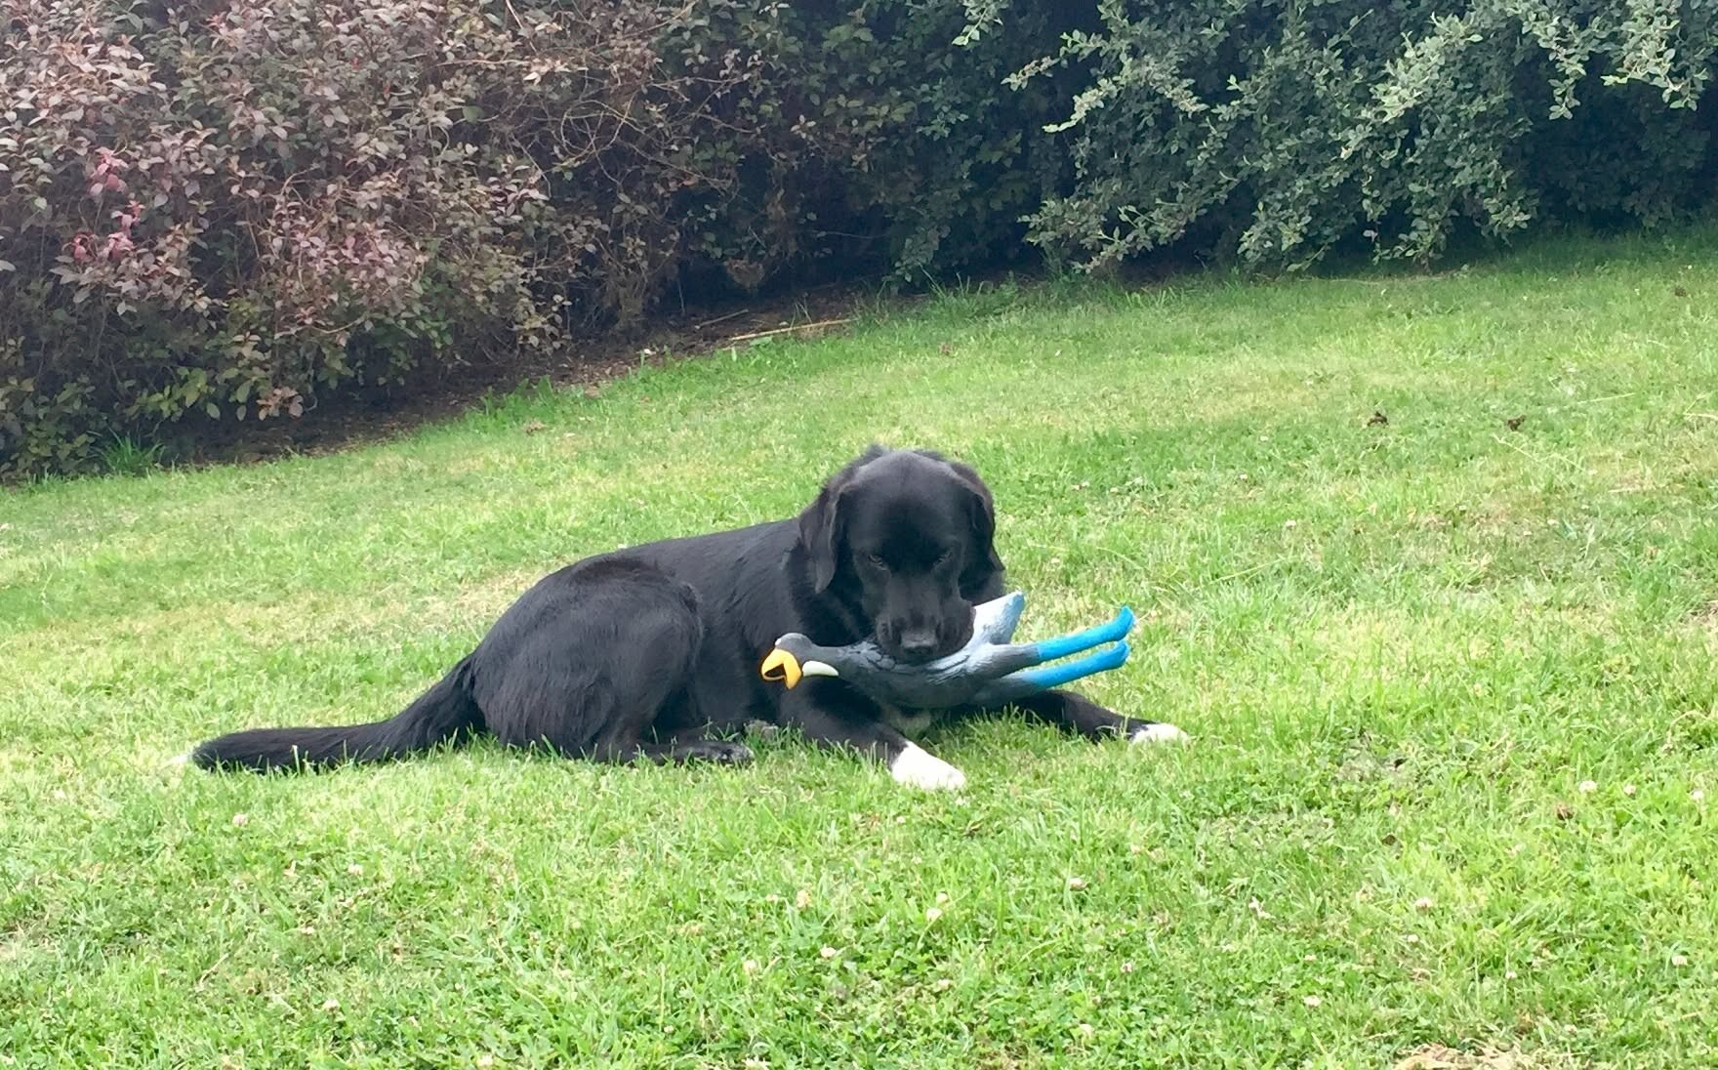
Part 2 – Dog control management

Dog control policy
Section 10 of the DCA requires that each council adopt a policy on dogs. It sets out the mandatory and discretionary content of the policy, the matters that a council shall have regard to when adopting it, and the process for its adoption.
Section 10 should be considered in full when developing a dog policy. In summary, s10(3) requires every policy to:
- specify the nature and application of any dog control bylaw
- identify public places in which dogs are to be prohibited, either generally or at specified times
- identify public places, and areas or parts of the district, in which dogs (other than working dogs) are to be controlled on a leash
- identify places within areas, or parts of the district that are to be designated as dog exercise areas
- state whether dogs classified as menacing dogs by the council, or any other council, are required to be neutered and, if so, whether the requirement applies to all such dogs; or, if not, the matters considered when requiring any particular dog to be neutered
- include other details the council considers appropriate (for example fees, owner classifications, and the use of infringement notices).
A dog policy is the primary means by which a council explains its approach to dog control to their community, so it should clearly articulate objectives and expectations. It also provides the foundation for council operational policy and practices. Table 7 below provides prompts for the content of a dog policy.
Given the range of enforcement options available under the DCA, a good policy should explain how those options will generally be applied. It should also indicate how the council intends to exercise its discretion under the DCA.
Table 7: Prompts for determining content of a dog control policy
Content in policy | Prompt
Issues | What are the dog control issues in the district? How are they identified?
Objectives | What are the council’s objectives to be achieved through its dog control and enforcement activities?  How will the policy and its implementation address the matters to which the council must have regard under s10(4)?
Registration | What will be done to encourage or enforce registration?
Funding | What is the basis for funding dog registration, education, dog control and enforcement activities? How clearly is the rationale explained?  What fees will be collected?  Are levels of service referred to and are they readily understandable in terms of the services provided (for example, pound operating hours, after-hours service)?
Responsible dog ownership | Will responsible dog ownership be formally rewarded? If so, how?  What criteria determine responsible dog owner status? How may responsible dog owner status be lost?
Community relations and education | What activity will be undertaken? How proactive will the council be?  What special interest groups in the community might be targeted? Will education activity be undertaken at schools?  Are there communication opportunities that may be utilised? What channels might be used? Are there opportunities to work with stakeholders to coordinate and distribute key messages?  What opportunities will be taken to build rapport and community relationships through the implementation of dog control activities?  Is the level of service covered directly or by reference to Long-term Plan or Annual Plan processes?
Bylaws | What bylaws will be made, what is their nature, and how will they apply?  How clearly are the dog policy and bylaws linked?  Are the policies and associated bylaws easily understood by the community? Are they supported by clear, sufficient, and easily understood signage?
Nuisance | Is the definition of “nuisance” clearly communicated?  What tools will be used to mitigate dogs creating a nuisance? Will advice and assistance be provided?  What services will be provided in response to complaints? What actions might result?  What is the escalation path, from minimal to significant interventions, where nuisance persists? Are they backed up by enforcement actions?
Enforcement | Has the full range of tools and techniques available under the DCA been considered? Is there an enforcement response that matches the circumstances (for example, first time/low level offences, repeat offences, serious offences)? Are exceptions made? Do they match the policy objectives?  How and when will warnings be used? Is there a clear signal of the types of incidents/circumstances where a council will prosecute?  Are there clear, documented procedures for all complaint types?  Are there any alternative resolutions that could be suitable?  Will discretionary powers under the DCA be utilised in respect of neutering, dogs classified as menacing by council or another council, the training of probationary owners and other matters?  Do the fees charged reflect the objectives of enforcement? For example, graduated pound fees.  Are surrendered dogs accepted, and in what circumstances? Does surrender absolve dog owners of their responsibilities?
Shared services and coordination with other councils | Is it possible for the council to share services (for example, a pound) with neighbouring councils or other key stakeholders?  Is it possible for neighbouring councils to combine resources for communications activities, deliver education campaigns or staff training programmes?  Is it possible to work with neighbouring councils to address common issues?
Recreation space | How will the recreation needs of dogs and their owners be recognised?  Can recreation needs be recognised through the performance of other council activities, for example, reserve management?  Will dedicated areas be made available, or will integration be sought?
Prohibited area | Can prohibited areas be clearly identified? Is the rationale clearly explained, for example, areas of high population density or ecologically sensitive areas? Are the areas clearly identifiable on the ground, such as through appropriate signage?
On-leash and off-leash areas | Can on-leash and off-leash areas be clearly identified? Is the rationale clearly explained? Are they clearly identifiable on the ground, such as through signage?
Monitoring and reporting | What monitoring and reporting is undertaken? How does this contribute to the development and implementation of the dog policy?  How clearly and informatively are the results reported to the community in s10A reports, and where and when can these be accessed?
Consultation | Has the community been fully engaged in the development/approval of the policy? Have dog owners and the wider community been kept informed and provided with opportunities for input?
Reviews | How frequently will the dog policy be reviewed?

Dog control bylaws
A council must give effect to its dog control policy by making the necessary bylaws to implement that policy. These bylaws provide a mechanism for regulating dogs and support the effective management and enforcement of dog control measures. No bylaw may be inconsistent with the council’s dog control policy.
Section 20 of the DCA should be referred to in its entirety when developing a dog control bylaw. In summary, s20(1) of the DCA allows a council to make bylaws for all or any of the following purposes:
- prohibiting dogs, whether under control or not, from specified public places
- requiring dogs, other than working dogs, to be kept under control on a leash in specified public places or specified areas of the district
- regulating and controlling dogs in any other public place
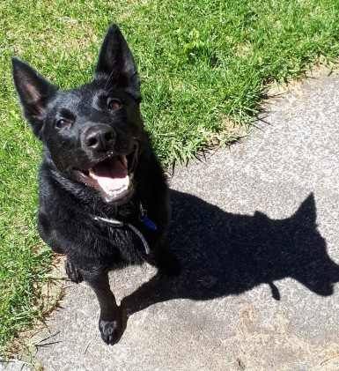
- designating specified areas as dog exercise areas
- prescribing minimum standards for the accommodation of dogs
- limiting the number of dogs that may be kept on any land or premises
- requiring dogs in its district to be tied up or otherwise confined during a specified period (not earlier than half an hour after sunset and not later than half an hour before sunrise)
- requiring the owner of any dog that defecates in a public place or on land or premises other than that occupied by the owner to immediately remove the faeces
- requiring any bitch to be confined but adequately exercised, while in season
- providing for the impounding of dogs found at large in breach of a bylaw made under the DCA or any other Act, whether or not the dog is wearing a collar and registration tag
- requiring any dog that has not been kept under control on several occasions to be neutered at the owner’s expense, whether or not the owner has been convicted of an offence against s53 of the DCA
- any other purpose that is desirable to further the control of dogs in the council’s opinion.
Failure to comply with a dog control bylaw is an infringement offence under the DCA. Depending on the circumstances, non-compliance may also constitute an offence that is punishable on conviction in accordance with the relevant provisions of the DCA and s242(4) of the LGA.

Standard operating procedures
Standard operating procedures (SOPs) provide a consistent and documented approach to streamline work processes. There are currently no national SOPs for the work of DCOs and animal management staff. A council should develop their own SOPs for operational tasks, health and safety practices, and decision-making processes. An SOP can also provide clear guidance for staff undertaking higher-risk activities.
SOPs establish a knowledge base that supports training and competency, reducing variability in practice. They help ensure that DCOs carry out their duties in a safe, compliant and defensible manner.

Dog control and elected members
Generally, it is not appropriate for elected members (councillors and the mayor) to interfere with the routine operational activities of council staff, including the enforcement decisions of DCOs. Political interference can result in undue pressure, selective enforcement, diminished public confidence, and lower staff morale.
It is good practice for a council to adopt internal policies that clearly define the distinction between governance and operational responsibilities. This helps protect DCOs from inappropriate direction or political interference in enforcement decisions.
Where a prosecution is being pursued, elected members should be informed, in-confidence, of the parties involved and the nature of the charges for information purposes only. It is not an opportunity to comment on whether a prosecution should proceed. Keeping elected members informed helps reduce helps reduce the risk of inappropriate media comment or contact with affected parties that could jeopardise the right to a fair trial.
Councillors play an important governance role in setting the desired local outcomes, considering risk settings for compliance and monitoring functions, and allocating resources through council planning and budgeting processes. This supports an animal management team to prioritise its resources and deliver on council objectives.
Elected members also have a role in debating, consulting on, and adopting dog control bylaws. They may also sit on regulatory hearings panels or committees established under the LGA to consider objections to council actions under the DCA.

Funding and resourcing dog control
Under the LGA, a council must have a funding policy and consider a range of factors when determining how funding needs are best met. These factors include community outcomes, costs and benefits, and impacts on wellbeing.
The main funding sources available to a council for dog control activities include registration fees, infringement fees, and rates. Some costs may also be recovered through mechanisms such as impounding fees and daily care charges.
Budgeting for dog control should consider the activities to be funded (based on a council’s policy and approach to dog control), the funding sources available, and the sustainability of those funding arrangements.
New Zealand has a wide range of environments, diverse geography, and landscapes. Population patterns vary from densely populated urban centres to more evenly distributed and sparsely populated rural communities. As a result, councils operate in considerably different circumstances.
The primary dog control issues within each district will also vary, as will the resources available, the level of support provided by other agencies, and degree of geographic isolation. In rural areas, staff are more likely to become involved with animals other than dogs as part of their role.
It is important to maintain alignment between the issues the council faces, the resources and funding available, the approach taken to dog control, and the activities undertaken as a result.
Support of other council services can assist dog control activities. For example, staff from other parts of the organisation may identify and report roaming or problematic dogs and owners. Local knowledge is valuable and effective internal systems are essential in collecting and sharing relevant information.

Training and health and safety

Training
DCOs are appointed under s11 of the DCA. In considering an appointment, a council must be satisfied that the candidate has, or can quickly gain, the education, experience, and competence needed to perform the duties and exercise the powers of a DCO under the DCA.
Ongoing development and training enhance the professionalism of DCOs and enable them to benefit from new technologies and improved practices. At the time of writing, no formal animal management qualification exists. However, a council can train on-the-job (under supervision) and support opportunities for professional development where possible and available.
Networking opportunities for animal management professionals as well as opportunities to share knowledge and resources, are primarily available through membership-based organisations, such as Taituarā and the New Zealand Institute of Animal Management (NZIAM).
Training is also an area where neighbouring councils may achieve efficiencies and better value by coordinating, sharing resources and participating in joint learning opportunities.
The following areas of knowledge are sufficiently important that DCOs should understand:
- bite prevention
- animal handling and behaviour, across the range of animals DCOs are expected to encounter in their role
- animal welfare, across the range of animals DCOs are expected to encounter in their role
- communication skills, including strategies for managing challenging interactions and de-escalation
- awareness of, and competence in using, any supporting systems and equipment, and technologies provided
- first aid
- the DCA and associated statutory requirements
- council policies and processes, including registration and other fees, enforcement options, record keeping, and due process
- judicial processes, including how to record evidence, take a good witness statement and prepare investigation files
- search and seizure law
- acting as an expert witness
- on-going relationship management.

Good practice considerations
- Provide a structured induction programme and buddy system for new employees.
- Document procedures and make guidance material available to staff.
- Provide appropriate safety equipment (for example, bite safety sticks, catchpoles, Snappy Snares, and Freeman Leash Poles) and training on their safe and effective use.
- Ensure DCOs know when to escalate and seek assistance in pairs, particularly where there are known safety concerns or a history of conflict.
- Ensure staff have access to ongoing training and professional development opportunities.

Training animal control contractors
Rather than rostering staff to provide after-hours coverage, some councils engage animal control contractors to respond to dog-related complaints and service requests outside normal business hours, particularly those requiring a high priority response.
As after-hours contractors may change frequently, it is good practice for a council to have standardised training, procedures and guidance for responding to complaints and service requests. Enforcement follow-up, investigations, and administration should generally remain the responsibility of daytime staff.
After-hours animal control contractors may be classified as “dog rangers” under the DCA. Dog rangers generally have less stringent appointment criteria and do not need as much background knowledge on the regulatory/legislative context of dog control, making them well-suited for after-hours contracting, where staff turnover may be higher.
Generally, dog rangers have similar powers to DCOs although there are exceptions. For example, s14 of the DCA authorises only DCOs, and persons assisting them, to enter premises under specified conditions.

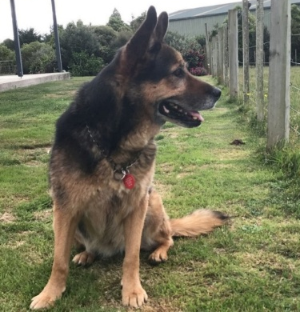
Health and safety
The purpose of dog control is to increase public safety, which requires identifying, managing and responding appropriately to risk. Alongside these responsibilities, council must ensure the health and safety of dog control personnel. This requires appropriate equipment, training, operational procedures, supervision, and peer support. DCOs should also wear identifiable clothing when undertaking their work so dog owners can recognise them as council staff.
Health and safety considerations extend beyond physical hazards. A council should have protocols in place for responding to threats against staff. For example, threats involving firearms should be reported to the Police immediately.
Managing mental wellbeing is another important health and safety consideration. Stress, exposure to traumatic incidents, and negative interactions with the public, whether in person or through social media, can affect the wellbeing of DCOs. Comprehensive training, access to support resources, adequate breaks and time off, and rotation of staff, can help mitigate these impacts.
Counselling and employee support services should be available following incidents that, either individually, or cumulatively, affect the wellbeing of DCOs.
DCOs are also likely to encounter dangerous or aggressive dogs. It is important that they are provided with adequate personal protective equipment (PPE) and trained for its use.

Good practice considerations
- Red flag system to identify properties (or individuals) that are unsafe to attend alone.
- Require two-person attendance when responding to dog attacks or other high-risk incidents, especially in rural or remote areas.
- Seeking Police assistance where there are concerns for staff safety.
- Consider use of body-worn cameras to support staff safety and investigations.
- Regularly review health and safety risks associated with animal management activities.
- Establish clear processes for reporting, managing and reviewing health and safety incidences or near misses.

Difficult dog owners
DCOs will likely encounter difficult or uncooperative dog owners, including when requesting information about the owner or their dog. It is good practice for DCOs to remain cordial when dealing with difficult dog owners and attempt to de-escalate wherever possible.
De-escalation may include:
- ensuring you are responding calmly and empathetically as it is important that people feel they are being listened to
- offering clear options and explaining what choices the owner has to demonstrate them that you are trying to work with them
- maintaining a safe distance from the person while being aware of your surroundings to help keep the DCO safe and the person feel less threatened.
Despite using these techniques, situations may continue to escalate, and it is important to have plans in place for getting DCOs out of these situations and to safety. In threatening situations, Police may need to be called.
It is an offence under the DCA to wilfully obstruct a DCO. It is good practice to provide reasonable warnings and sufficient information to dog owners before proceeding with an infringement or prosecution for wilful obstruction.

Refusal to give information and owners with no fixed abode
A DCO, dog ranger, or constable may request information from a dog owner. If the owner refuses to provide the information, or provides false information, they may be issued an infringement notice. If, after being warned of this, the owner continues to refuse to provide information and there is reasonable grounds to believe that an offence against the DCA or a council bylaw has been committed, the dog may be seized and impounded. A constable may also arrest the person without a warrant.
Before considering escalation, it may be possible for DCOs to obtain the required information through other lawful means, such as the following, while having regard to applicable legal requirements and privacy principles, including:
- the council’s dog register
- Motor Vehicle Register (via a council’s transport team, in accordance with New Zealand Transport Agency guidelines)
- Land Information New Zealand records
- the Companion Animal Register
- the National Dog Database
- Kāinga Ora (where appropriate) or the owner’s landlord
- Police (during or after an interaction)
- CCTV footage – if suspected of committing an offence.
A physical address is legally required to issue someone with an infringement notice. This can create difficulties where a dog owner has no fixed abode. However, if a person is living in a vehicle, the vehicle should be registered to an address. Where council systems allow, recording the vehicle registration number may be a way of recording the owner’s “address”, as well as information about where the dog is kept (for example, in a camper van). If an owner has no fixed abode, correspondence relating to matters such as dog registration or service of documents may be sent electronically.

Provision of dog recreation areas and pound facilities

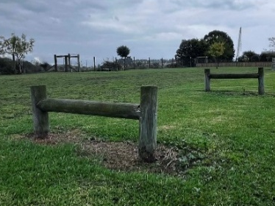
Provision of recreation areas
The DCA recognises the importance of recreation and the provision of appropriate exercise spaces by enabling local authorities to designate dog exercise areas in council dog policies and bylaws.
A council can take different approaches to the provision of dog exercise areas, such as:
- areas specifically designed for dogs that provide safe and interesting opportunities for fitness and agility activities
- exclusive dog exercise areas
- integrating dogs and their owners into the use of open space
- a district-wide approach including recognising dog exercise needs in reserve management planning under the Reserves Act 1977.
The approach chosen by a council should seek to achieve animal welfare, animal control, and community outcomes. A range of opportunities can be explored without necessarily giving rise to significant costs.
Private dog parks can provide dog owners with safe off-lead exercise areas for dogs that are less sociable or unable to utilise public spaces. This enables their exercise needs to be met in a low-risk environment.

Good practice considerations
- Locate recreation areas appropriately, for example, away from wildlife and heavy traffic flows.
- Fence recreation areas appropriately to provide separation from traffic where necessary.
- Provide receptacles and dog waste bags for the disposal of dog excrement.
- Ensure recreation areas provide dogs with safe opportunities for interest and challenge through a mixture of terrain and flora.
- Clearly communicate and signpost recreation areas, including their nature, boundaries, and any limitations (for example, hours, on- or off-leash), so they can be easily understood.
- Provide sufficient space for dogs to run and remove any obstacles that could cause harm to dogs.

Provision of a holding facility (pound)
Under s67 of the DCA, a council must have a facility for dogs to be impounded. This may be operated separately by the council or in association with other councils (by agreement). Provision must be made for the ‘proper custody, care, and exercise of dogs impounded, seized, or committed to its custody’.
It may also house the office for animal control services and may be referred to as an ‘animal care centre’.
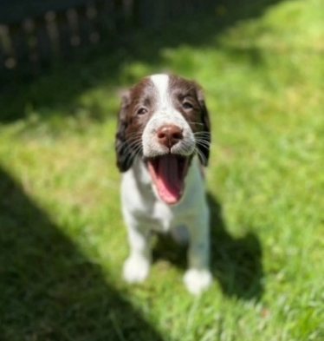
MPI’s Code of Welfare: Temporary Housing of Companion Animals states that “Adequately maintaining the welfare of companion animals requires experience, training and the observance of high standards. There are many stressors associated with animals being housed temporarily. Animals are confronted by new surroundings, change of diet and routine, and separation from familiar people and/or other companions. Most temporary housing facilities also keep animals at a much higher density than is common for more permanent pet homes, increasing the risk of contagious diseases. Maintaining a high standard of animal welfare in a temporary housing facility can be a challenge and requires particularly strict attention to behavioural needs and hygiene standards”.
Many council pounds operate at or near full capacity, meaning difficult decisions may need to be made (following compliance with any statutory time requirements for unclaimed or unwanted dogs) about whether a dog should be rehomed, if appropriate or euthanised.

Impound fees
Under s68 of the DCA, a council may set reasonable poundage fees and other fees for the:
- seizure of dogs
- daily care of any impounded dogs
- destruction of any impounded dogs.
In setting these, a council may wish to consider consistency with the fees of neighbouring councils. Different fees may be set for registered and unregistered dogs, along with a graduated scale of fees for repeated impounding of the same dog. Other fees may include fees for after-hours impoundment and microchipping. These should all be published online.

Accepting surrendered dogs
In addition to dogs impounded by DCOs under the DCA, owners may choose to surrender a dog or litter for a range of reasons. Whether a council pound facility chooses to accept such dogs is a matter of individual council policy and/or standard operating procedure. A council may choose to work with another rescue or rehoming agency if they are near or at full capacity. Alternatively, accepting the dog (s) and euthanising in due course may be the only option if they are unsuitable for rehoming or cannot be rehomed.
A council may wish to charge a surrender fee to cover administrative costs and the care of the dog(s) while in custody.

Rehoming dogs
Making dogs available for rehoming or adoption provides an opportunity for people to enjoy the companionship of a dog. Such dogs should be temperament assessed to ensure that they are unlikely to pose a risk of harm and should be assessed to ensure that they are being placed in a suitable home. A council may wish to consider requiring all rehomed dogs to be neutered through its bylaws.

Good practice considerations
- Only consider dogs for rehoming after careful evaluation.
- Do not rehome dogs with a known history of aggression or dogs that have been classified as dangerous or menacing.
- Register, microchip, vaccinate, and neuter all rehomed dogs, where appropriate.
- Consider the suitability of the match between dog and prospective owner and home environment (including the size and nature of the prospective owner’s property, size and nature of the dog, recreation requirements of the dog, and whether the prospective owners have other pets).
- Do not rehome dogs to a location that is in the vicinity of their previous home.
- Advertise dogs online with a profile including a photograph after two to three days, with a disclaimer that the dog may be reclaimed.
- Reduce/waive registration fees for rehomed dogs for the first year of registration.

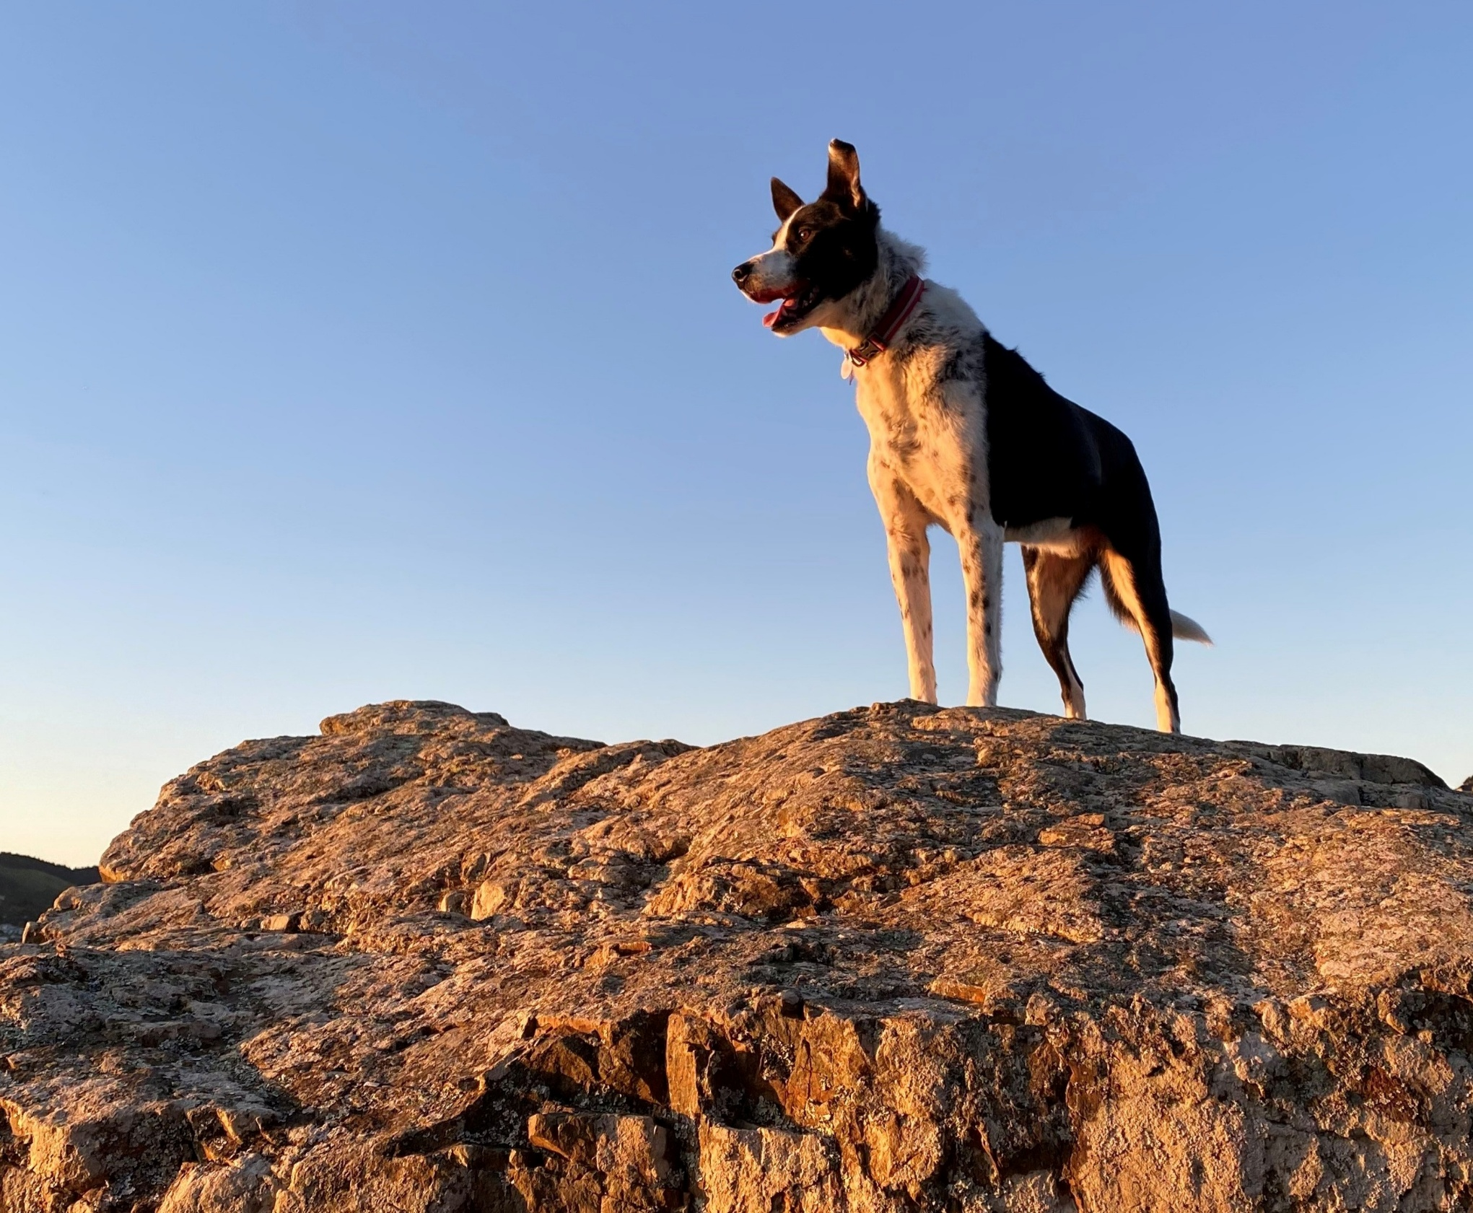
Part 3 – Enforcement

Enforcement policy
It is recommended that a council develops and maintains an overall ‘Enforcement Policy’ for its regulatory matters, including dog control. This helps to ensure enforcement is consistent and decision-making is transparent. Enforcement policies help ensure enforcement decisions are robust and made appropriately. Making the policy publicly available can further the community's understanding of how enforcement of dog control will be approached and help drive compliance.
The following sections of this guidance cover enforcement measures and decision-making specific to dog control. Some of this material may be incorporated into a general Enforcement Policy, Dog Control Policy and internal guidance and operating procedures.

Enforcement measures
The DCA provides for a range of penalties in response to incidents that may occur. The penalties are intended to achieve legislative compliance, reducing the risk of harm or injury caused by dogs, penalising dog owners for incidents that have occurred, and deterring future occurrences.
The range of penalties, or enforcement measures, is set out in Table 8 alongside the rationale for their use.
Table 8: Range of enforcement measures and their primary rationale
Enforcement measures | Primary rationale for penalty
Enforcement generally | Deterrence, accountability
Late fees | Incentive for timely payment
Infringement fees | Deterrence (immediate sanction for owner’s non-compliance)
Seizure | Establish and communicate owner responsibilities  Remove a nuisance or risk posed by dog
Impounding | Establish and communicate owner responsibilities
Removal of barking dog | Prevention of future occurrence or nuisance
Classify dog as dangerous or menacing | Prevention or reduction of risk (through additional controls on classified dogs)  Deterrence (classification itself and increased registration fees)
Prosecute – fine, imprisonment | Major sanction for breach of responsibility or serious offending
Place owner on probation | Prevention or sanction
Disqualification from owning dog | Prevention or sanction
Destruction of dog | Prevention
Liability for damage caused (remedy that can be ordered by Court) | Reparation
These measures are available either directly under specific sections of the DCA or through combined effect of multiple sections. They can be described as falling into four main groups as shown in Figure 5.
Figure 5: Four main types of enforcement measures, the actions, and when these are used
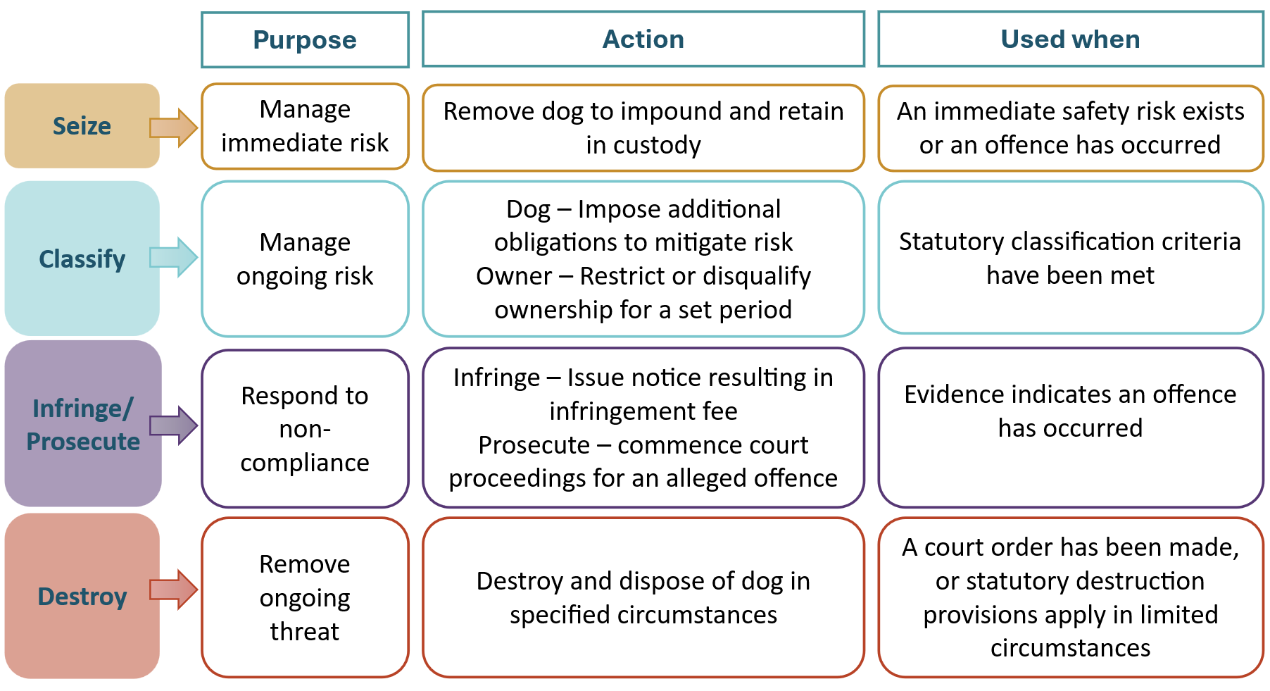

Enforcement decision making
The availability of this range of enforcement measures requires decisions to be made about the most appropriate and effective course of action to prevent further incidents. Key questions include:
- What has occurred and how is this established?
- What are the appropriate actions to be taken?
- Are the consequences appropriate to the circumstances?
Developing a decision matrix may assist in determining the most appropriate course of action, while recognising that every situation is different and involves a range of variables. A decision matrix could incorporate aspects of the Solicitor-General’s Prosecution Guidelines and relevant case law.
Investigation and the collection of evidence will help determine what occurred, what is alleged, what can be established as fact and, with the exercise of professional judgment, whether enforcement action should be taken.
If no offence occurred, it may be appropriate to offer advice or information to raise awareness. If an offence has occurred, it may be appropriate in the first instance to issue either an informal warning or written formal warning, which is recorded and forms part of the history of the dog and its owner.
Penalties may be applied separately or concurrently (for example, seeking a conviction of the dog owner and the classification of the dog as dangerous or menacing) so that the consequences can be matched to the seriousness of what has occurred.
The relevant kinds of factors and general considerations in applying penalties are indicated in Table 9. They relate to what occurred in the wider sense – causation, provocation, prevention, impacts, and responses to what has occurred.
Table 14 to Table 22 of the Enforcement pathways for non-compliance section of this guidance summarise the potential enforcement pathways available under specific sections of the DCA for the full range of offences and instances of non-compliance. Table 23 further outlines considerations in deciding which enforcement pathway to take.
Table 9: Factors for consideration in applying penalties
Preventative/ mitigating factors | - Behaviour of victim (for example, if a child, was there supervision of interaction with dog).  - Behaviour of dog (for example, startled, feeling threatened, protecting family, food, or pups).  - Extent of control exerted over dog (for example, fencing, containment, owner present).  - Location of incident (for example, public space, private land, dog’s territory).  - Age, health of dog.
Impacts | - Severity of injuries (for example, scarring, loss of function, etc.).  - Extent and persistence of aggression and/or attack.  - Extent of trauma/shock.  - Age/health of victim.  - Rehabilitation period (for example time off work, etc.).
Exacerbating factors | - History of dog (complaints and/or previous offences).  - History of owner (complaints and/or previous offences).  - Attitude of dog owner (response to situation, willingness to accept responsibility).  - Owner’s knowledge of their dog’s behaviour.  - Negligence, recklessness, or disregard.  - Likelihood of recurrence.  - Registration status of the dog.
In determining which enforcement measures to use, it may be possible to have regard to other considerations, such as ability to pay. For example, if it is the first time a dog is picked up, the impounding and daily care fee may be waived.
Decisions should be unbiased and based on available evidence that meets the objectives of the DCA and the council’s dog control policy and bylaws.
A council should provide clear guidance in its policy on the processes and steps to be followed, and the considerations to be applied in making decisions on enforcement. This will also ensure that consistency is achieved, providing ‘fairness’ between dog owners where ‘like is treated as like’. Significantly, it also provides for greater certainty in the consequences, which is important for deterrence.

Investigation and collecting evidence
Recording the investigation process and collecting evidence is important for supporting whichever enforcement measure is selected. A council should develop its own standardised forms for this process. Body cameras, which are increasingly used by councils, can be used to record interactions, so long as the recording complies with the requirements of the Privacy Act 2020.
The selected enforcement measure will determine the pathway to be followed, the requirements of the process to be observed, and the resulting consequences. The dog owner needs to be informed of the options that can be considered and their corresponding consequences.
For example, where a dog has been behaving aggressively but no offence has been committed, the dog owner could be given and taken through a letter which sets out the relevant information. The letter then also provides a record and enables the owner to consider the implications.
There may also be options open to the dog owner as well, particularly if the surrender of the dog and/or compensation are possible options. For example, action could be mitigated by surrender and by reparation or reimbursement fees for ripped jeans or vet bills.
Care needs be taken in the way information is provided to a dog owner, and the way options are discussed, to guard against the perception that a dog owner may be making decisions under duress.
Appendix 1 includes a list of templates and prescribed forms that may be useful during (or after) an investigation.

Alternatives to prosecution
Some councils have trialled various ways of not proceeding with prosecution where it may have commenced or it would otherwise be pursued. Where a council is confident that lessons have been learned, and a repeat of the behaviour or incident is unlikely, some incidents may be dealt with through a warning or requiring some specific action (such as fencing), where appropriate.
Some councils, like Auckland Council, have a Diversion Policy as a way of providing ‘an alternative means of resolving some offences without going through a formal trial process, while still addressing the key public interest factors leading to the decision to prosecute’.
The attitude of a dog owner will be an important consideration. This is a subjective area where it is desirable to apply the experience and judgment of senior staff.

Good practice considerations
- Record interviews between DCOs and dog owners (if able to meet Privacy Act requirements).
- Effectively use dog policy to indicate how council will utilise the DCA’s enforcement mechanisms.
- Ensure consistency across council dog policy and standard operating procedures, to provide guidance to assist in decision-making and spell out the steps and procedures to be followed.
- Consider the full range of enforcement mechanisms available that can be used.
- Apply consistent decision-making and clear communication, supported by robust investigation, which is clearly documented and recorded.

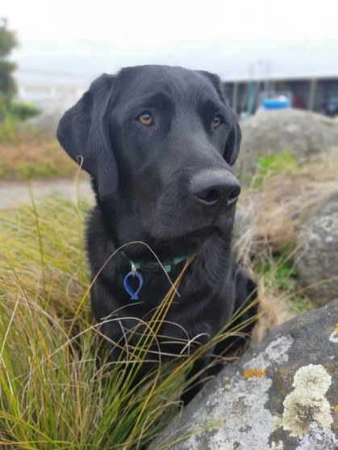
Responding to complaints
Complaints generally arise where members of the community become concerned about nuisance or as the result of non-compliance with the DCA.
Responding to complaints is at the core of dog control activities, often in circumstances involving conflict or where conflict is emerging. A good understanding of dog control issues, sound operational policy, and available resources provides the basis for timely and appropriate responses.
Response to complaints can:
- facilitate early intervention to prevent a more serious event occurring or further ongoing harm or nuisance
- reinforce sanctions (increase certainty of consequences)
- provide opportunities to raise awareness and provide information to improve public knowledge of dog control issues
- encourage the public to report problems, contributing to a compliance culture.
On investigation, a DCO will need to assess the situation and decide on the appropriate action. Immediate action to restrain or remove the dog(s) may be required. Most likely, follow-up work and investigation will be required. The collection of evidence is made easier when investigation happens as soon as possible after the incident.
Most attack complaints are received after the fact, and it is unlikely that a DCO responding to a complaint would find an attack in progress. A council should respond as soon as possible to complaints involving aggressive or attacking dogs.
It is especially important that the people receiving the complaint know what information they should request from the caller, and what information and advice they should provide. Call centres are usually the first point of contact, and it is important that the information exchanged is complete and accurate. The necessary information needs to be conveyed to the responding DCO so that they are as informed as possible about what to expect on arrival.
Complaints may be categorised in operational policy to assist in determining the appropriate response as indicated in Table 10. The types of complaints and time taken to respond can be heavily influenced by the nature of a district, its physical features, its population, and the infrastructure available.

Table 10: How complaints may be classified
Level of urgency | Why urgent | Response time
1 – urgent | Associated with physical harm to people, dogs, stock, poultry, or wildlife  Involves aggressive behaviour by a dog or dog owner, especially where there is an immediate threat or the threat of further aggression | Immediately (with Police assistance if required)
2 – moderately urgent | Associated with recent, ongoing nuisance with little prospect of physical harm | [Could be set in operational policy]
3 – non-urgent | Associated with past nuisance | [Could be set in operational policy]
Appropriate resolution of complaints can defuse tensions and build community support.
Monitoring complaints also provides valuable information about potential dog control issues, the location of ‘hot spots’, assists dog control activities, and can inform operational policy and dog policy reviews.
Far North District Council uses location information (GPS where available) and their dog control dashboard to track and monitor the number and nature of complaints/issues by geographic location, down to street name. This enables prioritisation of dog control activities when and where required. Proactive patrolling can be concentrated on priority areas (for example, by suburb) and adapt as information changes.
Monitoring responses to complaints within prescribed timeframes may not be the best measure due to the variables that impact response times. It may be preferable to prescribe the time between the receipt of the complaint and the time a DCO contacts the complainant (one hour, for example where there is ongoing risk). On gaining a better understanding of the situation, the DCO can agree when to attend with the complainant. Observance of these time frames can then be monitored.

Good practice considerations
- Accurately record complaints received (on council template).
- Provide call centre staff with specialist training in dog control issues.
- The nature and urgency of the complaint is the key determinant of a timely response.
- Roaming dog complaints should be attended to as soon as possible; the longer a dog is left to roam the more likely a subsequent offence(s) may occur.
- Clearly recognise possible offences and their seriousness and follow up with appropriate action.
- Provide feedback to the complainant on the outcome of the complaint and information on further action.
- Monitor complaints and corresponding actions to provide information to assist issue identification, development and fine-tuning of dog policy and operational policy, and contribute to a whole-of-council approach.
- Consider geographic context (for example, urban vs rural) when monitoring complaint hot spots.
- Discuss and agree levels of service (such as hours of coverage, responding to complaints after hours, etc.) between the council and the community (either directly in a council dog policy or by reference to LTP/AP processes).

Seizing and impounding
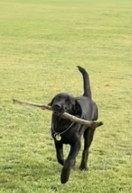
The seizing and impounding of dogs are a necessary and effective enforcement tool. It can prevent further incidents occurring. It may also be necessary after an incident has occurred. In some cases, it will be appropriate to seize and impound the dog as the first course of action. This will usually be based on the seriousness of the attack or a continued threat to the community and the likelihood of further incidents.
On many occasions it will be appropriate to return a captured dog to its owner if they can be identified and contacted.
Under s71, a dog may be retained in custody after seven days, even where the dog has been claimed by the dog owner who has paid the fees, because:
- the dog has been seized under s57 or s57A and the owner is going to be prosecuted under one of s57, s57A, or s58
- council considers that the release of the dog would threaten the safety of any person, stock, poultry, domestic animal, or protected wildlife.
In addition, non-compliant classified dogs may be held under s32 and s33EC until the owner shows willingness to comply with the requirements. Also, under s56 if seized following non-compliance with a barking abatement notice, until provisions are in place to comply with the notice.
If the decision has been made to hold the dog in custody, the dog owner must be given a written notice of the seizure and/or impounding in the prescribed form.
A council may sell, destroy, or otherwise dispose of the dog under s69 if seven days have elapsed since:
- the dog has been impounded, and the owner is not known or cannot be identified
- the owner has received written notice and the dog is unclaimed and fees are not paid.
A dog cannot be retained in the pound for any other reason once claimed and fees paid.
Dogs that are, or become, injured, sick, or unwell must be assessed by a veterinarian as soon as possible and receive appropriate treatment.
All impounded dogs must be registered and microchipped before being released, except for a dog that is registered but not microchipped and has not previously been impounded.
A council may require all relevant fees (microchipping, neutering, registration, daily care fee, infringement fees) to be paid in full before a dog is released.
All dogs classified as dangerous or menacing must be muzzled when released and it may be appropriate to provide owners with advice on the fitting of muzzles. Dog owners should provide their own muzzle.

Good practice considerations
- Handle all dogs in a humane way with consideration for the animal’s welfare.
- Minimise the time a dog spends in vehicles to avoid heat stress.
- Do not unnecessarily subject dogs to painful, adverse, or unpleasant stimuli.
- Ensure dogs receive appropriate veterinary attention.
- Isolate dogs infected with parvo virus (if it is within the 7-day holding period, veterinary sign-off is required if the dog is to be euthanised; after this time the council can take the appropriate action required).
- Take all necessary steps to prevent accident or injury to staff.
- Leave a seizure notice for the dog owner - inform the owner promptly that their dog has been impounded, of the relevant registration and microchipping requirements, and the fees payable to secure release.
- Use the prescribed forms ‘Notice of seizure and removal of dog’ and/or ‘Notice of retention of dog threatening public safety’ as appropriate.
- Take care to ensure dogs remain separated, except where they are suitably matched for exercising together.
- Provide bitches and their pups with extra warmth and separate them from other dogs.
- Provide safety equipment and ensure it is used – handle any dog considered aggressive using safety equipment.
- Kennel aggressive dogs in an area off limits to the public.
- Accurately record a dog’s details in the impound register – maintain a record of care while a dog is impounded.
- Request ID to ensure the person claiming the dog is the owner on record – alternatively, can they provide evidence that the dog has been in their care (for example, photos, vet statement, NZ Companion Animal Register).
- Microchip claimed unregistered dogs before release (and registered dogs impounded for the second time before release).
- Only release dogs to their owners or duly authorised agents after all outstanding fees (for example, registration, infringement, sustenance, microchipping) have been paid in full.
- Provide muzzle fitting advice to owners of dogs classified as dangerous or menacing, and ensure the dogs are muzzled when released.
- Do not destroy or rehome/adopt a dog until it has been impounded for at least seven days.
- Do not exempt an owner from enforcement action being taken, even if release, destruction, or rehoming/adoption has occurred.
- If a dog is suspected of attacking any person, stock, poultry, domestic animal, or protected wildlife – take a DNA sample to assist with further investigations.
- Animal welfare concerns may contribute to offending or be identified during investigations. Where appropriate, DCOs should consider referral to SPCA, MPI, or Police where concerns arise under the Animal Welfare Act while continuing to exercise their own responsibilities under the DCA.

Powers of entry
The DCA enables entry onto land or premises to address issues such as dog welfare, nuisance, other suspected offences, and active situations. Part 4 of the Search and Surveillance Act 2012 (SSA) intercepts here and sets out the general provisions in relation to search, surveillance, and inspection powers. ‘Entry’ is a ‘search’ under the SSA. Table 11 below shows the DCA powers where Part 4 of the SSA applies.
A DCO may not enter any dwellinghouse (including a vehicle) unless entry is authorised by a warrant and the DCO is accompanied by a constable. Exceptions to this are:
- s28(7) a DCO may enter a dwellinghouse to seize a dog from a disqualified owner
- s57 a DCO may enter a dwellinghouse if they are in fresh pursuit of a dog that they believe (on reasonable grounds) has committed an attack described by that section or has been identified by a witness to the attack. A constable may also exercise the powers of a DCO contained in s57
- s64(3) a DCO, if accompanied by a constable, may enter a dwellinghouse to seize a dog that has previously been ordered for destruction by the court.
A search warrant to enter a dwellinghouse may be applied for to deal with any current or prior offences or bylaw breaches as indicated by s14(1) to (3). This may include to remove:
- an unregistered dog
- a roaming dog
- a dog that is not confined on the property
- a dog that has rushed at a person, animal or vehicle
- a dog that has attacked a person or animal.
Section 14(4) notes this section of the DCA on power of entry is ‘subject to any express provision to the contrary in this Act’. This may include the exceptions to entering a dwellinghouse as noted in the prior paragraph or as noted in the enforcement pathways summarised in Table 14 through Table 22.
Section 20(2) prohibits a bylaw from conferring any power of entry onto land or premises without the consent of the occupier.
Table 11: DCA powers where Part 4 of the SSA applies
DCA section | Brief description of power | Which provisions in Part 4 of SSA apply
Power of entry:  14(1) to (3) | Dog control officer who has good cause to suspect that an offence against the Dog Control Act 1996 or bylaw under that Act is being committed presently, or any time in the previous six months, may enter land or premises, and inspect any dog, and, if authorised by that Act, seize or take custody of dog (note: warrant must be obtained to enter dwellinghouse and constable must accompany) | Subparts 1, 2, 4, and 7 to 10 (except that sections 118 and 119 apply to constables only)
Removal of barking dog causing distress:  56(3) | Dog ranger or dog control officer may enter dwellinghouse to remove barking dog (following non-compliance with remedial notice) if he or she obtains warrant to enter | Subparts 1, 3, 7, 9, and 10
Dogs attacking person or animals:  57(6)﻿(b) | Dog ranger or dog control officer may enter dwellinghouse to seize dog that has attacked a person or animal if they hold a warrant to enter (note: entry may be without warrant in exigent circumstances) | Subparts 1, 3, 7, 9, and 10

Search warrants
Subpart 3 of Part 4 of the SSA covers search warrants. DCOs must apply to an ‘issuing officer’ for a search warrant to enter a dwellinghouse where it is required so by the DCA. A person cannot be the issuing officer if they are employed by, or elected to, the council which is applying for the search warrant.
A search warrant:
- is issued for a period of 14 days but may be for a period of up to 30 days if deemed necessary by the issuing officer to enable its execution
- is executed only once, unless it has been authorised for more than one occasion (then the number of times must be specified)
- may authorise the search of more than one place.
If the conditions of the search warrant have expired before it can be executed, a new warrant will need to be applied for.

Police involvement in search and seizure
There is a requirement for a DCO to be accompanied by a constable when executing a search warrant. This is in the interests of the safety of the DCO, the council, and the community generally.
Police have a prescribed form that should be completed if Police assistance is required to execute a warrant. However, in an emergency where there is a threat to the safety of a DCO from a dog owner or dog, or where a dog poses a serious threat, or attack on any other person, 111 should be called.
In non-threatening situations, Police may not be available when a DCO wishes to execute a warrant. This constraint creates a risk that in the time between the DCO-planned action and the actual executing of a warrant, the dog may, for example, have been discretely removed from the property by the owner to avoid enforcement action.

Good practice considerations
- An effective working relationship between the council, issuing officer(s), and the New Zealand Police is important to ensure efficient and appropriate enforcement of dog control laws and bylaws, particularly where people and animals may be in danger.
- DCOs should be familiar with the procedures and information required to apply for a search warrant and to carry out a search, before the need arises.

Classification of dogs
The DCA provides for the classification of dogs, as either ‘dangerous’ or ‘menacing’, based on whether they pose a threat to people and animals. Figure 6 summarises the classification of dogs and the associated conditions under the DCA.
Where not strictly prescribed in the DCA, decisions on the classification of a dog as menacing or dangerous depend on the extent of the risk of harm after consideration of relevant factors, such as:
- the circumstances of the attack (for example, rushing or physical contact)
- injuries caused
- impact on the victim
- history of the dog’s offending
- the dog’s observed level of aggression
- owner’s readiness to accept responsibility
- likelihood of reoccurrence.
Developing a framework applicable to people and animals as a part of operational policy can assist DCOs in making decisions. Under the DCA, dog owners are obliged to prevent their dogs from worrying or endangering stock, poultry, domestic animals, and wildlife. A dog that does so may be classified by the council as dangerous or menacing.
When a dog that has been impounded, classified (new or existing), and is to be released, it should be fitted with a muzzle before it leaves (provided by the dog owner). It is also an appropriate time to give the dog owner advice on recommended minimum fencing requirements.

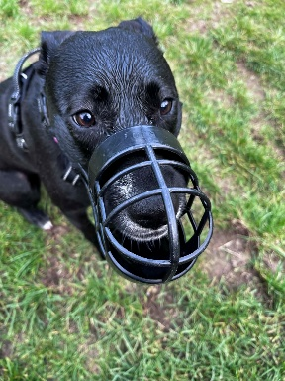
Monitoring a dog classification
Once a dog has been classified, its classification should be updated on the NDD. It is good practice to notify and follow up in one month to ensure the obligations of the classification are being met.
If a recently classified dog moves to a different territorial authority area, responsibility for following up will generally fall to the council in whose district the dog now resides. However, communication between councils can ensure the most appropriate course of action is taken.
A council’s dog policy must state whether dogs classified by them as menacing are required to be neutered. The policy must also state if this applies for any dogs classified by any other territorial authority as menacing if the dog is then registered with the territorial authority whose policy it is.
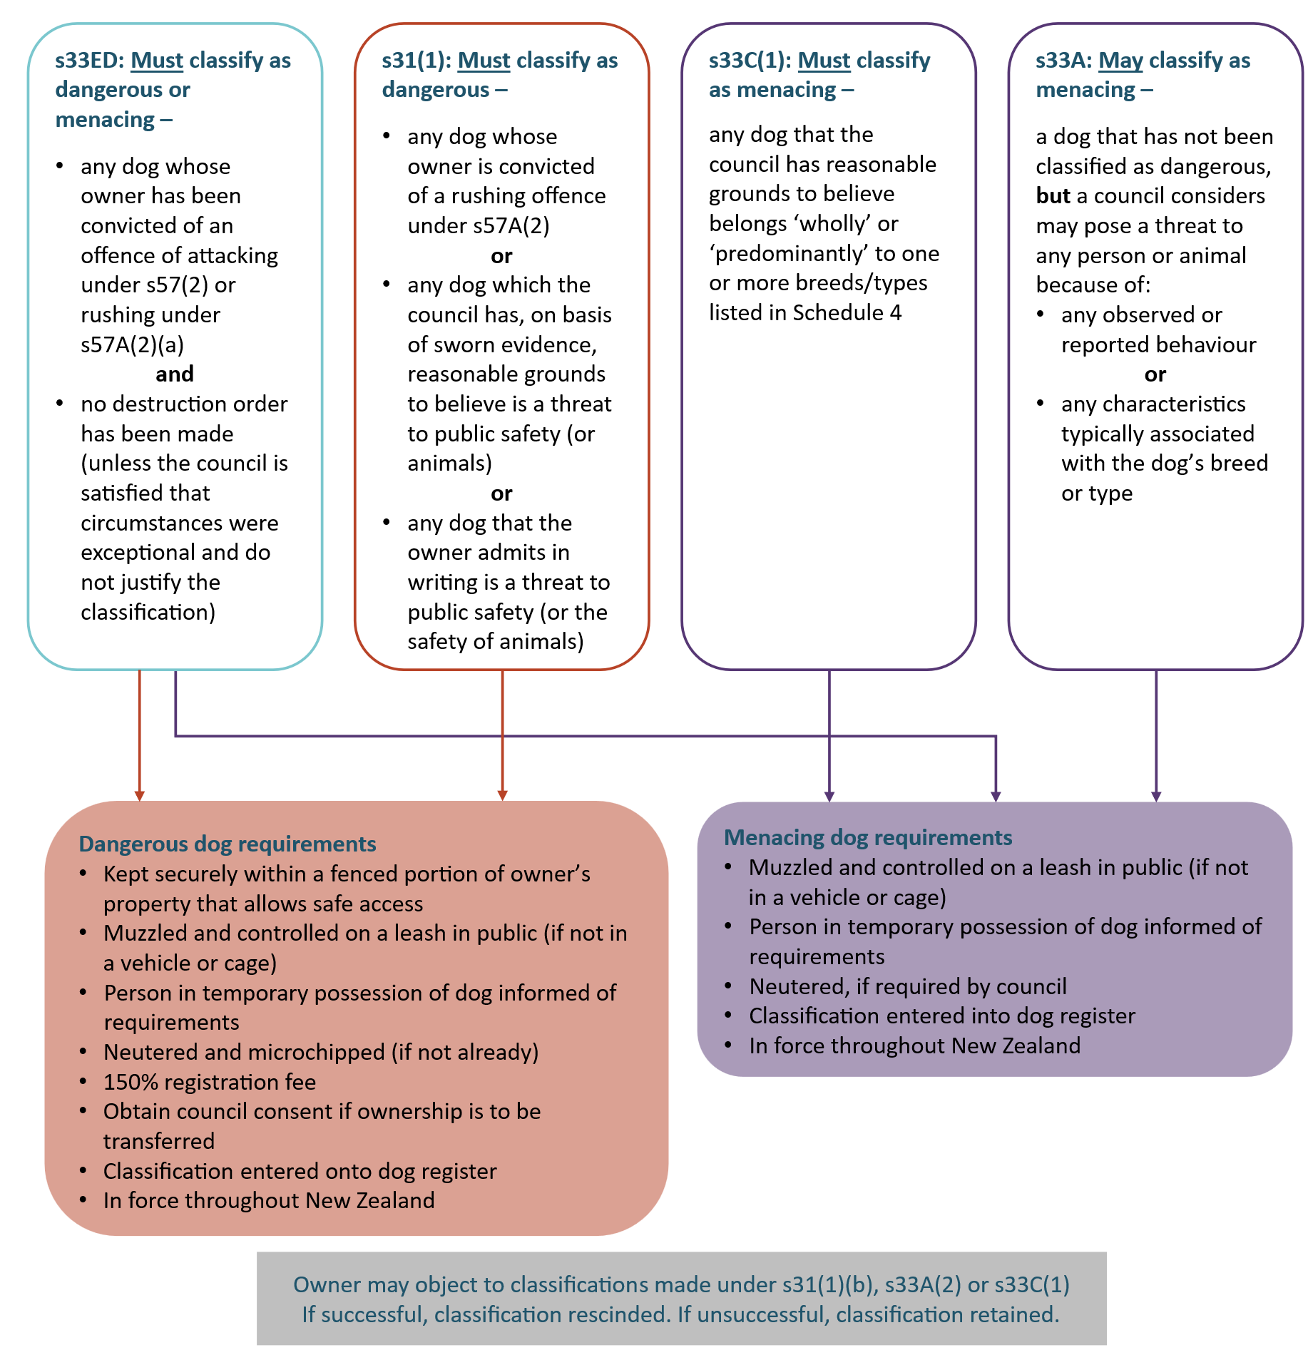
Figure 6: Menacing and dangerous dog classification under the DCA

Good practice considerations
- Provide muzzle fitting advice when releasing impounded dogs that have been classified as menacing or dangerous.
- Provide information and advice to owners to assist them in dealing with behaviour problems.
- Provide information on appropriate obedience training courses.
- When a dog is registered, if the breed listed is a Schedule 4 breed or type, ensure it is classified as menacing.
- Once classified, check the obligations of the classification are being met, for example, fencing, neutering, muzzling.
- Use the prescribed form Notice of classification of dog as dangerous dog or Notice of classification of dog as menacing dog when notifying an owner of the classification of a dog.

Classification of owners
The DCA recognises irresponsible dog owners through the ability to classify them as either probationary or disqualified, as shown in Figure 7. Dog owners may be disqualified for a maximum period of five years or placed on probation for a period of up to 24 months. The DCA provides for penalties to be imposed for failing to comply with the effects of the classification.

Figure 7: Probationary and disqualified owners under the DCA
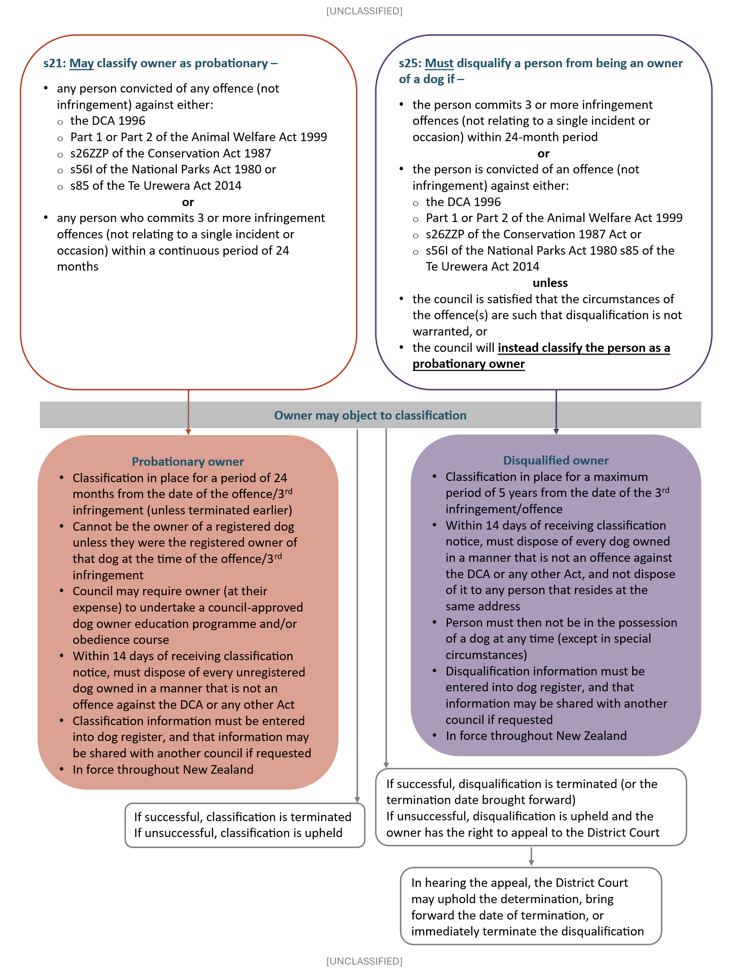

A council may wish to develop a matrix of the circumstances that may warrant probation or disqualification and the period of that classification. In developing a matrix, or for general consideration of classification periods, a council should apply discretion regarding matters such as the number of offences, the severity of the offences, and any prior history of the dog owner. A classification matrix can support consistency and transparency in decision-making while allowing council to consider the circumstances of individual cases.
A council may also, at its discretion, revoke a probationary owner classification and replace with a disqualified owner classification at any time.
The period of classification should be proportionate to the risk posed by the owner’s behaviours and likelihood of future non-compliance.
Breaching the effects of disqualification can result in an infringement fine being issued or a fine of up to $3000 on conviction. Breaching can also result in an extension to the disqualified owner classification.

Good practice considerations
- A council should make it clear to dog owners upon receiving a second infringement within a 24-month period that they may be classified as probationary or disqualified if they receive any further infringements. This can be done with a written warning and reference to s21 and s25 of the DCA.
- A council should seek disqualification of owner on prosecution for serious offences under s57 or s58 of the DCA.
- A council should explain to disqualified owners the process of reviewing the classification and the matters the council may take into account.
- Prescribed forms should be used when advising of classification or disqualification.
- A council should follow up on probationary or disqualified owners soon after they have been classified to educate and ensure they are not breaching any requirements.

Dog breed or type restrictions
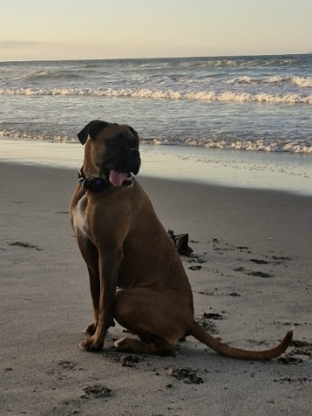
Schedule 4 of the DCA sets out the breeds and types of dogs subject to a ban on importation. At the time of writing these are:

Breed | Type
Brazilian Fila | American Pit Bull Terrier
Dogo Argentino
Japanese Tosa
Perro de Presa Canario

Where a council has reasonable grounds to believe that a dog belongs wholly or predominantly to one or more of the breeds/types listed, it must be classified as menacing.
Identifying Schedule 4 dogs can be difficult for DCOs and other dog control staff, particularly when trying to determine if they are ‘predominantly’ of the restricted breed or type. The Standards New Zealand 8800 Guide to Identifying Dog Breeds was developed as a guide to support the consistent identification and data capture of prominent and secondary breed and colour of dogs and is a recommended resource to aid in dog breed and type classification.
Appearance-based classification has limitations. It is recommended that a council also consider other factors such as dog and dog owner history when assessing a dog breed for dog classification as menacing. This can help avoid undue requirements of responsible dog owners.

Offences and prosecution
The DCA provides for several offences, including infringements, as well as prosecutions through the court process. The outcomes of these may result in infringement fees, fines, other sentences including imprisonment, and dog destruction orders.

Warnings
Warnings (for example, verbal or letters) are not provided for under the DCA but are an enforcement measure that can be used in relation to minor breaches. Where there is a satisfactory compliance response, a warning may be more appropriate than an infringement. For example, where it is a first offence, where a person wants to become compliant and it is easy for them to do so, or if there is no history of non-compliance.
In general, it is good practice to first give a warning, which provides the opportunity to seek an explanation and to provide advice, before issuing an infringement notice on a repeat of the offence. However, warnings should not be used for:
- where there is an element of deceit, wilfulness, or obstruction on the part of the dog owner in the manner of offending
- a serious offence which merits issuing an infringement notice in the first instance
- where the council is seeking to provide a stronger signal about the seriousness of the offence.

Infringements
Infringements are a significant enforcement tool under the DCA for dealing with a minor to moderate breach which warrant some form of sanction. They are both a deterrent and an ‘on the spot’ sanction and are most effective when applied consistently.
Infringement offences are offences that could otherwise be proceeded with in the courts. Issuing an infringement notice ensures speedier completion and avoidance of a conviction being entered against the offender’s name. In this way, less serious and less complex matters are diverted from the courts.
The DCA provides a choice requiring the exercise of judgment. Decisions need to be made as to whether an offence has occurred, whether the facts support enforcement action being taken, and what action should be taken (infringement or prosecution). Matters that could be taken into consideration are set out in Table 8 (Range of enforcement measures and their primary rationale).
Further enforcement action (such as owner classification or disqualification) can be taken even if the infringement has not yet been lodged with the court.
Table 12 includes Schedule 1 of the DCA offences for which infringements notices may be issued (and the corresponding infringement fee). There are 27 infringement offences, with infringement fees ranging from $100 - $750. Different offences incur different penalties, indicating the seriousness with which the offence is regarded.

Good practice considerations
- Provide certainty using dog policy to indicate the intent to use the range of infringement provisions available.
- Provide guidance about the escalation path for repeat offences in dog policy and operational policy.
- Issue an infringement notice where it has been established that an offence has occurred, and all the elements of a charge can be proven (using the prescribed form).
- Record the offender’s full details (or as full as possible) when issuing an infringement notice to speed up the process, including full name (including middle names), address, gender, and date of birth.
- Only waive infringements (once the notice is issued) in exceptional circumstances.

Prosecution
Most offences under the DCA are summary offences that can be dealt with by infringement notice or summary prosecution, as shown in Table 12. Prosecution results in fines being set by the court as well as the possibility of the court ordering the destruction of the dog(s) and other penalties.
A s54(2) offence (dog welfare) can result in a term of imprisonment up to three months or to a fine not exceeding $5,000. Other serious offences dealt through the courts include offences committed by a dog owner under s57 (Dogs attacking persons or animals) or s57A (Dogs rushing at persons, animals, or vehicles), both of which are liable on conviction to a fine not exceeding $3,000. Provision is also made for the liability of the dog owner for any damage caused by the dog.
Other serious offences (Category 3 and 4 offences under the Criminal Procedure Act 2011) include offences under s58 (Dogs causing serious injury), for which a person is liable on conviction to imprisonment for up to three years, a fine not exceeding $20,000, or both. Under s63, a dog owner may also be liable for damage done by their dog.
Proceeding with a prosecution through the courts can be a lengthy and costly process. It is important therefore to ensure that investigations are thorough and that due process is strictly observed. On completion of an investigation, consideration needs to be given to the adequacy and weight of the evidence, and whether pursuing prosecution would be in the public interest.
The Solicitor-General’s Prosecution Guidelines (2025) set out a two-stage test for prosecution:
- Evidential Test: Is there enough evidence to prove the proposed charge beyond reasonable doubt?
- Public Interest Test: Does the public interest require a prosecution to be brought?
In relation to public interest, the Prosecution Guidelines pose the following questions for consideration:
- How do the features of the offending weigh for or against prosecution?
- How do the personal characteristics and circumstances of the suspect weigh for or against prosecution?
- How do the interests of the victim(s) (if there are any) weigh for or against prosecution?
- Are there any alternative methods of resolving the matter short of prosecution which are available and appropriate in the circumstances?
A council may wish to consider these questions before deciding whether to proceed with prosecution, or whether issuing an infringement notice (or taking no enforcement action) would be a more practicable or worthwhile response.
Additionally, a council should consider the potential impact of prolonged investigations or court proceedings on the welfare of impounded dogs. Where dogs remain in council custody, council should seek to progress proceedings as efficiently as practicable.
Serious offences generally warrant the destruction of the dog. A council may consider that prosecution is appropriate because a destruction order is required. If the dog is then voluntarily surrendered, a council may review whether prosecution remains necessary.
Continuing a prosecution, despite a dog being surrendered to a council for destruction or having been previously destroyed, should be considered for serious cases or where there is a history of offending including previous serious offences.
Table 12: Offences under the DCA
Key to types of offences
Obstruction, wilful disobedience, dishonesty
Mixture of nuisance and failure to observe general obligations to control dog (general safety)
Failure to observe owner-specific obligations to control dog (targeted preventative intervention)
Failure to observe general obligations to control dog (general safety preventative)
Regulation
Animal welfare
Nuisance
Actual harm, injury to persons, animals or property (punitive, retribution)

Section | Offence | Infringements ($) | Conviction  ($ or prison term)
18 | Wilful obstruction of dog control officer or ranger | 750 | 3,000
19(2) | Failure or refusal to supply information or wilfully providing false particulars | 750 | 3,000
19A(2) | Failure to supply information or wilfully providing false particulars about dog | 750 | 3,000
20(5) | Failure to comply with any bylaw authorised by the section (penalty prescribed by s242(2) of LGA) | 300 | 20,000
23A(2) | Failure to undertake dog owner education programme or dog obedience course (or both) | 300 | 3,000
24 | Failure to comply with obligations of probationary owner | 750 | 3,000
28(5) | Failure to comply with effects of disqualification | 750 | 3,000
32(2) | Failure to comply with effects of classification of dog as dangerous dog | 300 | 3,000
32(4) | Fraudulent sale or transfer of dangerous dog | 500 | 3,000
33EC(1) | Failure to comply with effects of classification of dog as menacing dog | 300 | 3,000
33F(3) | Failure by dog owner to advise person in possession of dangerous or menacing dog of muzzle and leashing requirements | 100 | 500
36A(6) | Failure to implant microchip transponder in dog | 300 | 3,000
41 | False statement relating to registration | 750 | 3,000
41A | Falsely notifying death of dog | 750 | 3,000
42 | Failure to register dog | 300 | 3,000
46(4) | Fraudulent procurement or attempt to procure replacement dog registration label or disc | 500 | 3,000
48(3) | Failure to advise change of ownership of a dog | 100 | 500
49(4) | Failure to advise change of address | 100 | 500
51(1) | Removal, swapping, or counterfeiting of registration label or disc | 500 | 3,000
52A | Failure to keep dog controlled or confined | 200 | 3,000
53(1) | Failure to keep dog under control | 200 | 3,000
54(2) | Failure to provide proper care and attention, to supply proper and sufficient food, water, and shelter, and to provide adequate exercise | 300 | 5,000 or 3 months
54A | Failure to carry leash in public | 100 | 500
55(7) | Failure to comply with barking dog abatement notice | 200 | 1,500
57(2) | Dogs attacking persons or animals |  | 3,000
57A(2) | Dogs rushing at persons, animals, or vehicles |  | 3,000
58 | Dogs causing serious injury |  | 20,000 or 3 years or both
61 | Orders relating to dogs seen worrying stock |  | 150 per day
62(4) | Allowing dogs known to be dangerous to be at large unmuzzled or unleashed (owner’s offence) | 300 | 3,000
62(5) | Failure to advise person of muzzle and leashing requirements for dogs at large that are known to be dangerous (owners obliged to advise person in possession < 72 hrs) | 100 | 500
64(6) | Failure to comply with order for destruction of dog |  | 3,000
72(2) | Releasing dog from custody | 750 | 3,000
78(3) | Failure to comply with regulations regulating or prohibiting the keeping or possession of dogs of any specified type or breed or cross-bread |  | 3,000

Destruction
Destruction will need to occur:
- when instructed by a court order (including by a DCO where an owner has not carried out this order)
- where an unclaimed or surrendered dog cannot be housed in temporary accommodation and/or rehomed due to its temperament or lack of suitable accommodation/ownership
- in certain circumstances, by a DCO or constable, when an attack or threat is taking place, by a DCO or constable
- when a dog is at large among protected wildlife disturbing or threatening it (if seizing isn’t an option), by a DCO, warranted DOC officer, or constable
- a dog is running at large among stock or poultry (if seizing isn’t an option), by the owner of the stock or poultry, or their employees, constables, and DCOs.
The destruction of dogs is an area where sensitivity is required. DCOs should be familiar and comply with part 10 (euthanasia) of the Code of Welfare for dogs. Euthanasia must be carried out in a humane manner (instantaneous and painless for the dog), preferably by lethal injection using the services of a veterinarian.
If a firearm or captive bolt pistol is to be used, where practicable, the dog should be held securely and restrained by some means that does not involve the person with the weapon. The shot must be delivered in a manner to ensure death is instantaneous.
The welfare of the dog immediately prior to euthanasia is also important. Fear and distress should be minimised by using low-stress handling techniques, providing sedation where appropriate, avoiding unnecessary restraint, and ensuring dogs are not exposed to the euthanasia of other animals.
Similarly, disposal is also sensitive. Increasing pressure on access to disposal facilities is noted, with access to offal pits and disposal in landfills becoming more constrained. It may be appropriate for a council to investigate opportunities to access other facilities where they exist, such as commercial incinerators. Incineration may be a good option depending on costs which may vary.
The lethal control of feral dogs is undertaken as a form of pest control on public conservation land by DOC officers where under the AWA, feral dogs are considered an animal in a wild state.

Good practice considerations
- Euthanasia should be carried out by a registered veterinarian where possible, or otherwise by a fully competent person with due regard to safety.
- Carry out euthanasia in a place off limits to the public and remove collars before disposal.
- Place dead animals in a disposal bag, not in view of the public when transported to a disposal facility.
- Disposal facilities should be secure and, where possible, away from public areas.
- Where possible, offer support to staff involved in euthanasia.
- Where possible, recognise the ‘caregiver’ role of shelter staff by using other staff to carry out destruction and disposal.
- Where possible, ensure staff share the task of euthanising dogs to avoid prolonged exposure to this task.
- Provide psychological support, training, and critical incident debriefing to staff involved in euthanasia procedures or decisions.

Objections, appeals and applications
Dog owners can object to various council actions under the DCA and may also appeal to the District Court in certain circumstances, usually if they are dissatisfied with the outcome of the objection.
Table 13 below summarises the actions that dog owners may object to or appeal, with the relevant section of the DCA enabling the objection or appeal. The table also outlines what dog owners may apply to the council for.
Table 13: Objections/applications and appeals that can be made under the DCA
What may be objected to | What may be appealed
Dangerous dog classification (s31(3)-(5)) | No ability to appeal
Menacing dog classification (s33B, s33D) | No ability to appeal
Probationary owner classification (s22) | No ability to appeal
Disqualification classification (s26) | Disqualification classification – if unsatisfied with objection outcome (s27)
Barking dog abatement notice (s55(2)-(6)) | Council decision to not return dog removed for barking (s70(4))
No ability to object | Council decision to not return dog retained for threatening public safety (s71(6))
No ability to object | Disposal of dog seized under s15 or s33EC – s71B
What may be applied for
Application to release dog that is being retained due to it being considered a threat to safety (s71(4))
Application to release dog that has been removed due to barking nuisance (s70(2))
Many councils utilise a Regulatory Hearings or Dog Control Hearings Panel or Committee established under the LGA to determine any objections to council decisions. Factors for consideration may include whether the initial penalty was proportionate, if the dog owner is a first-time offender, and if they have shown remorse and a willingness to learn (for example, by attending educational courses).

Enforcement pathways for non-compliance
The following tables summarise the enforcement options available under the DCA (horizontal headings) for a range of non-compliance matters, primarily offences (vertical headings).
In viewing the tables, please note the following:
- the “investigate complaint/incident” and “gather evidence” columns are not enforcement steps but the starting point for any scenario
- where under “enter property” it is noted “not dwellinghouse”, this means without a warrant, but a warrant may be able to be applied for under s14(1)-(3) in certain circumstances (refer Powers of entry section of this guidance)
- not all pathway steps/options may be explored for each scenario
- there may be more than one pathway option available (skipping different steps) as appropriate
- the tables provide a high-level overview of common enforcement pathways under the DCA and are intended as guidance only. They are not exhaustive, and in some circumstances multiple non-compliance matters may need to be addressed at the same time. A council remains responsible for exercising its statutory powers appropriately and determining the most appropriate enforcement response in each case (as indicated in Table 3)
- the tables are not intended to function as operational procedures or standard operating procedures (SOPs), and a council may wish to develop its own SOPs, flowcharts, or aide-mémoires to support operational decision-making and enforcement activities.

Key for tables:
Pathway includes the steps it passes through
Pathway does not include the steps it passes through
Beyond the enforcement pathway tables, Table 23 provides a list of general considerations for each pathway step and why that action, or the next action, may be taken.
To complement the enforcement pathways, the Taituarā Council Toolkit provides a source of legally compliant processes that can be used alongside this document. These are listed in Appendix 1 along with associated templates and prescribed forms.
Table 14: Enforcement pathways for offences/non-compliance against DCA sections 15, 18, 19, 20, and 54
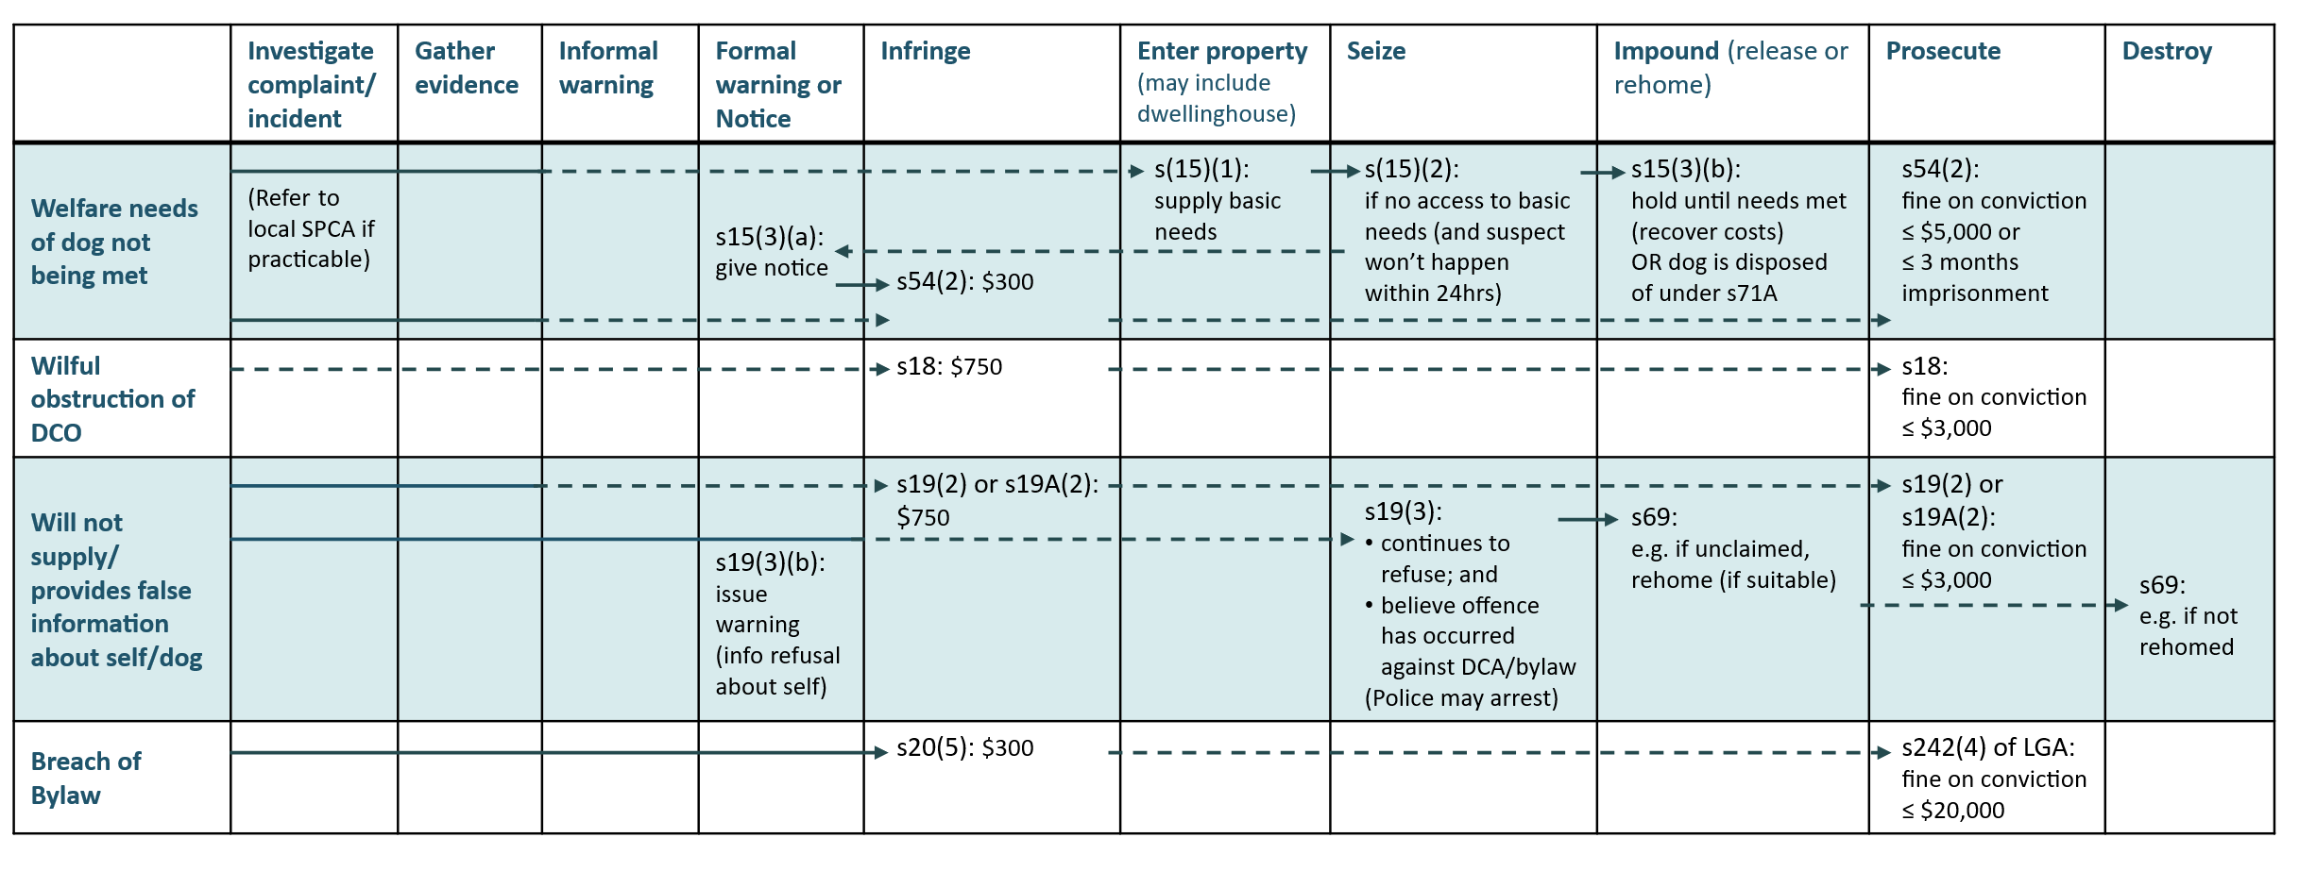

Table 15: Enforcement pathways for offences/non-compliance against DCA sections 23A, 24, and 28
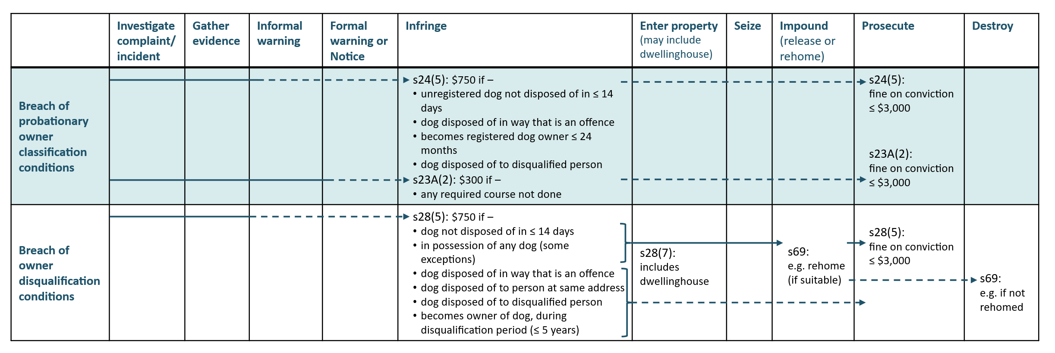
Table 16: Enforcement pathways for offences/non-compliance against DCA sections 32, 33EC, and 33F
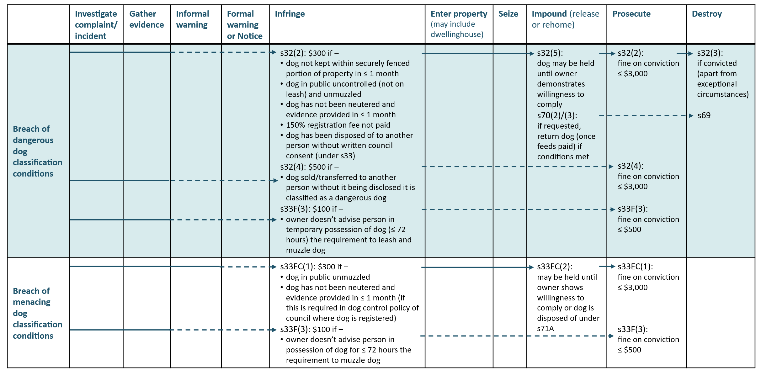

Table 17: Enforcement pathways for offences/non-compliance against DCA sections 36A, 41, 41A, 42, 46, 48, 49, 50 and 51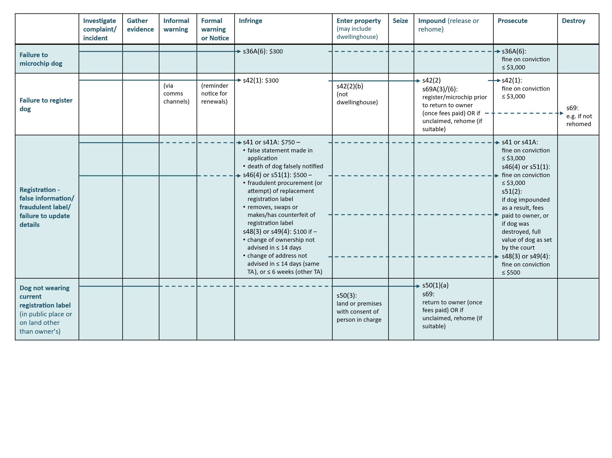

Table 18: Enforcement pathways for offences/non-compliance against DCA sections 52, 52A, 53 and 54A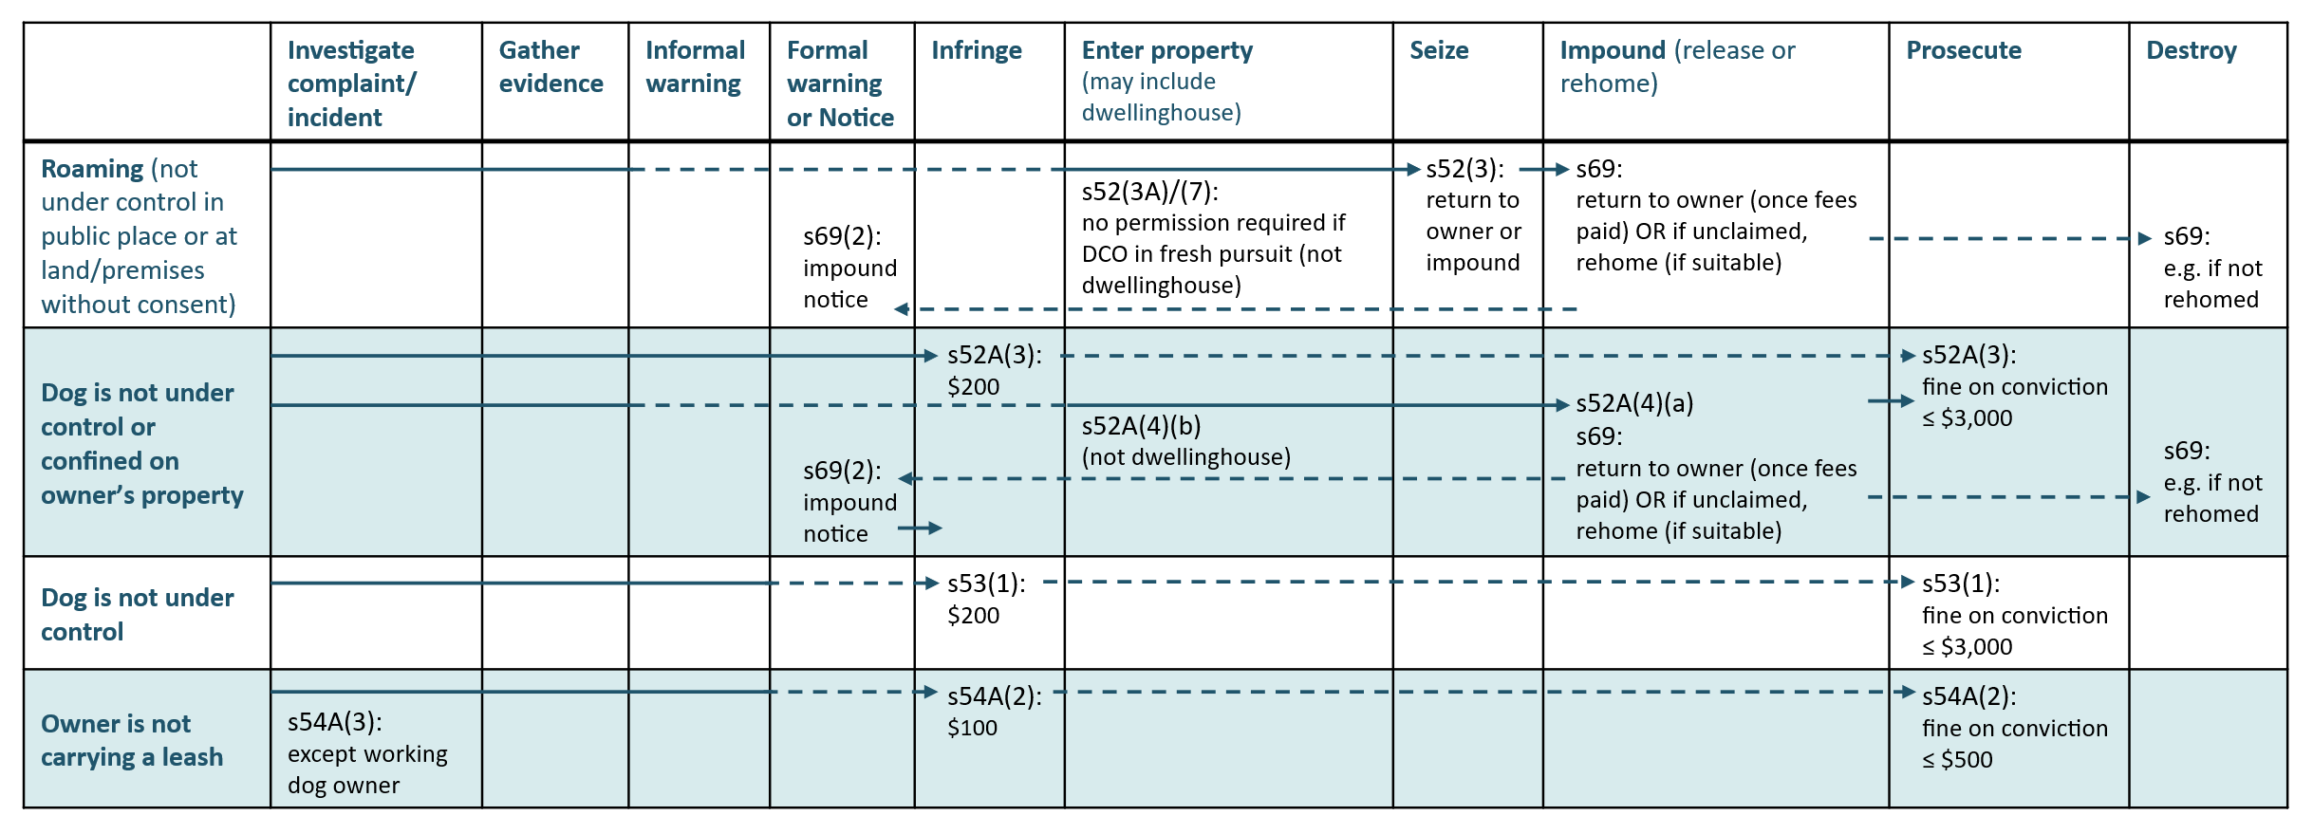
Table 19: Enforcement pathways for offences/non-compliance against DCA sections 55 and 56
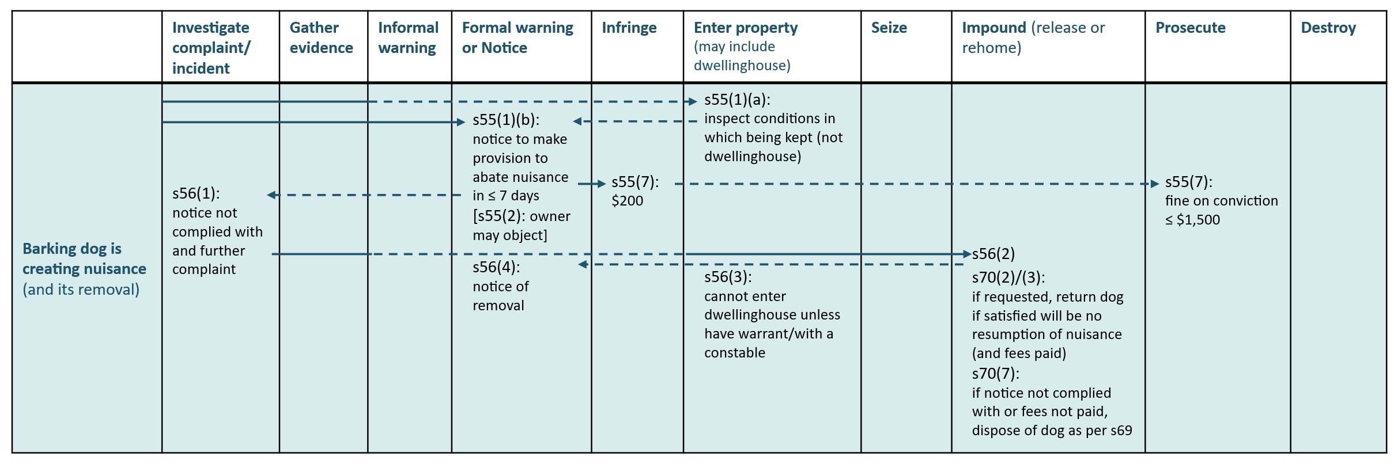
Table 20: Enforcement pathways for offences/non-compliance against DCA sections 57, 57A and 58
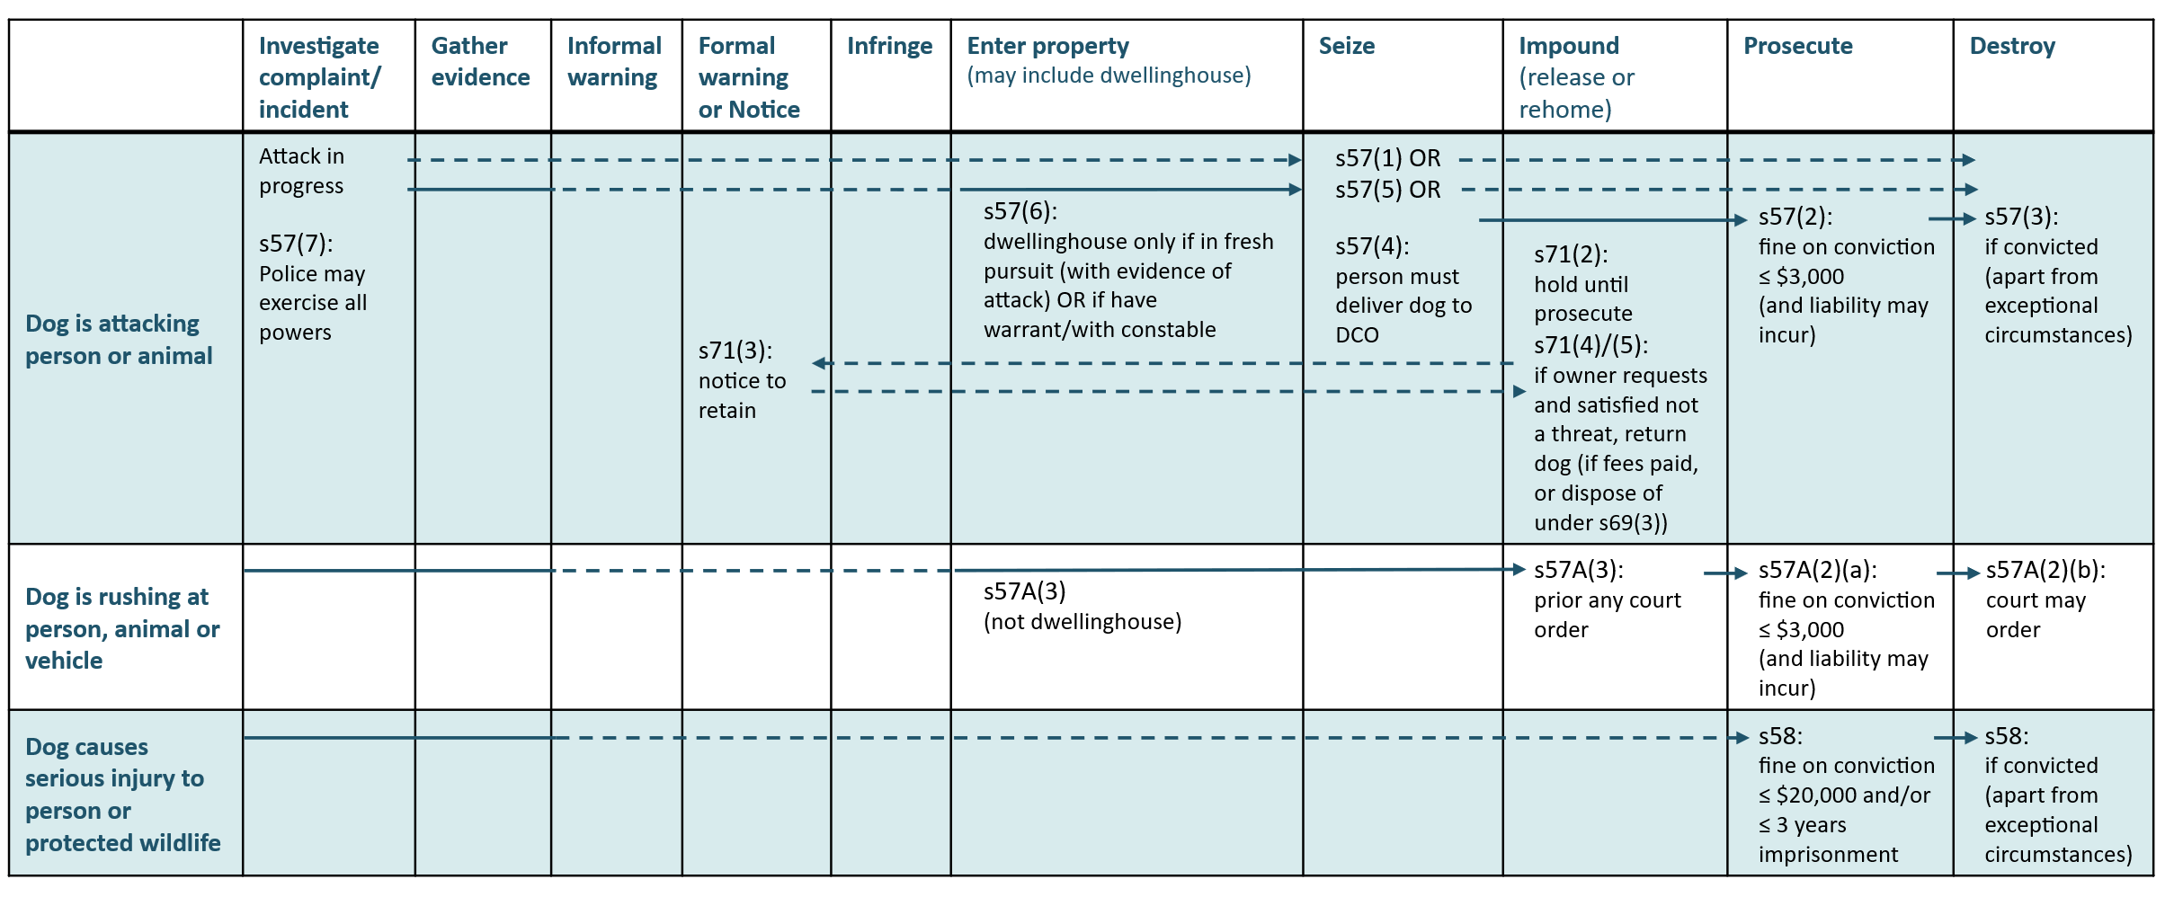
Table 21: Enforcement pathways for offences/non-compliance against DCA sections 59, 60 and 61
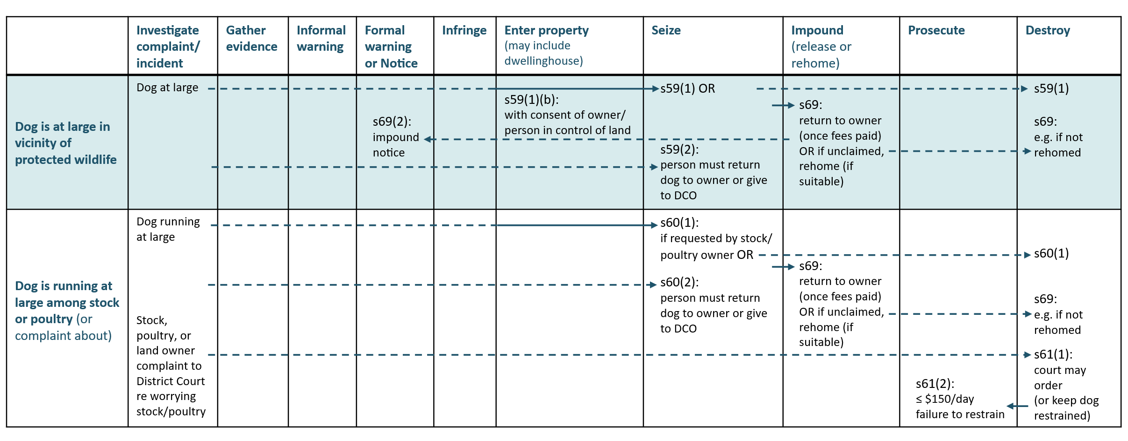
Table 22: Enforcement pathways for offences/non-compliance against DCA sections 62, 64, 72 and 72A
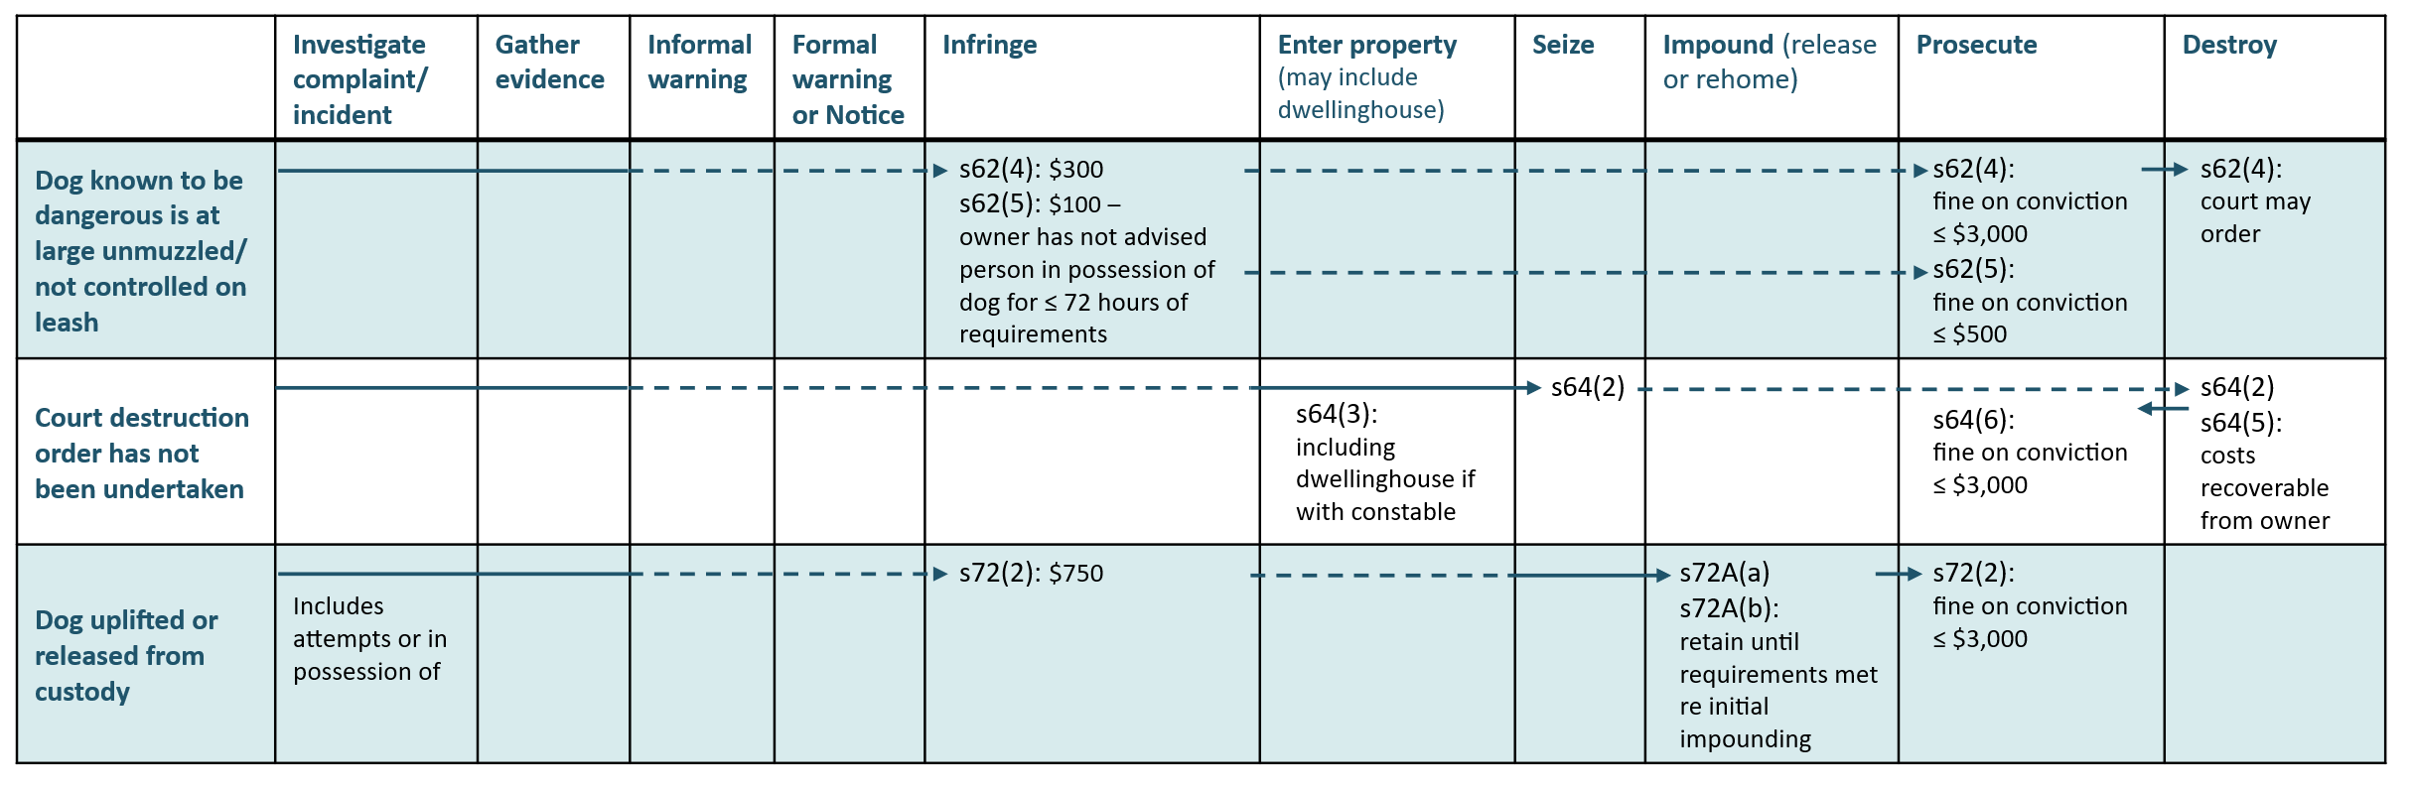

Table 23: Enforcement pathway considerations
Investigate Complaint/incident and Gather evidence | Informal warning and Formal warning/notice | Infringement | Entering property
What triggers the need for an investigation?  What information is required?  Consider the who, what, where, when, why, and how?  Are there any witnesses and have they made a statement?  Is the owner readily identifiable?  Can the dog be identified and is it registered?  How is the information being recorded and filed? | Is the owner readily identifiable?  Is the owner willing to receive guidance and eager to comply?  Can the dog be identified and is it registered?  Does the dog have any history of roaming?  Is it appropriate to apply discretion in this instance?  Is a warning a reasonable step in the enforcement pathway?  Should a record be kept of the situation and details of the warning?  For barking nuisance - how can you show reasonable ground for believing?  Is there a history of multiple complaints?  Has a site visit been undertaken?  For barking nuisance - can objective data be collected, for example, using decibel meters within distance from source? Has the noise control team received complaints? | Is the infringement relatively minor and the scale of the impact known and small?  Are the facts of the offence clear? (for example, date, time, location, offence, offender, dog)  Will the infringement act as a deterrent?  Has the owner made no effort to comply, or is the owner not readily identifiable?  Can the dog be identified and is it registered?  Has there been any history of an infringement associated with the dog?  Is the dog dangerous/menacing or is there a history of it having attacked any person or animal, or damaging property?  Has the dog been seized?  Is the infringement on the prescribed form?  How is it best to deliver the infringement notice to the owner? | Is there a history of offences against the DCA?  Is a search warrant required?  Is it a reasonable time to enter onto the land or premises?  Is there a history of aggression with the dog or dog owner at the property?  In what scenario can a house be entered?  Is it necessary for a constable to be in attendance?  Has a request for a constable to attend been completed?

Table 23: Enforcement pathway considerations - continued
Seizing of dog | Impounding of dog | Prosecution | Destruction of dog
Has the owner made no effort to comply, or is the owner not readily identifiable?  Is there a history of non-compliance with a barking abatement notice?  Can the dog be identified and is it registered?  Has there been any history of infringement/offence associated with the dog?  Is the dog dangerous/menacing or is there a history of it having attacked any person or animal, or damaging property?  Is adequate welfare being provided to the dog (food, water, shelter)?  What notice requirements are there? | What notification requirements are there?  What information does the owner need to know, what is the deadline to reclaim?  What consequences are there?  Is the dog dangerous/menacing or is there a history of it having attacked any person or animal, or damaging property?  Can the dog be rehomed? | Has the owner made no effort to comply?  Can the dog be identified and is it registered?  Is there a history of multiple offences under the DCA?  Is the dog dangerous/menacing or is there a history of it having attacked any person or animal, or damaging property?  Has the dog been seized?  Is the case serious and persistent with no other option remaining?  Does the available evidence provide the prospect of successfully obtaining a conviction?  Is it in the public interest to exercise the discretion to commence a prosecution? | How does case law impact on any destruction notice?  Has a court order been made for destruction?  Are there any exceptional circumstances?  Is the impounded dog suffering from injury/sickness and has a vet certified this?

Part 4 – Preventative measures

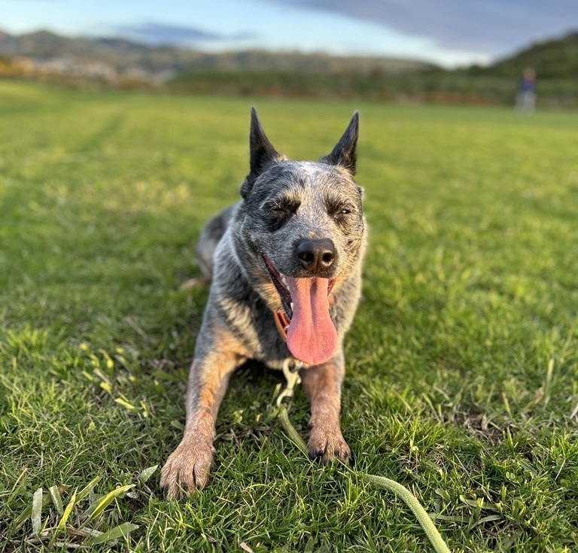

Intervention to control dog numbers
Controlling the number of dogs helps to keep the overall dog population in check and correspondingly reduces the number of issues caused by unwanted or uncared for dogs.

Neutering
Neutering (or desexing) is highly encouraged by councils, and agencies such as the SPCA, to control dog numbers, prevent roaming, the spread of diseases, and reduce costs for owners and councils.
Generally, neutering is not mandatory in the DCA, except where a:
- council policy requires neutering for dogs classified as menacing
- council bylaw requires neutering for dogs that have repeatedly not been kept under control
- dog has been classified as dangerous, in which case neutering is mandatory.
Councils are strongly encouraged to make full use of their discretionary powers under the DCA to neuter dogs, particularly dogs that have been seized or impounded.
Some owners may not possess the means to neuter their dogs (due to financial or logistical constraints) or are not aware of the importance of doing so. To encourage neutering, a council may wish to run educational programmes or provide educational material about neutering (including at the time of registration or collecting a dog from the pound) and offer free or subsidised neutering on certain occasions. Setting a lower registration fee for neutered dogs may also encourage neutering.
Establishing a working relationship with the SPCA or other organisations that advocate for neutering, as well as local veterinarians, will provide support for neutering initiatives.

Good practice considerations
- Advertise neutering incentives and programmes to encourage buy-in from dog owners.
- Work with other organisations to deliver programmes.
- Offer free neutering vouchers or support transport of animals to be neutered where practicable.

Control of dogs on public conservation land
DOC has legal authority to manage unauthorised, uncontrolled, and feral dogs on public conservation land. These dogs can pose a significant threat to wildlife, stock, poultry, and public safety.
DOC utilises a variety of tools to deal with these dogs on public conservation land. This may include shooting or live capture followed by humane destruction.
Under s17 of the DCA, every warranted officer under the Conservation Act 1987 has the same powers and functions of dog control officers in relation to protected wildlife.

Education and community awareness
Dog control is a regulatory activity involving the behaviour of dogs, their owners and people in the wider community. Effective dog control is assisted by developing and maintaining strong relationships within the community and by educating people.
Communications are a significant element of building and maintaining relationships. A communications plan, focused on key messages and identifying target audiences, is a useful way of coordinating the information provided. Such a plan also enables a council to respond promptly and appropriately to a serious incident and when there is media interest.
Generally, most people are responsible dog owners. A council should take opportunities to engage with people and explain the reasons for dog control, to raise community awareness and understanding of dog control policy. Dog owners should also be made aware of their responsibilities in providing for the welfare of their dog.
School and community group visits, and attending events relevant to dog owners and communities, such as rural shows, are opportunities for wider engagement. Online advertising, social media posts, e-newsletters, and some printed information are examples of the type of communication that can be targeted both in terms of the audience and the message. Communications can also be used to share good news stories such as when a dog has been rehomed, or to profile a responsible dog owner.
In engaging with communities on dog control, it is helpful to recognise that there are different audiences including dog owners, the public (the majority of whom are not dog owners), and victims of dog aggression.
People’s attitudes and responses to dog control vary as with other regulatory activities. Success will depend, in part, on the policy developed by the council, but mostly on the effectiveness, skills, and experience of DCOs working in the community.
Education, whether through online material, events or DCOs speaking at schools, is key to promoting dog safety and compliance. Historically, educational material was provided by the Department of Internal Affairs – it is currently up to councils to develop and distribute their own educational material. However, to ensure consistency, working with other councils and advocacy organisations such as the SPCA and Companion Animals New Zealand will ensure that there are consistent key messages.
Dog bite prevention is an important subject for DCOs to cover, especially when visiting schools. Educating both children and adults on how to prevent dog bites helps to reduce harm. Areas with a high number of roaming dogs may wish to prioritise dog bite prevention education. To further this work, there are various dog bite prevention groups and initiatives which a council may consider supporting.
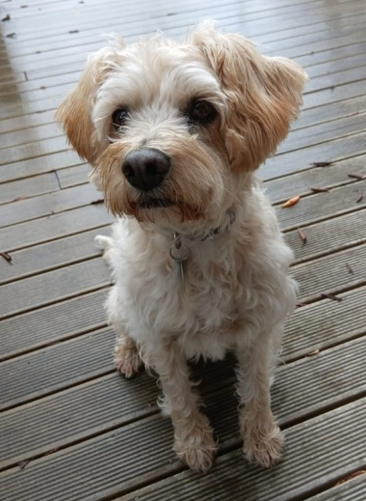
When engaging with the community, consider that:
- recognition and reward may be most effective for those who want to, and will, comply with dog control
- reminders, assistance, and a helpful, personal approach may be most effective for those who want to comply but may forget, be impeded, or find it difficult
- opportunities should be taken to build rapport wherever possible to show empathy
- innovation and working together with other authorities, agencies, or people present opportunities to be more effective.

Good practice considerations
- Identify opportunities and media channels to disseminate key messages and information (online including social media, school visits, veterinary clinics, etc.).
- Provide bite prevention safety information and education to the community.
- Promote the importance of proper dog socialisation and run events to support this.
- Talk to and connect with dog owners about their dogs where opportunities arise, such as through public events at the beginning of the registration year.
- Build strong relationships with key stakeholders, including the SPCA, veterinarians, Police, dog obedience clubs, kennel/dog breed clubs, NZIAM, elected members, and neighbouring councils.
- Align council policy, allocation of resources, and implementation of dog control activities.
- Communicate clear and consistent messages to dog owners and the general community, including through signage that connects with a council’s dog policy and bylaw.
- Translate messages into te reo Māori and other languages where these are particularly relevant for the community.
- Incorporate educational messages into enforcement activities, with the ability to spend time with dog owners where appropriate.
- If referring dog owners to external educational providers, ensure that these providers are reputable and their programmed evidence-based.
- Maintain the capacity to provide advice to dog owners (for example, evaluation services, remedial advice, and support to owners of problem dogs, recognising that care needs to be exercised when providing advice where legal responsibilities may be involved).
- Include relevant and appropriate books on dogs, dog behaviour, and dog control in libraries.
- Ensure that the results of enforcement actions (successful prosecutions in particular) become well known in the community.
- Maintain high standards of professionalism at all times.

Working with other organisations
A council and its DCOs will need to engage with a variety of other organisations while carrying out their functions. These organisations include government agencies and non-government organisations. Establishing productive, efficient, and positive relationships with other organisations will greatly contribute to a council’s dog control efforts.

Police
It is important for a council to establish partnerships with its local Police with clearly defined processes that outline powers, responsibilities and boundaries. A council may wish to establish memoranda of understanding with its local Police, or designate liaison/contact persons.
Dog-related incidents can be complex and, at times, high-risk, therefore DCOs need to work closely with Police where enforcement action is required at gang-associated or otherwise challenging addresses. In these situations, there should be clarity of roles, strong relationships, and a sound understanding of legislative boundaries to support effective de-escalation and minimise the risk of boundary creep between agencies.

Rescue and welfare organisations
Rescue and welfare organisations play a role in dog control. The SPCA can enforce animal welfare issues whilst other local or national organisations can also assist with rehoming unwanted, unclaimed or surrendered dogs (for example, HUHA). Having a positive working relationship with the local SPCA and rescue organisations operating in the area (whether through formal agreements or less formal understandings) will help jointly resolve welfare issues and the rehoming of dogs, as well as the dissemination of key educational information and resources.
A council should be aware that anyone can establish a rescue organisation if they comply with relevant bylaws, legislation, charity rules, etc.

Good practice considerations
- A strong relationship between the council and the local branch of the SPCA is important to manage overlaps and differences in the welfare provisions under the DCA and AWA.
- If an owner fails to provide adequate exercise, an infringement under the DCA is possible but can be difficult to gather evidence to enforce. It may be better to alert the local SPCA as they are usually better placed to investigate.

Veterinary clinics
A good working relationship with local veterinarians is important as DCOs may need to liaise on matters such as assessing and treating dogs that have been seized or involved in dog attacks, and euthanising services.
The Veterinary Council of New Zealand (Vet Council) provides guidance to veterinarians around how to conduct themselves and what actions to take if they encounter an unregistered dog, a dog with a history of aggression, and/or a dog that poses a potential risk to members of the public. This guidance can be accessed via their information Hub.

Housing providers and tenancy agencies
It is recommended that a council identify large-scale housing providers and tenancy agencies such as Kāinga Ora, community housing providers, and private property managers with large portfolios. These housing providers must allow a tenant to keep a dog unless there is good reason to refuse under the Residential Tenancies Act 1986. One of the reasons can be that the tenant is not a responsible owner. Consent to keep a dog at the tenancy may be revoked at any time on reasonable grounds.
This means that it will be beneficial for a council to have cooperative working arrangements with these large-scale housing providers and other agencies. Arrangements may include collaboration on enforcement, education, safety, and information sharing. For instance, Kāinga Ora partners with the SPCA on welfare issues and participates in the national multi-sector Dog Bite Prevention Group.

Other landowners
A council may wish to establish a working relationship with DOC if there is public conservation land within its district, particularly if the control of dogs in these areas is a concern.
DCOs will also likely encounter private landowners, including farmers, especially in rural areas. DCOs may wish to establish working relationships and positive rapport with representative bodies for the primary sectors, farmers, and other relevant landowners, especially in areas with roaming dog issues.

Part 5 – Information management and reporting

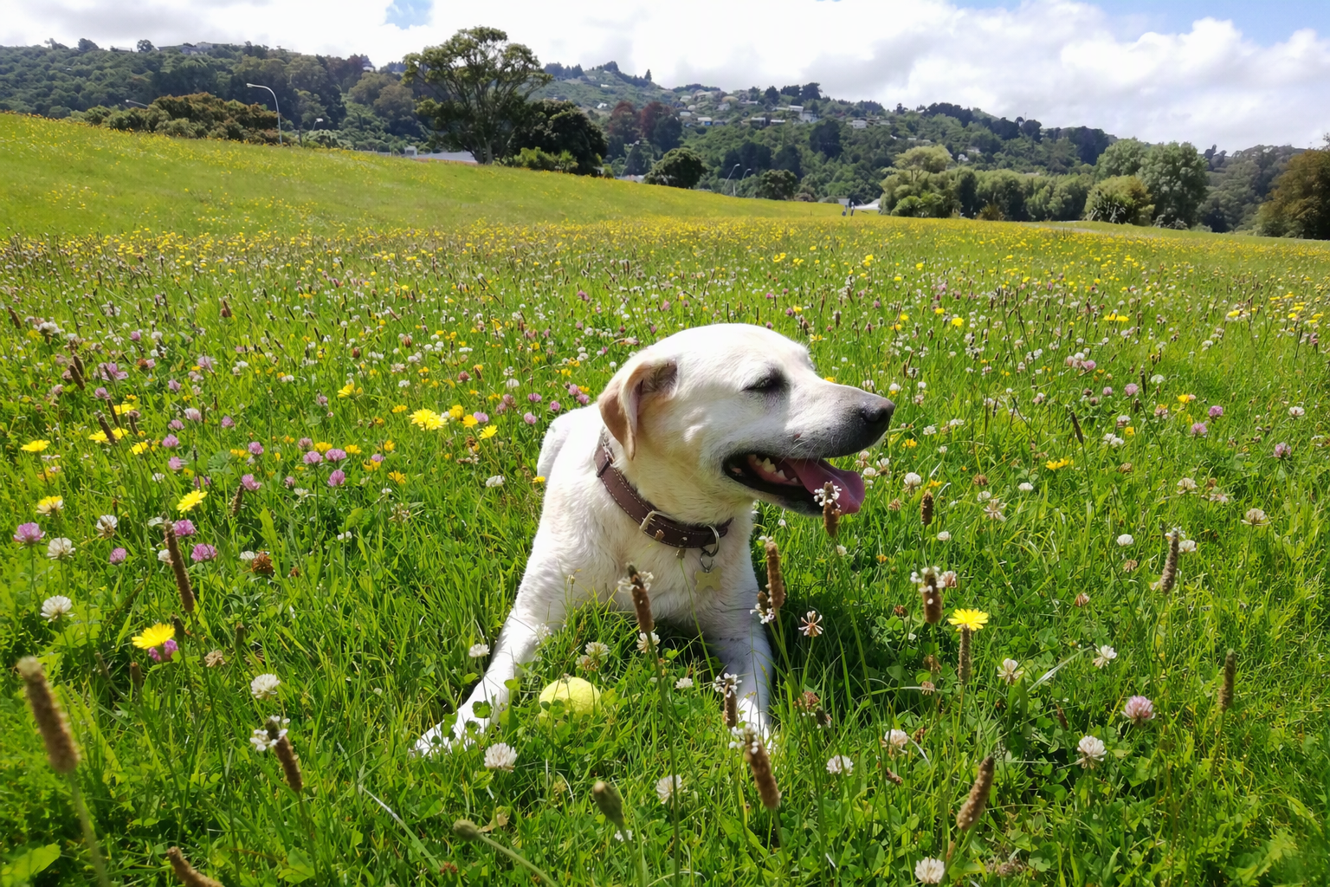

Record keeping, reporting and monitoring
Record keeping is critical for gathering and maintaining information. Reporting and monitoring are essential to help inform policy development and review and to improve implementation. These measures assist in identifying issues and priorities, provide feedback on changes in local circumstances, and demonstrate the effect of dog control activities in general and any particular initiatives.

National Dog Database
The National Dog Database (NDD) holds information on all registered dogs including registration details, microchip number, breed, and year of birth. The name, address, and date of birth details of owners are also recorded. New or renewal registration information is entered into a council’s database for uploading into the NDD.
Councils supply and maintain information held on the NDD. The information is only accessible to relevant council staff and is not available to the public, although the information may be supplied to the Secretary for Local Government for policy analysis purposes. Local councils hold breed and colour reference lists for use with the NDD. Additional information on the NDD, including detailed user guidance, is available on MCERT’s website here.
Councils pay a levy to the Crown each financial year to fund the costs of maintaining the NDD.

Dogs register
The NDD should not be confused with a council’s own dogs register. Under s34 of the DCA, every council should keep a register of all dogs registered within its district. Under s35, information held in this register may be supplied for valid purposes to certain entities, including constables, DOC officers, other councils, welfare inspectors, biosecurity inspectors, animal welfare societies, and veterinarians, who may request the information using the prescribed form.
Although not compulsory, a council having its own dogs register is an effective way of record keeping however it does not replace the NDD. Alternatively, a council may directly enter the required information into the NDD instead of maintaining their own dogs register.

Section 10A reporting
Section 10A of the DCA requires a council to publicly report each financial year (1 July to 30 June) on the administration of its dog control policy and its dog control practices (s10A(1)). The report must include a range of dog control-related statistics (s10A(2)).
To enable more straightforward and consistent statistical reporting, Appendix 2 provides a template for a council to report its dog control statistics, both the information required by s10A(2) as well as optional reporting fields.
One of the primary purposes of these reports is to allow communities to see how their local council is managing its dog control responsibilities. A council must provide public notice of the report and make it accessible, through their website for example.
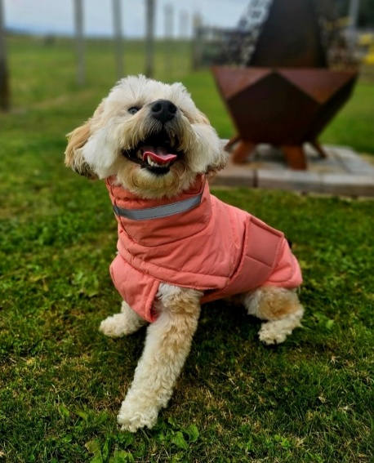
The DCA has relatively minimal reporting requirements. Good practice is to undertake more comprehensive monitoring and reporting, such as comparing activities/reports across financial years. Including relevant pictures and stories in a report, especially those that promote compliance and dog safety, could help illustrate dog control activities for the public.
It is good practice to also accompany the publication of the report and statistics with a press release, and to forward the reports to MCERT as soon as practicable to facilitate analysis at the national level.
Table 24 below provides prompts on the content of a s10A report. These have been compiled from recent reports and include good practice considerations:
Table 24: Prompts for determining content of a s10A report
Introduction/background | What is the purpose of the s10A report?  Clearly state the reporting period (financial year – 1 July to 30 June).  What are the council’s dog control functions?  Did the council focus on anything in particular over the financial year (for example, reducing the number of roaming dogs)?
Summary | What were the overall trends and activities in dog control this financial year compared to the last one?  What was of particular interest (for example, major changes)?
Dog control policy and practices | What is the council’s dog control policy and bylaw and their objectives? Have there been any changes to the policy or bylaw?  How is dog control structured by the council?
Fees | What fees (and categories, for example, discounted fees for responsible dog owners) were collected over the financial year?  What are the categories and percentages of revenue/funding (for example, fees, rates etc.) and expenditure (for example, administration, enforcement etc.)?  How did this differ to the previous financial year?
Registration | What were the trends in registration?  What initiatives did the council undertake to encourage registration (for example, events, discounts etc.)?
Enforcement | What enforcement activities (including reactive responses to complaints, and proactive activities) were undertaken?  Was there a particular enforcement focus area over the financial year?
Impounding | What pound(s) do the council maintain?  What was the impounding activity over the financial year? How did this differ to the previous financial year?
Education, communications, and community engagement | What education activities were undertaken (for example, school visits, courses, events)?  How did DCOs and the council communicate their activities (for example, social media, newsletters etc)?  How else did DCOs engage with the community through events etc?  How did this differ to the previous financial year?
Dog control staffing | How does the dog control team operate?  What was the number of full-time equivalent staff (FTEs) over the financial year? How is after-hours staffing conducted?  What were the health and safety issues for DCOs?  How did this differ to the previous financial year?
Dog control information | Utilise the statistical reporting template in Appendix 2 to report the mandatory dog related data required by s10A(2) of the DCA.  Utilise Appendix 2 to report optional data if practicable.  What trends do the statistics show, especially compared to the last financial year? Are there any statistics that stand out? Are there any caveats for the data?

Information sharing
It is good practice for a council to share relevant information with other councils and agencies, such as DOC and the Police (as permitted by law such as under the Privacy Act 2020) to facilitate more effective dog control.
Establishing rapport with neighbouring councils and sharing information is particularly important when probationary or disqualified owners, or menacing or dangerous dogs, move (transfer) between councils. There are several situations under the DCA which may involve more than one council, for instance:
- probationary and disqualified owner classification extends throughout New Zealand and is not limited to the council district in which the classification was made
- dangerous dog and menacing dog classification extends throughout New Zealand and is not limited to the council district in which the classification was made
- if a dog is classified as menacing by one council, and is later registered with another council, that other council may require the menacing dog to be neutered no later than 1 month after registration (depending on its policy)
- under s35, certain entities (including councils) may request, for any lawful purpose, certain dog related information that is recorded in another council’s register of dogs, by means of the prescribed form.
When carrying out dog control activities, a council may need to engage with other agencies as listed in the guidance section Role of central government agencies and other organisations. As outlined in the guidance section Working with other organisations, building rapport and establishing and maintaining contacts is good practice.

Website information on dog control
A council website should clearly show how to report dog control issues including making a complaint. The need to call 111 in an emergency (for example, serious and active dog attack) should be prominent.
A dog control webpage should include phone, email, and/or online reporting options. Clear, consistent navigation means people can easily find dog-related information, with prominent notices about reporting dog attacks or other issues placed near the top of relevant pages. This can be done using a popout notification with key information and links. It is helpful for the public if the main dog control webpage provides an overview of dog control issues that can be reported on.

Use of apps and AI
A council can utilise apps to further support its dog control practices. A council app can enable quick, safe, and convenient reporting of dog complaints and lodgings of requests for service. Many councils utilise apps for general queries or reporting problems, and including dog control functions in these apps is a logical way to better integrate council services.
Because they enable quick reporting of dog control problems, council apps can support proactive and targeted dog control enforcement. They can also support information gathering activities which may lead to more effective targeted patrolling.
Council apps can be used to quickly and easily disseminate information, such as registration reminders, to dog owners. A council may choose to utilise web app forms, which can be more user-friendly than a specific council app that must be downloaded.
A council may wish to consider the use of artificial intelligence (AI), such as in the form of an AI assistant within a council app. An AI assistant could answer public queries, direct users to resources, analyse photos submitted by users, process complaints, and converse in te reo Māori. A council should develop and deploy such AI tools in a safe, secure, and responsible manner, and be receptive to user feedback.

Resources and Appendices
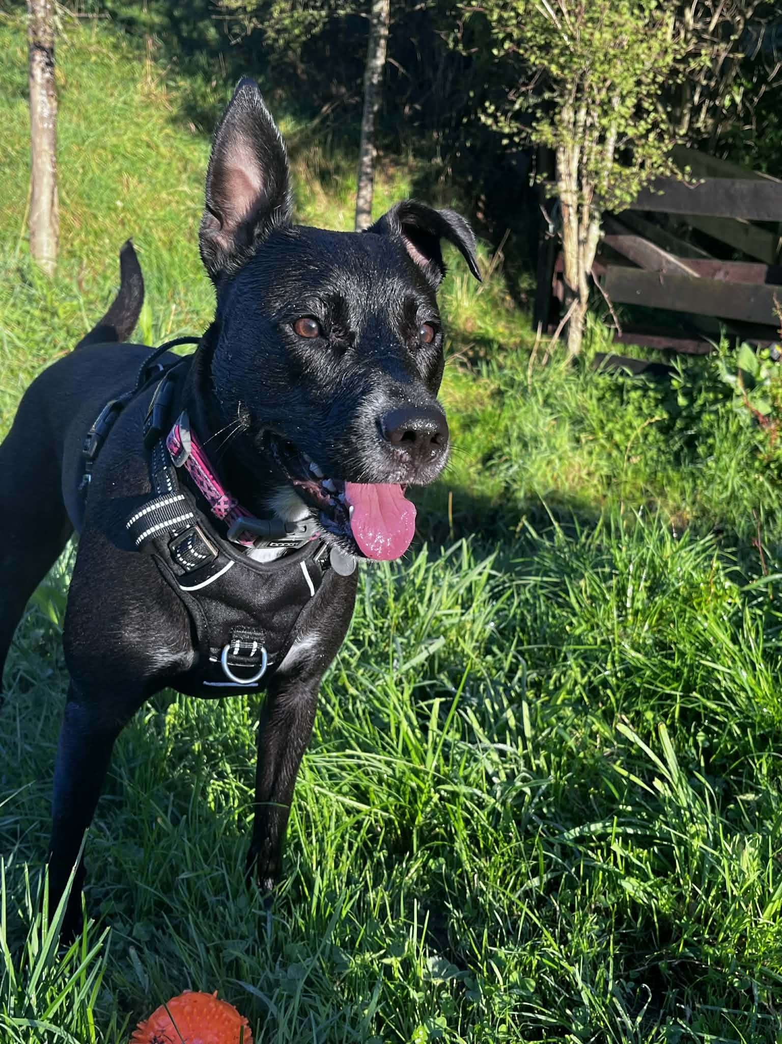

Resources and links
Industry bodies
- Companion Animals New Zealand (CANZ) – host the New Zealand Companion Animal Register – a database for microchipped animals. CANZ also provides other data on pets and a range of evidence-based educational resources about dogs.
- Dogs New Zealand (DNZ) – information/resources for breeders and the public including breed information (previously the New Zealand Kennel Club)
- New Zealand Institute of Animal Management (NZIAM) – information and resources that is member-specific, as well as for the public.
- New Zealand Veterinary Association (NZVA) – includes information for the public such as veterinary clinic locations
- The Royal New Zealand Society for the Protection of Animals (SPCA)
- Veterinary Council of New Zealand (Vet Council).
Local Government advocates
- Local Government New Zealand (LGNZ)
- Taituarā – member-specific resources, some of which is listed in Appendix 1.
Central Government organisations involved in dog control and welfare
- Department of Conservation (DOC) – Dogs on conservation land: Parks and recreation
- Ministry for Cities, Environment, Regions and Transport (MCERT) – information on dog safety, matters related to the DCA including the guidelines, and dog statistics can be accessed on the Ministry’s website
- Ministry for Primary Industries (MPI)
- National Animal Welfare Advisory Committee (NAWAC)
- New Zealand Customs Service (NZCS)
- Police
Animal welfare
- Animal Welfare (Care and Procedures) Regulations 2018 | New Zealand Legislation (MPI)
- Code of Welfare: Dogs | NZ Government (MPI)
- Code of Welfare: Temporary Housing of Companion Animals | New Zealand Legislation (MPI)
- MPI leaflet on dog welfare: 2026 AW Regulations dog pamphlet
- Dog abuse or neglect reporting to the SPCA: Report animal cruelty - SPCA New Zealand
Education
- SPCA provide advice and welfare articles for pet owners and the public: Advice & welfare - SPCA New Zealand
- SPCA provides desexing and microchipping advice and resources: Helping you desex & microchip your animals - SPCA New Zealand
- SPCA also provide a kids-focused site on dog safety: Dog Safety | SPCA Kids Education
Council dog policies and bylaws
- A council’s dog control policies and bylaws and related information can be accessed on individual council websites. A full list of linked council websites can be found here: Council websites - LGNZ.
- Some examples of good dog control website pages are:
  - Auckland Council
  - Christchurch City Council
  - Far North District Council
Prosecution guidelines
- Crown Law provides the Solicitor-General's Prosecution Guidelines for public information: Prosecution Guidelines » Crown Law.

Case law resources and examples
- New Zealand Animal Law Association: Dog Attacks and the Enforcement of the Dog Control Act 1996 (2025) (refer Appendix A for case summaries).
- Law News: Navigating the complexities of the Dog Control Act (April 2024).
Table 25: Case law examples
Case | Outcomes
Tauranga City Council v Fraser [2023] NZHC 723 | - The offence created by the DCA is an offence of strict liability.  - The total absence of fault is the only defence in the context of dog attack prosecution.  - It does not matter that the victim could have acted differently. The law requires that there was no practical step the dog owner could have taken to avert the attack.  - The total absence of fault is not to be confused with the standard of reasonableness.
Auckland Council v Hill [2020] NZCA 52 | - Considered the provision where the dog owner can establish that the circumstances of the offence (attack) were exceptional and do not warrant destruction of the dog.  - Court of Appeal confirmed that the exceptional circumstances inquiry must focus on the immediate circumstances of the attack itself.  - This decision reversed the findings in Halliday v New Plymouth District Council (2005).  - Post and pre attack features are now effectively irrelevant to the question of a destruction order.
Telford v Auckland Council [2022] NZHC 31 | - The High Court ruled that a conviction is a mandatory precondition for a dog destruction order under s57(3) of the DCA.  - Clarified that destruction could still be ordered under s106(3)(c) of the Sentencing Act 2002. When a judge grants a discharge without conviction, they still retain the discretion to impose orders that would normally be required upon conviction.
Solicitor-General’s reference from CRI-2022-404-212 ([2022] NZHC 31) – [2024] NZCA 401 | - Court of Appeal considers Telford v Auckland Council [2022] NZHC 31 questions of law.  - High Court was correct in concluding that conviction of a dog owner is a precondition to an order for destruction being made under s57(3) of the Dog Control Act 1996.
R v Wira – [2025] NZHC 3148 | - The first sentencing for manslaughter involving a dangerous animal in New Zealand.

Appendix 1 – List of templates, forms, and processes

Taituarā Council Toolkit
The Taituarā Council Toolkit is a sector resource that may support a council to implement the guidance in practice. The Toolkit contains detailed, step-by-step workflows, templates, and controls developed by Taituarā to support councils in delivering dog control services and managing legal risk.
The Toolkit is available to Taituarā members through the Taituarā Council Toolkit.
These guidelines and the Dog Control legal compliance module in the Toolkit can be considered together.
A council may wish to refer to the Dog Control legal compliance module in the Toolkit for practical support on process steps, documentation requirements, templates and compliance processes.
The guidance and Toolkit resources do not replace or override the need for a council to follow its own policies, bylaws, and legally compliant processes. A council remains responsible for ensuring that its actions are consistent with the DCA and other applicable legislation.
Processes/flowcharts available to Taituarā members through the Taituarā Council Toolkit (Dog Control Module)
Process name | What relates to in guidelines
- Request for service | Complaints
- Scene management | Complaints  Seizing and impounding
- Complaint investigation | Complaints
- Complaint investigation outcomes | Complaints
- Food, water and shelter | Animal welfare  Enforcement pathway
- Barking nuisance | Barking nuisance  Enforcement pathway
- Dog identification and microchip number validation | Complaints  Microchipping
- Information checks | Difficult dog owners
- Dog owner is disqualified | Enforcement pathway
- Dog is classified as dangerous or menacing | Classification of dogs
- Dog is unregistered | Registration  Enforcement pathway
- District Court order exists for destruction of dog | Destruction  Enforcement pathway
- Dog has been released or uplifted unlawfully | Enforcement pathway
- Annual dog registration | Registration
- Non-registration | Registration  Enforcement pathway
- Monitoring menacing dog classification | Monitoring a dog classification
- Monitoring dangerous dog classification | Monitoring a dog classification
- Seizure | Seizing and impounding
- Seizure of dog from property which is not owned or occupied by the dog owner | Seizing and impounding
- Surrender | Accepting surrendered dogs
- Impounding | Seizing and impounding
- Retention and release – s55 notice relating to barking | Seizing and impounding  Barking nuisance  Enforcement pathway
- Retention and release – threatening public safety or causing serious injury | Seizing and impounding  Enforcement pathway
- Retention and release – food, water, shelter or menacing dog classification | Seizing and impounding  Classification of dogs  Enforcement pathway
- Dispatch | Accepting surrendered dogs  Rehoming dogs
- Infringement issue | Infringements
- Infringement enforcement | Infringements
- Probationary and disqualification classification | Classification of owners
- Objections to probationary and disqualification classification | Classification of owners
- Annual reporting | Section 10A reporting
Templates available to Taituarā members through the Taituarā Council Toolkit (Dog Control Module)
The Taituarā Council Toolkit (Dog Control Module) provides a variety of templates, forms, notices, etc. to support DCOs. These are available to Taituarā members.

Other templates a council may wish to develop
Template name | Description
Attack rating evaluation | Dog attack rating evaluation method/form. Such a form may be based on the Ian Dunbar Bite Scale alongside contextual factors
Letter regarding investigation of a complaint | Advisory/educational letter from council to a dog owner whose dog is subject to a complaint
Letter regarding investigation outcome | Letter to a complainant informing them of the outcome of an investigation
Classification of dangerous and menacing dogs under the DCA | Guidance on rationale, process, and obligations of classifying dogs as dangerous and menacing
Checklist for approving multiple dog ownerships | Checklist for assessing an application for extra dogs
Complaint investigation form | Form for assessing complaints in the field
New DCO induction checklist | Checklist for inducting a new DCO
Rehoming evaluation | Form for evaluating the rehoming of dogs
Considerations for prospective owners of rehomed dogs | Process for considering the compatibility of a dog to be rehomed and its prospective owner
Written formal warning | Written formal warning (to form part of records)
Approved dog owner checklist | Example of a checklist for assessing an approved dog owner application
Windscreen card for dogs in hot cars | Warning/informational card for placing on the windscreen of a car with a dog inside during hot weather

Dog Control (Prescribed Forms) Regulations 1996
Template name | Use
Form 1 [Territorial authority] Notice of seizure and removal of dog | Under s15
Form 2 [Territorial authority] Notice of classification as probationary owner | Under s21
Form 3 [Territorial authority] Notice of disqualification from dog ownership | Under s25
Form 3A Exempting statutory declaration by or on behalf of importer of dog | Under s30A
Form 4 [Territorial authority] Notice of classification of dog as dangerous dog | Under s31
Form 4A [Territorial authority] Notice of classification of dog as menacing dog | Under s33A
Form 4B [Territorial authority] Notice of classification of dog as menacing dog | Under s33C
Form 5 [Territorial authority] Application for name and address of registered owner of dog | Under s35
Form 6 [Territorial authority] Application to register dog: For the year 1 July … to 30 June … | Under s36
Form 7 [Territorial authority] Notice of removal of barking dog | Under s56
Form 8 Infringement notice | Under s66
Form 9 [Territorial authority] Notice of retention of dog threatening public safety | Under s71

Appendix 2 - Statistical reporting template

Section 10A(2) of the Dog Control Act 1996
Purpose
- Under s10A of the Act, territorial authorities (city and district councils) must report on the administration of their dog control policy and practices in respect of each financial year. Under s10A(2) of the Act, these reports must include certain data.
- The purpose of this template is to provide standardised reporting fields for council use that meet the requirements of s10A(2) of the Act, and to enable more accurate and consistent collection of optional data. This is valuable for illustrating the delivery of dog control and informing more effective practices across the country.
- While usage of this template is not mandatory, it does enable consistent reporting of the dog control data mandated by s10A(2) as well as optional data, and its usage is therefore encouraged.

How to use this template
- Please provide data as of 30 June of the financial year (1 July to 30 June) you are reporting on, even if you use a different reporting period, unless otherwise stated.
- Table 1.1 of this template contains fields for the mandatory reporting required under s10A(2).
- Under s10A(2)(f), dog related complaints must be reported. However, no breakdown of specific complaint types is required. Table 1.2 of the template provides suggested fields for dog related complaints or requests for service (RFS) to be recorded.
- The second part of this template contains optional reporting fields that a council may wish to provide data for, although there is no requirement to do so. However, entering optional information would be useful for analytical purposes. A council may answer as many or as few of these optional fields as practicable.
- Table 2.6 provides space for a council to provide additional data that is not otherwise specified, if they wish. Such information may also be included in the body of a council’s s10A report.
- This template does not replace the requirement for a council to report on its dog control policy and practices under s10A(1). Rather, this template is intended to provide a standardised way for a council to provide dog control statistics under s10A(2).
- Part 4 of the dog control guidelines provides guidance on s10A reporting and other operational dog control matters.
What to do with the completed template
- This template, once completed, can be attached to (or incorporated in) a council’s overall s10A report for the financial year. This report must also contain the information required under s10A(1) and must be publicly notified and made publicly available under s10A(3).

1. Mandatory reporting fields

Table 1.1 Mandatory reporting fields under s10A(2)
Field | Answer
(a) number of registered dogs in the territorial authority district
(b) [part one] number of probationary owners in the territorial authority district
(b) [part two] number of disqualified owners in the territorial authority district
(c) number of dogs in the territorial authority district classified as dangerous under section 31 and the relevant provision under which the classification is made:
s31(1)(a) owner convicted of offence under s57A(2)
s31(1)(b) territorial authority has sworn evidence of aggressive behaviour with grounds to believe the dog constitutes a threat
s31(1)(c) owner admission in writing the dog constitutes a threat
(d) number of dogs in the territorial authority district classified as menacing under sections 33A or 33C and the relevant provision under which the classification is made:
s33A(1)(b)(i) territorial authority considers may pose a threat because of observed or reported behaviour
s33A(1)(b)(ii) territorial authority considers may pose a threat because of characteristics typically associated with the dog’s breed or type
s33C(1) territorial authority has reasonable grounds to believe dog belongs to Schedule 4 breed or type
(e) number of infringement notices issued by the territorial authority
(f) number of dog related complaints received by the territorial authority in the previous year and the nature of those complaints [refer to Table 1.2]
(g) number of prosecutions taken by the territorial authority under the Act:
number of prosecutions started (and not completed) over the financial year
number of prosecutions still in progress from prior financial years
number of prosecutions completed this financial year
number of appeals filed this financial year

Table 1.2 Suggested fields for dog related complaints or RFS
Field – number of: | Answer
Dog attack on people – minor
Dog attack on people – serious
Dog attack on animals
Dog worrying stock or poultry
Dog rushing
Aggressive dog behaviour other than rushing or attacking
Roaming/wandering dogs
Barking or howling
Fouling
Unregistered dog
Dog reported lost
Welfare
Miscellaneous

2. Optional reporting fields

Table 2.1 Suggested reporting fields for infringement notices (optional)
Field – number of: | Answer
s18 – Wilful obstruction of dog control officer or ranger
s19(2) – Failure or refusal to supply personal information or wilfully providing false particulars
s19A(2) – Failure to supply information or wilfully providing false particulars about dog
s20(5) – Failure to comply with any bylaw authorised by the section
s23A(2) – Failure to undertake dog owner education programme or dog obedience course (or both)
s24 – Failure to comply with obligations of probationary owner
s28(5) – Failure to comply with effects of disqualification
s32(2) – Failure to comply with effects of classification of dog as dangerous dog
s32(4) – Fraudulent sale or transfer of dangerous dog without advising its classification
s33EC(1) – Failure to comply with effects of classification of dog as menacing dog
s33F(3) – Failure by dog owner to advise person in possession of dangerous or menacing dog of muzzle and leashing requirements
s36A(6) – Failure to implant microchip transponder in dog
s41 – False statement relating to dog registration
s41A – Falsely notifying death of dog
s42 – Failure to register dog
s46(4) – Fraudulent procurement or attempt to procure replacement dog registration label or disc
s48(3) – Failure to advise change of dog ownership
s49(4) – Failure to advise change of address
s51(1) - Removal, swapping, or counterfeiting of registration label or disc
s52A(3) – Failure to keep dog controlled or confined
s53(1) – Failure to keep dog under control
s54(2) – Failure to provide proper care and attention, a supply of proper and sufficient food, water and shelter, and to provide adequate exercise
s54A(2) – Failure to carry leash in public
s55(7) – Failure to comply with barking dog abatement notice
s62(4) – Allowing dog known to be dangerous to be at large unmuzzled or unleashed
s62(5) – Failure to advise of muzzle and leashing requirements
s72(2) – Releasing dog from custody

Table 2.2 Dog impounding totals (optional)
Field | Answer
Number of dogs impounded
Of those dogs impounded this financial year, how many were claimed/returned to owner?
Of those dogs impounded this financial year, how many were adopted?
Of those dogs impounded this financial year, how many were transferred to rescue organisations?
Of those dogs impounded this financial year, how many were euthanised?
Of those dogs impounded this financial year, how many died in shelter?
Of those dogs impounded this financial year, how many were stolen/escaped from shelter?
Of those dogs impounded this financial year, how many were neutered?
What was the average length of stay for impounded dogs this financial year?

Table 2.3 Dog impounding reasons (optional)
Field – number of: | Answer
Dog attack on people – minor
Dog attack on people – serious
Dog attack on animals
Dog worrying stock or poultry
Dog rushing
Aggressive dog behaviour other than rushing or attacking
Roaming/wandering dogs
Dog not under control or confined on owner’s property
Barking or howling
Unregistered dog
Dog is not wearing current registration label
Welfare
Request from public to collect
Dropped off at shelter by public
Voluntary surrender by owner (relinquished)
Failure to comply with disqualified owner classification
Failure to comply with dangerous dog classification
Failure to comply with menacing dog classification
Miscellaneous

Table 2.4 Other information on the dog population (optional)
Field – number of: | Answer
Estimate of known dogs (including both registered and estimated unregistered dogs)
Dogs newly registered this financial year
Registered dogs transferred from another TA this financial year
Missing dogs
Registered dog owners
Probationary owners newly classified this financial year
Probationary owners transferred from another TA this financial year
Disqualified owners newly classified this financial year
Disqualified owners transferred from another TA this financial year
Registered dogs that are microchipped
Registered dogs that are neutered
Dangerous dogs that are neutered
Menacing dogs that are neutered
Dangerous dogs newly classified this financial year
Dangerous dogs transferred from another TA this financial year
Menacing dogs newly classified this financial year
Menacing dogs transferred from another TA this financial year
Welfare related referrals made to SPCA, MPI, or Police this financial year

Table 2.5 Proactive animal management actions (optional)
Field – number of: | Answer
Hours of patrols
Hours enforcing compliance
Hours running educational programmes/activities
Property inspections

Table 2.6 Additional information (optional)
Field | Answer

The group also included an executive member of the New Zealand Institute of Animal Management (NZIAM)
Dog Control Act 1996 | New Zealand Legislation
It has been amended six times – in 2003, 2004, 2006, 2010, 2012, and 2019
Dog Control (Prescribed Forms) Regulations 1996 | New Zealand Legislation, Dog Control (Microchip Transponder) Regulations 2005 | New Zealand Legislation
Animal Welfare Act 1999 | New Zealand Legislation Animal Welfare (Care and Procedures) Regulations 2018 | New Zealand Legislation
Companion Animals New Zealand 2024 survey shows 31% of households have at least one dog.
Ministry for the Environment (2018). Best Practice Guidelines for Compliance, Monitoring and Enforcement under the Resource Management Act 1991
The Dog Control (Microchip Transponder) Regulations 2005 prescribe technical requirements for microchips, along with where and how these are to be implanted.
Clarify that a pig hunting dog is not a ‘working dog’, for example.
A council may require the owner of a working dog to make a written statement that the dog they are attempting to register is a working dog of a specific class.
Registered under regulations made under s120 of the Health Act 1956.
s10 DCA - policy on dogs
s20 of the DCA allows a council to make dog control bylaws in accordance with the LGA.
A dog policy must be reviewed whenever a dog bylaw is reviewed.
Except for in an emergency where it is appropriate to call 111, seeking Police assistance requires completion of their online form at least a day in advance of when assistance is required.
This may include those with mental health conditions or addiction issues, “sovereign citizens” and others who may be difficult to engage with. It may be appropriate to refer instances of dealing with such individuals to a council’s social wellbeing team, a designated staff member or similar support service.
Code of Welfare: Temporary Housing of Companion Animals
Case law developed through the New Zealand Court System is largely concerned with the destruction order of dogs. The Resources and links section at the end of these guidelines contain Case law resources and examples.
Duress involves pressure that is improper and coercive, compelling a person to act against their will.
Auckland Council Diversion Policy
This may be based on a council’s attack rating evaluation method or existing evaluation methods, such as the Ian Dunbar Bite Scale.
Under the SSA an issuing officer means a Judge, or a person, such as a Justice of the Peace, Community Magistrate, Registrar, or Deputy Registrar, who is for the time being authorised to act as an issuing officer under s108 of the SSA.
Includes the embryo, ova, or semen of a dog.
Under the Criminal Procedure Act 2011, Category 1 or Category 2 offences are still commonly called summary offences. Broadly speaking a summary offence is a less serious criminal offence with lower penalties (such as fines, community-based sentences, or imprisonment of less than 2 years), is heard in the District Cout with a Judge-alone trial (no jury) and has a faster, simpler court process.
Code of Welfare – Dogs
These are not necessarily applicable to the control of feral dogs.
Under the DCA, s35A, s35AB, and s35B cover the NDD. Sections 30(5)-(6) cover the provision of information in relation to the NDD (formally the “national dog control information database”).
Established by the DIA, transferred to MCERT from 1 July 2026.
This should not include infringement notices that were subsequently withdrawn or cancelled.
May also be called requests for service (RFS) or similar.
A council must report on the nature of the dog related complaints it received over the financial year. These are suggested fields for doing so and their use is highly encouraged, if practicable, to improve consistency.
Classified as serious according to any attack matrix/assessment mechanism utilised by the council.
As per Schedule 1 of the Act. This should not include infringement notices that were subsequently withdrawn or cancelled.
Classified as serious according to any attack matrix/assessment mechanism utilised by the council.

