

Climate Change Response Amendment Bill

Supporting the Efficiency of Aotearoa New Zealand’s Climate Change Law
The Government is introducing a bill to amend Aotearoa New Zealand’s key climate change law, the Climate Change Response Act 2002 (CCRA).
The Climate Change Response Amendment Bill (the Bill) introduces a number of changes to reduce duplicative or complex requirements in the CCRA.
At a glance: The Climate Change Response Amendment Bill
This Bill amends the CCRA. The CCRA is the legislation that sets out a range of legal requirements to help New Zealand transition to a low-emissions economy and prepare for the impacts of climate change. The Government announced the changes to the CCRA covered by this Bill in 2025.
The Bill makes changes to several different aspects of the CCRA. This includes:
- introducing a new requirement for local councils to undertake adaptation planning
- supporting the effective functioning of the New Zealand Emissions Trading Scheme (ETS), including making changes needed to enable the introduction of new eligible activities and strengthening secondary market governance
- amending complex or duplicative requirements in the CCRA.
The Government is not changing the fundamental mechanisms of the CCRA. The core elements of the Zero Carbon Framework established under the CCRA remain in place.
The Government is still required to meet New Zealand’s 2050 target, with appropriate checks and balances for climate policy including the independent advice of He Pou a Rangi Climate Change Commission (the Commission).
This publication is one of a series of factsheets on the Bill. For more information, please see our other factsheets:
- Climate Change Adaptation Planning
- Information for New Zealand Emissions Trading Scheme Compliance and Market Participants.

The Zero Carbon Framework
In 2019 the Government amended the CCRA to create the Zero Carbon Framework, designed to support the development and implementation of climate change policies to achieve our long-term emissions reduction targets and address adaptation risks.
The Zero Carbon Framework established the Climate Change Commission, which provides independent advice to the Government and fulfils a monitoring function in some instances.
Core elements of the Zero Carbon Framework for mitigation include:
- the 2050 target: this is the level of emissions reductions New Zealand intends to achieve by 2050. It is a split-gas target, meaning that we intend to reach different levels of reductions for biogenic methane and all other gases
- emissions budgets: an emissions budget is a total quantity of emissions that is allowed to be released during a multi-year period. They act as stepping-stones, or interim targets, to reaching our 2050 target
- emissions reduction plans (ERPs): for each emissions budget, there must be an ERP, which sets out the Government’s policies and strategies for meeting it
- monitoring progress on emissions reduction: the Commission provides independent monitoring and reporting on the Government’s progress towards meeting the 2050 target and emissions budgets.
Core elements of the Zero Carbon Framework for adaptation include:
- national climate change risk assessments (NCCRAs) that outline the most significant adaptation risks and opportunities
- national adaptation plans (NAPs) that set out the actions to address the risks outlined in a NCCRA
- progress reports on each NAP in which the Commission reports on the implementation and effectiveness of a NAP.
The CCRA also governs the ETS. The Minister sets unit limits and price control for the ETS, while the Commission provides advice on the ETS settings to the Government.
Figure 1: The Zero Carbon Framework
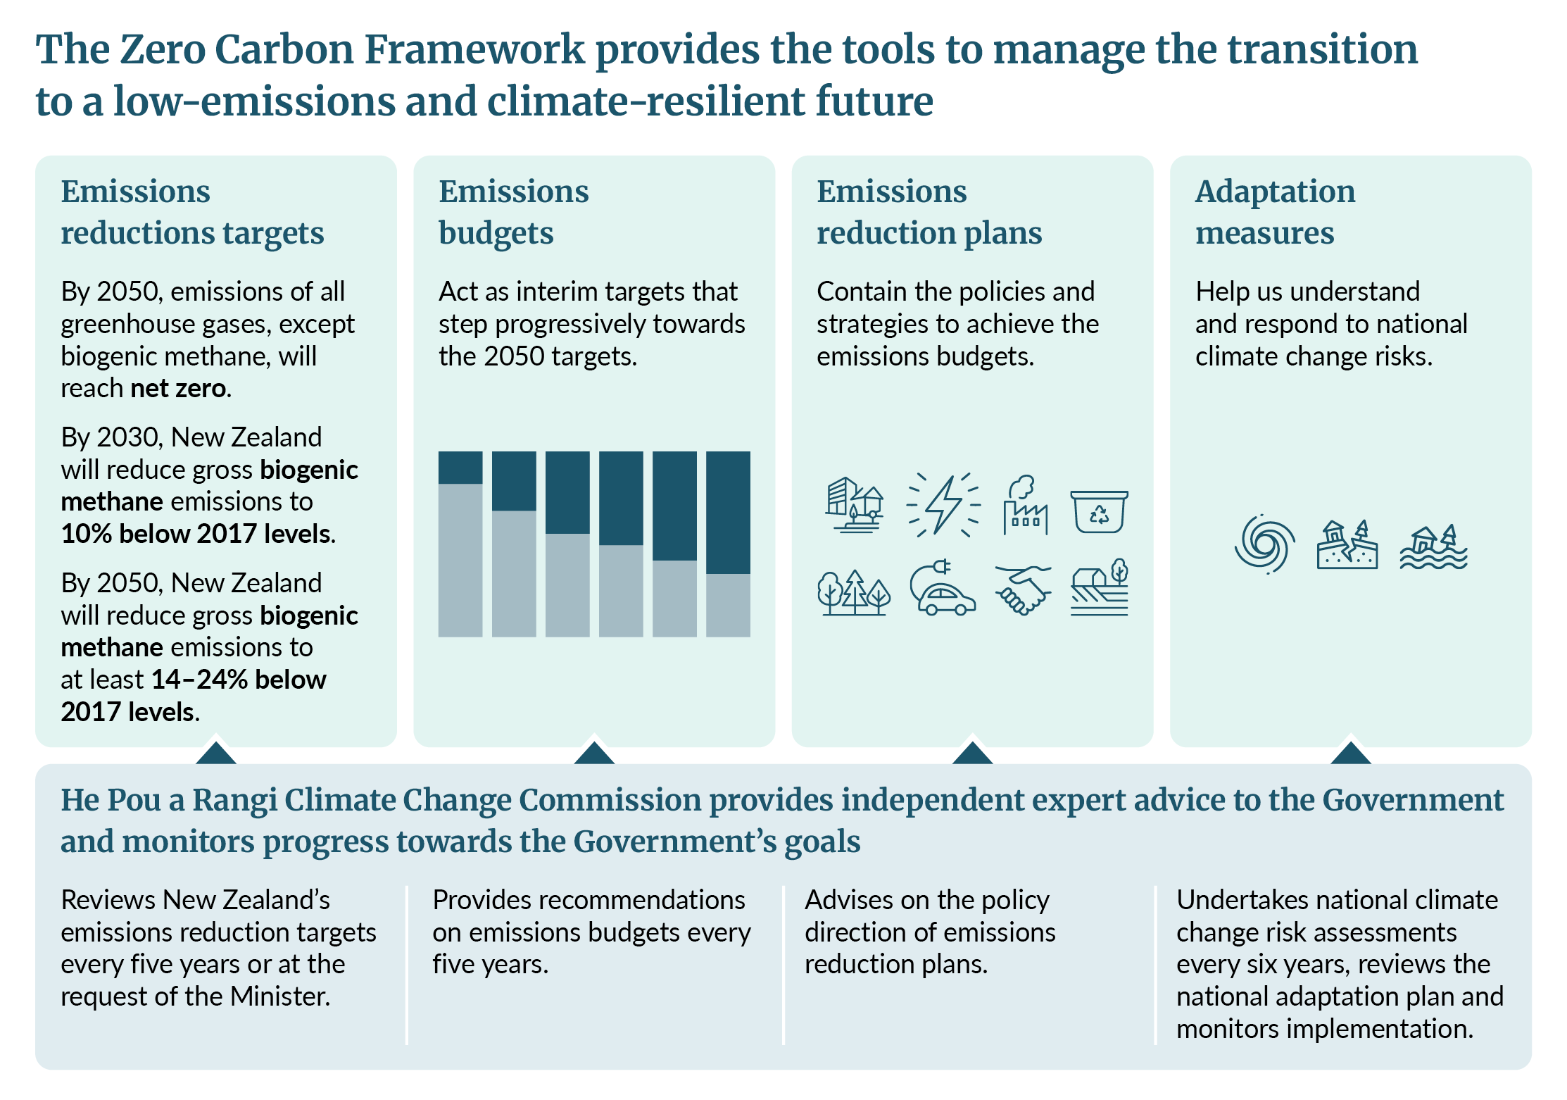

What does the Bill change?
The Bill is making changes that stem from a review of the Climate Change Response Act in 2025 looking at how to make the Act more efficient to implement (see figure 2).

ERPs and NAPs
- Removing duplication across the Commission’s deliverables. The Bill removes the requirement for the Commission to provide advice to the Government on the direction of an emissions reduction plan. This reflects that the Commission has alternative avenues for giving similar advice through its five-yearly emissions budget advice and annual emissions reduction monitoring report.
- Simplifying the required content of emissions reduction plans to:
- policies and strategies for meeting the relevant emissions budget
- a strategy to mitigate the impact on iwi and Māori
- other policies and strategies that the Minister decides are necessary.
- Clarifying and streamlining the process to amend an emissions reduction plan to support regular updates to reflect policy changes.
- Clarifying the process for amending national adaptation plans, so the national adaptation plan can be amended at any time, provided the Minister considers the implications of the changes for addressing the most significant risks in the NCCRA and any impacts on iwi and Māori.

Timing and sequencing of statutory deliverables
Amending the timing and frequency of Commission advice and reports, and Government decisions and responses to:
- create a more logical sequence
- spread work more evenly
- avoid potential duplication.
For further information about the timing of these changes, see the Ministry for Cities, Environment, Regions and Transport’s website.

Consultation requirements
The Bill removes duplicative consultation requirements to ensure consultation by the Commission and the Government is pitched appropriately.
Currently, the Government and the Commission both undertake public consultation when setting emissions budgets. The Bill requires the Commission to engage with experts, provides flexibility to the Commission for broader public engagement and removes complex public consultation requirements for the Minister.
The public will still have the opportunity to provide feedback on proposed ETS settings and proposed emissions reduction plans through Government consultation.

Other changes
- Creating a regulation-making power so the Minister can set an approach for calculating methodological improvements in relation to revising emissions budgets and tracking progress towards them. The intention is to ensure transparency and consistency in the Commission’s advice and monitoring, government emissions projections and government decision-making. To provide an additional layer of accountability and transparency, the Minister must first consult the Commission before finalising the regulations.
- Clarifying that an emissions budget that has begun can be revised to reflect methodological improvements since the emissions budget was set. This can only happen when the Minister responds to the Commission’s advice on emissions budgets.
- Creating a power for the Secretary for the Environment to formalise standards for emissions projections. Projections are a key tool for understanding if New Zealand is on track to meet its targets and budgets.
- Reducing the number of board members of the Commission from between five and nine to between five and seven. This would align the number of Commission board members with similar entities.
- Including references to ‘efficient and effective’:
- in the purpose of the CCRA
- when the Commission provides advice on emissions budgets
- when the Minister sets emissions budgets.
- Removing reference to the 1.5° Celsius temperature limit when setting emissions budgets. This change recognises that Parliament has determined New Zealand’s contribution to the 1.5° Celsius goal through the 2050 emissions target. Therefore, emissions budgets must be set with a view to achieving the 2050 target.
Figure 2: Efficiency changes included in the Climate Change Response Amendment Bill
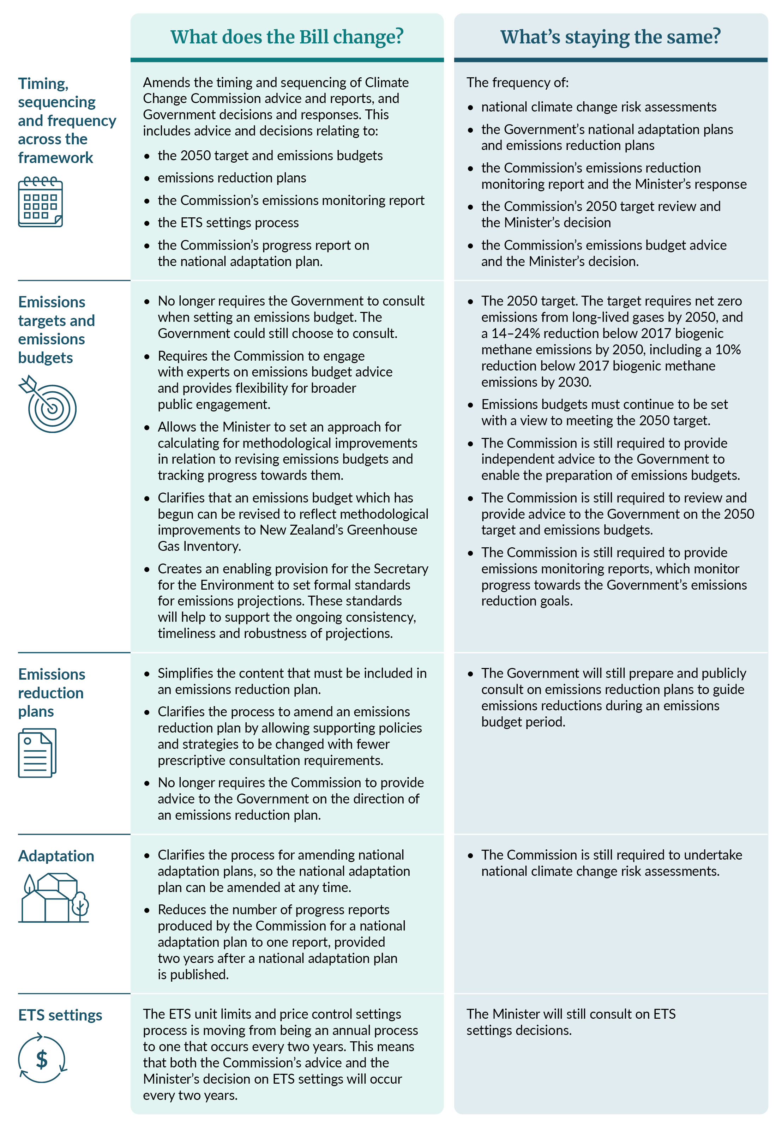
Published in July 2026 by the  Ministry for Cities, Environment, Regions and Transport  Publication number: INFO 1392 | 